**NEXT GROUP MEETING**

**7th JUNE - THE HR FESTIVAL IN SEFTON PARK LIVERPOOL**

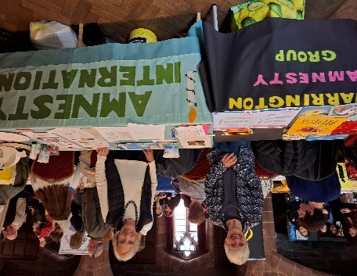

We participated in the Human Rights Festival in Liverpool. We were pleased to be accommodated in a nearby church as the forecast was for heavy rain. Although rather small for all the groups it was a good venue.

Our stall had a fairly steady stream of visitors looking at the human rights children’s books, signing the birthday card for José Rubén Zamora from Guatemala, and signing the petition urging the UK government to ratify the UN Convention for the Protection of All Persons from Enforced Disappearance.

The small number of children and teenagers who made dove mobiles were really delighted with their efforts making this activity worth repeating at a future suitable event.

Taking part in the festival gave us an opportunity to meet with other Amnesty Local Groups and it was interesting to experience the diversity of inspiring human rights groups.

Although it would have been more satisfying to have been in Sefton Park enabling us to meet with a much wider range of people and possibly able to recruit new members for Amnesty it was a very worthwhile event and a credit to the organisers.

**DEMONSTRATING SUPPORT FOR THE PALESTINIAN PEOPLE**

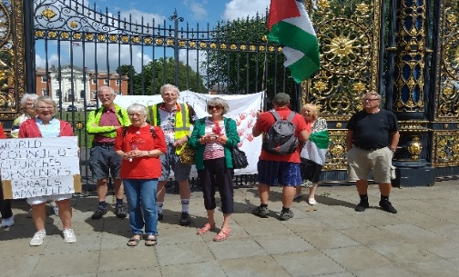

On Wednesday 2nd July a group met together outside the Town Hall gates to show support for the Palestinian people. It was supported by members of local churches, the Amnesty Group and concerned individuals.

Many in the group write or email regularly to the Prime Minister, the foreign secretary and to our own MP Sarah Hall, join protests and marches in Liverpool and Manchester whenever they are able keeping in touch via Facebook and email.

**Why Wear Something Red?**

Wearing something red was to signify that a red line has been crossed in the war in Gaza.

RED LINES CROSSED

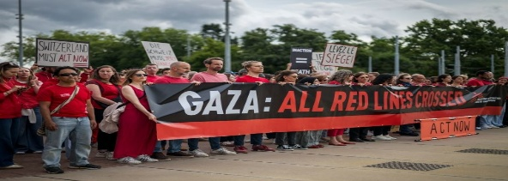

Thousands of people surrounded the Houses of Parliament in central London on Wednesday with one very clear message—s[top arming Israel](https://socialistworker.co.uk/palestine-2023/how-to-shut-down-britains-death-factories/). The “Red Line” that surrounded parliament symbolises the numerous red lines that Israel and its Western backers have crossed in the past 20 months of genocide.

**OGONI 9 PARDONED**

This is welcome news but it falls far short of the justice the Ogoni Nine need and deserve – the Nigerian government must recognise formally that they are innocent of any crime and fully exonerate them.  
Ken Saro-Wiwa and 8 other activists, were executed after a blatantly unfair trial on 10 November 1995.  
Officially accused of involvement in murder, the men had in fact been put on trial because they had challenged the devastating impact of oil production by Shell, in the Ogoniland region of the Niger Delta. Some of you may have been involved in campaigns for the Ogoni 9 since the 90s and beyond,

**PEACEFUL PROTEST UNDER THREAT**

[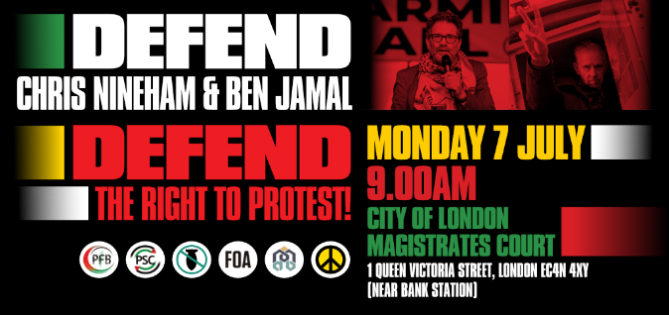](https://click.actionnetwork.org/ss/c/u001.XaF8mXqsA6b2dSPmhsleMQ7EEcf-sf2deMDLZZR3cKMTttVkeDjUbOeToSVNy35xW9O1gJdPL20qmEdCkoJf9ynFxKtKAXY_oMzYoOpz0AMm2J80ZhWwhs0t5D5vD_QnkDW7j_iSJLo2X2DTwNStNHeit3ZJ3-Ywa3a6W9FWTzWeATkGgOuKA0d1HUJjER8ipJAVFN1S9XVm-JQzZe872h-_2nl_drrNoNGOy-Z6jU7Gb1C2b7hLU5QtegNbXVsaORTJaSjkG14GsOgmO445z6XeXfMnyqElQCbfVeca0qVQlDszIwZOa0X_DOU0YFUVE74GrKz6Nx1w3weVr763Jg/4hp/7mRSQyfHRki21htdZ-guKA/h7/h001.AV_Z-jzIKz060NlAVUt3PfjjZRxtQNsCE84NvzYJW0s)

Two leaders of the Palestine movement, Ben Jamal and Chris Nineham, are facing criminal charges over the peaceful protest on 18 January. **They go on trial at City of London Magistrates’ Court on Monday 7 July.**

Actors Juliet Stevenson and Khalid Abdalla; Holocaust survivor and activist Stephen Kapos; current and former General Secretaries of the NEU, Daniel Kebede and Kevin Courtney; musician and President of StW Brian Eno; John McDonnell MP; Yasmine Adam, chair of MAB; and more tba.

**#FreeBenAndChris** and **#InOurMillions**

**2nd AUG. – FANCY A TRIP TO COLWYN BAY**

Colwyn Bay group are having a kite-flying event on 2 August. They also hope to have the Surviving Evin Prison exhibition at an event on 24 August, when they also hope to have Anoosheh Ashoori as a speaker

**AMNESTY WELCOMES JOURNALIST ALBERTO AMARO TO LONDON**

Over two days in June the Central America Team was delighted to host Mexican journalist Alberto Amaro in London. Alberto and his family are currently in the ‘human rights defenders’ programme at AI Spain, enjoying some respite after suffering multiple threats and attacks in Mexico for his work as a journalist. During his stay, Alberto had meetings in Parliament with the APPGs for Human Rights and Media Freedom, as well as meeting representatives from the British Foreign Office.

 He also shared his story with representatives from AI UK, AI Spain and Amnesty’s International Secretariat, as well as NGOs Peace Brigades, PEN International and Reporters without Borders.

**US: STOP ILLEGAL TRANSFERS TO EL SALVADOR**

Following a presidential proclamation invoking the Alien Enemies Act by President Trump, targeting alleged members of the Tren de Aragua (TdA) criminal group, 255 individuals have been illegally removed from the USA to El Salvador and are now being held at the Centro de Confinamiento Contra el Terrorismo, a prison notorious for its inhumane conditions. We call on the Trump administration to immediately return those that were illegally removed to El Salvador back to the US and halt any subsequent expulsions or deportations of Venezuelans or other third country nationals, complying with the decisions of the US Judiciary.

This on-line action closes on 11th JULY