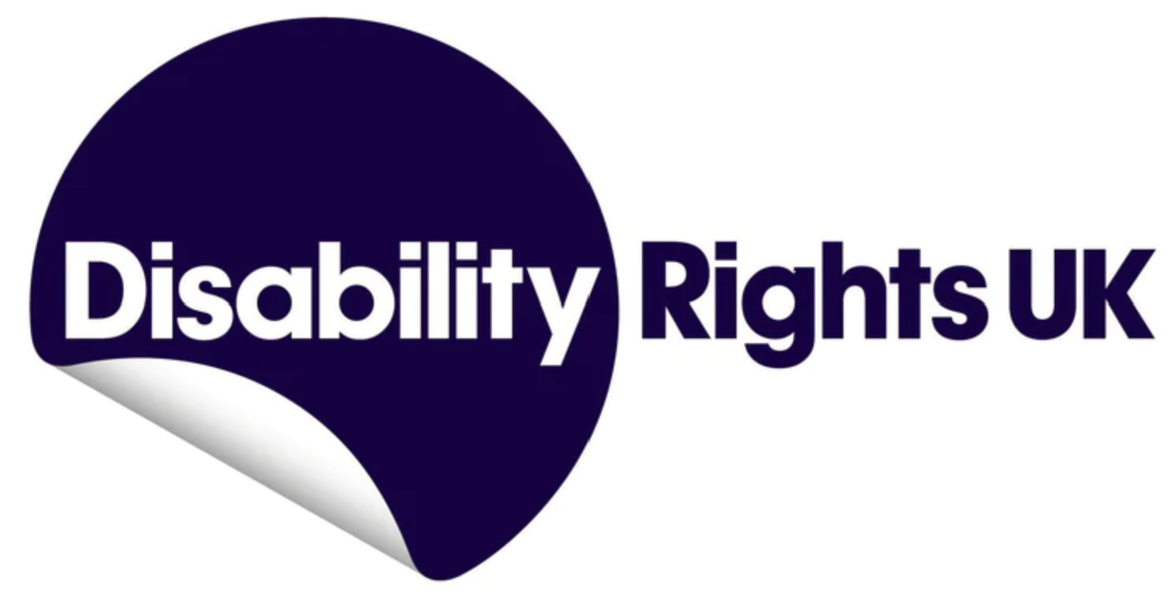

**Disabled People and Social Security**

Social security plays an important role in poverty reduction and alleviation. This right is a core component of international human rights law including the [International Covenant on Economic, Social and Cultural Rights (ICESCR)](https://www.ohchr.org/en/instruments-mechanisms/instruments/international-covenant-economic-social-and-cultural-rights).

A well-functioning social security system should protect the adequate standard of living of marginalised and vulnerable groups such as people living in poverty, Disabled people, children, the elderly, migrants etc. The UK Government and devolved administrations (where applicable) are obliged to provide a social security system which is human rights compliant.

[Disability Rights UK (DR UK)](https://www.disabilityrightsuk.org/about-us) is a national pan disability charity and [Disabled People’s Organisation (DPO)](https://www.disabilityrightsuk.org/disabled-peoples-organisations). We are the UK’s leading organisation led by, run by, and working for Disabled people. Our vision is a world where Disabled people have equal rights, opportunities, and access to power and our work is rooted in the lived experience of Disabled people. We are a membership organisation and work closely with DPOs across the country.

**How many people have a disability in the UK?**

The latest estimates from the Department for Work and Pensions (DWP) [Family Resources Survey](https://www.gov.uk/government/statistics/family-resources-survey-financial-year-2022-to-2023)  indicate that 16.1 million people in the UK had a disability in the 2022/23 financial year. This represents 24% of the total population. In the 10 years since 2012/13, the estimated number of Disabled people has increased by 3.9 million (up 32%).[1]

**The reality for Disabled people in the UK**

In relation to the International Covenant on Economic, Social and Cultural Rights (ICESCR)Disabled people are [hit hardest by the Cost of Living Crisis](https://www.resolutionfoundation.org/publications/costly-differences/), and substantially [more likely to live in poverty](https://www.scope.org.uk/campaigns/extra-costs/disability-price-tag-2023/#:~:text=On%20average%2C%20disabled%20households%20(with,to%20%C2%A31%2C122%20per%20month.) – whether they are disabled themselves or live with somebody who is. Barriers to adequate housing, social care and healthcare also lead to us falling out of work and not being able to re-join the workforce.

Barriers to employment are systemic – beginning with [no support in school](https://www.specialneedsjungle.com/send-tribunal-2023-councils-stop-wasting-public-funds-send-appeals-fail-almost-all-time/) leading to [poorer outcomes](https://www.ons.gov.uk/peoplepopulationandcommunity/healthandsocialcare/disability/articles/outcomesfordisabledpeopleintheuk/2021#education), a higher rate of [social exclusion and abuse](https://www.disabilityrightsuk.org/news/disability-hate-crime-rises-only-1-see-prosecutions), and a [punitive social security system](https://www.disabilityrightsuk.org/news/wca-reforms-will-reduce-claimant-caseload-37-times-more-it-will-increase-employment) which sanctions and demonises Disabled people rather than supports them into work. Government policy has led to a regression in our rights, and by describing us as “economically inactive” Disabled people [are scapegoated for a failing economy](https://www.disabilityrightsuk.org/news/dr-uk-says-pm-must-stop-scapegoating-disabled-people-failing-economy).

**Benefit Adequacy**

The [Disability Price Tag 2024](https://www.scope.org.uk/campaigns/disability-price-tag) report by Scope found that on average, disabled households need an additional £1,010 a month to have the same standard of living as non-disabled households.

On average, Scope says, if this is adjusted for 2023/2024 inflation these extra costs go up to £1,067 a month.

In its research report, [UK Poverty 2023](https://www.jrf.org.uk/sites/default/files/jrf/uk_poverty_2023_-_the_essential_guide_to_understanding_poverty_in_the_uk_0_0.pdf), the Joseph Rowntree Foundation (JRF) highlighted that “Disabled people face a higher risk of poverty and have done so for at least the last 20 years.

“This is driven partly by the additional costs associated with disability and ill-health, and partly by the barriers to work Disabled people face.

Shockingly, the Trussell Trust report that [nearly 7 in 10 (69%) of those referred to its food banks are Disabled people](https://www.disabilityrightsuk.org/news/number-trussell-trust-food-parcels-nearly-double-over-past-five-years).

**Claiming Benefits for Disabled People**

1. **The Work Capability Assessment (WCA)**

The Government has placed an emphasis on reducing “economic inactivity”, especially among Disabled People.

Our concern is that this will result in an increased emphasis on work conditionality and sanctions and reducing Universal Credit amounts.

Our worry is heightened by a [Resolution Foundation briefing](https://www.resolutionfoundation.org/app/uploads/2024/10/More-more-more-Budget-2024.pdf) finding that the Budget 2024 reforms will amount to a net welfare benefit cut of £3.9 billion by 2029/2030.

The [WCA](https://www.disabilityrightsuk.org/resources/work-capability-assessment#What) is used by the DWP in relation to Universal Credit to decide whether or not someone is “fit for work”.

Rather than focusing on an individual's health condition, the WCA is a [“functional assessment”](https://www.advicenow.org.uk/know-hows/universal-credit-basis-having-limited-capability-work-activities-and-descriptors-and?gad_source=1&gclid=EAIaIQobChMI-6vp6Mj1iQMVuYBQBh3mITldEAAYASAAEgJtvPD_BwE). The test looks at someone’s ability to undertake a range of activities related to physical, mental, cognitive, and intellectual functions.

The WCA has been controversial from its 2008 outset. Despite changes made to the WCA following internal reviews, and five annual independent WCA reviews, the WCA still attracts strong criticism. – for example in the 2023 Work and Pension Committee report [Health assessments for benefits](https://committees.parliament.uk/work/1468/health-assessments-for-benefits/).

It heard evidence of -

* Factual errors in assessment reports;
* Difficultly completing forms;
* Lack of knowledge of conditions from assessors;
* Poor communication from DWP, including issuing communications in formats which people cannot use;
* Delays and consequent financial and health impacts; and
* Over-frequent requirements to re-apply, particularly in circumstances where no improvement in the claimant’s condition may reasonably be expected.

A [2024 Joseph Rowntree analysis](https://www.jrf.org.uk/work/unlocking-benefits-tackling-barriers-for-disabled-people-wanting-to-work#executive-summary) highlighted that three-quarters of adults receiving health-related Universal Credit are experiencing material deprivation. This is even higher than the two-thirds of adults receiving non-health-related UC experiencing material deprivation. This compares to a fifth for the general working-age population.

1. **Personal Independence Payment (PIP)**

PIP was introduced in 2013 and is a benefit for people between the ages of 16 and [pension age](https://www.gov.uk/state-pension-age) who need help taking part in everyday life or who find it difficult to get around.

Like the WCA, PIP is functional test and eligibility is restricted to meeting specified activity [“descriptors”](https://www.advicenow.org.uk/know-hows/personal-independence-payment-pip-activities-and-descriptors?gad_source=1&gclid=EAIaIQobChMIt5Shy8j1iQMVWJtQBh1U_AnPEAAYASAAEgJ5uPD_BwE).

Again, like the WCA, PIP and its assessments have been criticised from its outset.

For example, [2023 research](https://www.mind.org.uk/media/sjbptudq/reassessing-assessments-report.pdf) by the mental health charity Mind found that:

* Almost 1 in 2 people (48%) did not agree with the outcome of their PIP

assessment.

* Almost 7 in 10 people (66%) said that going through their benefits assessment made their mental health worse.

Similarly, [2023 research](https://www.mssociety.org.uk/sites/default/files/2023-09/PIP%20and%20MS%20a%20decade%20of%20failure%20FINAL%20REPORT.PDF) by the Multiple Sclerosis Society found that:

* 2 in 3 (65%) said the PIP application process had a negative, or very negative, impact on their physical and mental health;
* 6 in 10 (61%) said their PIP assessment report didn't give an accurate reflection of their MS;
* over 3 in five (62%) said their PIP assessor didn’t consider their hidden symptoms;
* Almost two-thirds (63%) didn’t feel they got the correct PIP award;
* Over half (53%) said their assessment report didn’t include evidence gathered from their healthcare professionals.

This is reflected in 2024 statistics by the DWP showing that 70% of the DWP decisions cleared at a tribunal hearing were “overturned” (which is where the decision is revised in favour of the claimant).

**Universal Credit (UC)**

Unlike the [legacy benefits](https://www.turn2us.org.uk/jargon-buster/legacy-benefit) it is replacing, within UC there are no equivalents of the additional [enhanced disability premium or severe disability premium](https://www.gov.uk/disability-premiums/eligibility) paid at a weekly rate of £20.85 and £81.50 respectively. The equivalent of £5,300 a year. This does not only affect new UC claimants.

While those who are moved by the DWP from a legacy benefit to UC receive “transitional protection” to compensate for the loss of these premiums, this is withdrawn pound for pound whenever they have an increase in their UC entitlement.

UC also operates primarily as a “digital by default” benefit. This not only makes it difficult for some Disabled people to claim, but also to maintain their claim and communicate with the DWP.

**Safeguarding and disabled claimants’ deaths**

A [2024 survey](https://committees.parliament.uk/publications/45121/documents/223511/default/) of DWP carried out by the Work and Pensions Committee found that:

* two-thirds still do not have enough time to deal with safeguarding concerns “carefully”;
* more than two-fifths with direct contact with claimants did not believe they received adequate safeguarding training;
* nearly half said the safeguarding guidance for frontline staff was not clear, comprehensive and easy to access;
* more than a third did not feel confident about how to handle a safeguarding concern.

Timeline evidence stretching back more than a decade shows how the DWP has repeatedly ignored recommendations to improve the safety of its disability benefits assessment system, leading to countless avoidable deaths of disabled claimants.

In a [10,000-word investigation](https://www.disabilitynewsservice.com/the-department-for-work-and-pensions-deaths-cover-up-and-a-toxic-30-year-legacy/), published in March 2022, John Pring of the Disability News Service set out other evidence that shows how the DWP -

* ensured that key evidence linking its actions with those deaths was not considered by independent reviews;
* failed to keep track of what actions were taken in response to recommendations made by its own civil servants to improve the system;
* has cultural problems that touch all aspects of its dealings with Disabled people in the social security system, and how the roots of its “toxic” culture stretch back at least 30 years.

In its [2024 UK investigation report](https://www.inclusionlondon.org.uk/campaigns-and-policy/uncrdp/uncrdp-2023-24/report/), the UN Committee on the Rights of Persons with Disabilities, said that it “is appalled by reports of “benefit deaths” referring to fatalities among disabled people in the State party, subsequent to their engagement with the process for determining eligibility for benefits:

“The evidence received revealed a disturbingly consistent theme: disabled people resorting to suicide following the denial of an adequate standard of living and social protection, starkly contradicting the foundational principles enshrined in the Convention.

In addition to numerous personal accounts concerning benefit deaths, a research study shared with the Committee indicated a correlation between the government's initiative to reevaluate incapacity benefits through the Work Capability Assessment (WCA) and an estimated six hundred suicides over a span of three years.

Testimonies have also been received regarding the minimal, unsuitable, and/or abusive responses to individuals' mental health emergencies that are frequently precipitated by the benefits assessment procedure.”

**Pathways to Work: Reforming Benefits and Support to Get Britain Working Green Paper**

On 18 April 2025 the Government published the above [Green Paper](https://www.gov.uk/government/consultations/pathways-to-work-reforming-benefits-and-support-to-get-britain-working-green-paper) proposing wholesale and dangerous changes to how Disabled people are supported by the benefits system. Among the proposed reforms are -

* Scrapping the WCA and creating a new single assessment for PIP and the UC Health element addition
* Freezing the health element addition of UC until 2029/30
* PIP Daily Living component assessment changes
* Restarting WCA reassessments until the WCA is scrapped

Among the effects of these reforms would be that –

* Most Disabled claimants will be subject to all work conditionality enforced by a punitive benefit sanctions regime
* Freezing UC health meaning a [£1,100 average reduction in overall annual UC awards for the 3.0 million individuals by 2029](https://obr.uk/docs/dlm_uploads/OBR_Economic_and_fiscal_outlook_March_2025.pdf)
* The freeze and reduction together amounting to [a £1.5 billion cut to Universal Credit health spending by 2030](https://neweconomics.org/2025/03/government-is-concealing-the-true-scale-of-benefit-cuts-for-ill-and-disabled-people).
* [800,000 losing the PIP daily living component](https://obr.uk/efo/economic-and-fiscal-outlook-march-2025/) - this amounts to a minimum of £4,200 per year.

Amnesty International UK has now written to DWP Minister Liz Kendall highlighting human rights failures of the Green Paper. These include –

* A limitation on the extent to which some changes are within scope for the consultation - of 22 changes, only 11 are being consulted on and do not include the reforms listed above
* The failure to publish adequate impact assessments alongside the reform proposals

**Conclusion**

The UK social security system should provide a financial safety net for Disabled people and those with long-term health conditions.

The level of support should be such that Disabled people can live independent lives.

Yet, for more than a decade, changes to welfare benefits have led to this safety net failing, causing people to feel abandoned by a cruel and unfair system.

We urgently need a social security system built on compassion and justice. With rising costs and a healthcare system in crisis, having a robust system of support for seriously ill and disabled people has never been more important.

The Government must meet its responsibilities under the ICESCR.

A new benefits system needs and must be [co-produced](https://www.disabilityrightsuk.org/news/co-production-glance) with Disabled people for it to be fair and equitable – [Nothing about us without us](https://www.futurelearn.com/info/courses/global-disability/0/steps/37575) – and meet the UK’s obligations under the CRPD.

That way a new system would address the actual barriers that Disabled people face and reflect the extra costs that they have.

1. For detailed information on the prevalence of disability within the UK by type, age, sex and ethnic group see the House of Commons Library Briefing [UK Disability Statistics: Prevalence and Life Experiences](https://www.gov.uk/government/statistics/family-resources-survey-financial-year-2022-to-2023/family-resources-survey-financial-year-2022-to-2023#disability-1).]