**AMNESTY UK KENT NETWORK NEWSLETTER: SEPTEMBER 2024**

**HIGHLIGHTS**

A bumper newsletter this month as we get back into the swing of things after a busy summer of outdoor events. A warm welcome to those who have joined us this summer. This month you can

* **Join this Tuesday’s online speaker meeting** to learn more about human rights in Russia
* **Help us to communicate with your local MP** to advocate for his support for human rights
* **Improve your influencing skills** with Amnesty’s course on People, Power, and Politics
* **Learn about human rights in specific countries** by joining some of the many events listed below
* **Sign the petition** calling on the Prime Minister to **end the homelessness crisis**
* **Book a place** on Amnesty’s conference in London on 28 September on **Deconstructing Power**
* **Apply** to be one of Amnesty UK’s team of volunteer **Country Coordinators**

**SPEAKER MEETING THIS TUESDAY: RUSSIA**

**Join us online this Tuesday at 7:30pm** when **Barrie Hay**, Amnesty UK’s Russia Country Coordinator will talk about the current human rights situation in **Russia.** This will be a joint event with the recently formed Surrey and Borders Network. **Email** [**arianna.pisetti@amnesty.org.uk**](mailto:arianna.pisetti@amnesty.org.uk) **for a link.**

On 1 August, in a swap deal brokered between Russia and Belarus on the one hand and Germany, Norway, Poland, Slovenia and the US on the other, the authorities in Moscow and Minsk **pardoned, released and exiled 16 prisoners, including Russian activists and human rights defenders and journalists**. Many of the released individuals had been imprisoned following unfair trials under politically motivated charges relating to criticism of the authorities, anti-war activism and journalistic work. Is this an isolated episode or does it mark a shift in the Russian Government’s attitude to dissent?

**WHAT HAVE WE BEEN DOING?**

On 8 September, the Maidstone, Medway and Swale Group were at the **Maidstone Community MELA** in Mote Park, where they collected signatures for a letter to the Prime Minister calling on his government to place protection of human rights at the heart of its policies.

**LINKS WITH LOCAL MPs: ADVOCATING FOR HUMAN RIGHTS**

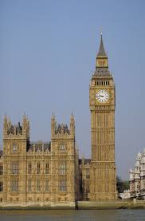

The General Election has led to **many new MPs** in our area and a significant change in the political balance. We have developed **a plan aimed at reaching every one of the 20 MPs** in our area to commit to supporting and defending human rights in this country and internationally, both in parliament and more widely, and to prioritise the following:

* protect and uphold the **Human Rights Act** 1998 and the UK's membership of the **European Court of Human Rights** and its commitment to the **European Convention on Human Rights**;
* support **a ban on UK arms sales to Israel** and call for an **end to Israel's system of apartheid** and its **illegal occupation of Palestinian territories**
* work to improve the protection of people's human rights in their daily lives, with the aim of eliminating **poverty**, tackling **homelessness** and ensuring **access to adequate food and health and social care**
* support the **right to peaceful protest** in the UK and press for the **repeal of the anti-protest measures** in the Police, Crime, Sentencing, and Courts Act 2022 and the Public Order Act 2023
* press for a **properly resourced** **asylum system** based on respect, fairness, safety, and regard for human rights, which recognises everyone's **right to seek asylum** in other countries under the Universal Declaration of Human Rights

Building links with local MPs is an important part of our work. These relations are a channel through which we can seek to influence government policy on human rights issues. **If you would like to help us to establish or strengthen links with your local MP, please email me.**

Amnesty’s course on **People, Power, and Politics: Influencing Political Decision-Makers on Human Rights** will help you to develop your knowledge of human rights and British politics and learn key strategies to influence and advocate for human rights. **You can access the course** [**here**](https://www.futurelearn.com/courses/people-power-and-politics-influencing-political-decision-makers-on-human-rights)**.**

**CHINA: ALL STATIC AND NOISE**

On 22 September from 3pm at the Human Rights Action Centre in London, Amnesty will present the award-winning documentary film [**All Static & Noise**](https://www.tickettailor.com/events/amnestyinternational/1383689), followed by a discussion with academics, activists and Uyghur scholar Abduweli Ayup, whose story is featured in the film. Tickets are free, but you are invited to make a donation to help cover the cost of the screening (suggested donation £5). All Static & Noise is a groundbreaking documentary about **atrocities committed against the Uyghur and Kazakh peoples in China**.

**IRAN**

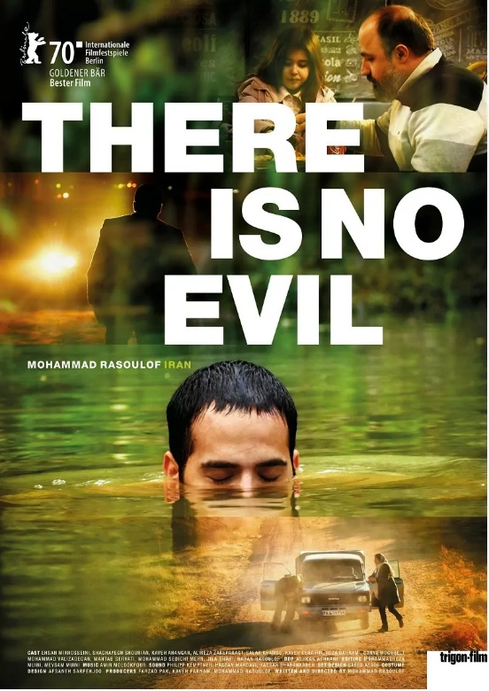

On **25 September** at the Garden Cinema in London, Amnesty is presenting a [one-off fundraiser screening of *There Is No Evil*](https://www.thegardencinema.co.uk/film/amnesty-international-presents-there-is-no-evil/)with an introduction by activist and actress [Elika Ashoori](https://www.instagram.com/lilika_49/), which will offer an insight into the death penalty in Iran. Winner of the Golden Bear at the Berlin Film Festival in 2020,*There Is No Evil* tackles Iran's use of the death penalty through four moral tales about men faced with a simple yet unthinkable choice.

**USA: DEATH PENALTY**

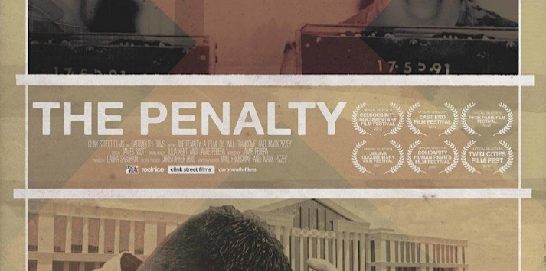

On **8 October** at the Human Rights Action Centre in London, Amnesty’s Anti-Death Penalty Project will host a campaign workshop and film screening on **The Death Penalty in the USA**. **To attend in person or online,** [**book** **here**](https://www.eventbrite.co.uk/e/the-death-penalty-in-the-usa-campaign-workshop-and-film-screening-tickets-1003064762707?aff=oddtdtcreator)**.**

**SOCIAL AND ECONOMIC RIGHTS IN THE UK**

Amnesty UK have released a new report [*Broken Britain: Voices from the frontline of the fight for everyday rights*](https://www.amnesty.org.uk/files/2024-08/ESCR_BriefingV17%20%281%29.pdf?VersionId=JnTAQrdV9A8ljy2fk4C0WVif010KD7Zm), which describes how people’s economic and social rights are routinely violated in the UK, as evidenced by the extent of **hunger**, **homelessness** and **health inequality**. Amnesty is calling on the new government to act urgently in response to the recommendations in the report.

Amnesty and the homelessness charity **Groundswell** have launched a new charter to ensure policymakers collaborate with individuals with **lived experiences of homelessness**.  On 2 September, as politicians returned to Westminster, projections upon the Houses of Parliament provided a stark reminder that ‘Homelessness is a Political Choice’.

[Please sign the petition](https://www.amnesty.org.uk/actions/end-homelessness-crisis) calling on the Prime Minister to **end the homelessness crisis** by making sure people can afford rent, ensuring funding to support people experiencing homelessness, and involving people who have experienced homelessness in creating solutions to end it.

**ANTI-RACISM IN THE UK**

On 23 August, the United Nations Committee for the Elimination of Racial Discrimination [**published its “concluding observations” on its recent reports on racism in the UK**](https://tbinternet.ohchr.org/_layouts/15/treatybodyexternal/Download.aspx?symbolno=CERD%2FC%2FGBR%2FCO%2F24-26&Lang=en)**.** Among the many recommendations is that the government **suspend the "prevent duty" policy** pending the adoption of robust measures to "**eliminate any discriminatory and disproportionate impact** on the human rights and fundamental freedoms of members of ethnic and ethno-religious minorities, including children".

**Amnesty is campaigning for Prevent to be abolished** due to the considerable evidence that Prevent has caused immense harm to minoritised and racialised communities over years, limiting and eroding their fundamental rights with little to no recourse to accountability and remedy.

Next month, **we shall resume our local conversations** about Prevent to learn more about its impact in our area.

The Amnesty Anti-Racism Network will hold **a conference in London on 28 September** on **Deconstructing Power**. The event will dive deep into the concept of power with engaging discussions, interactive workshops, and thought-provoking presentations, rethinking the UK's anti-racism efforts and delving into the realities of oppressive power, Islamophobia, representation and grassroots actions. You can [book a place here](https://www.eventbrite.co.uk/e/deconstructing-power-tickets-950745043017?aff=oddtdtcreator&utm-source=cp&utm-campaign=social&utm-content=attendeeshare&utm-medium=discovery&=&utm-term=listing).

**AMNESTY FEMINIST NETWORK: WOMEN IN AFGHANISTAN**

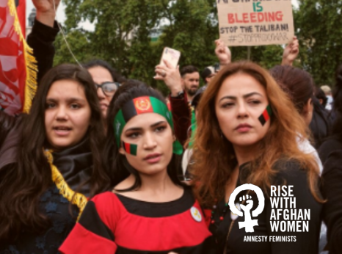

You can still [watch last month’s webinar](https://www.youtube.com/watch?v=Dsw36_DXhi4) about women in Afghanistan as it was recorded; and you can still [sign the petition](https://www.amnesty.org.uk/activist-actions/af-afghanistan1?utm_content=153956&utm_campaign=MEMA5668S_AF&utm_medium=email&utm_source=amnestyuk) to the Prime Minister calling on the UK Government to **do more to support women in Afghanistan**.

**REFUGEES**

At least **12 people, primarily of Eritrean origin, died on 3 September trying to cross the Channel.** Amnesty UK’s Refugee and Migrant Rights Director said: “Until **UK ministers and their counterparts in France start sharing responsibility**for the humans that take that perilous Channel crossing – and that includes **creating safe asylum routes to the UK** - Government policy will continue to be a cause for more lives being lost.”

**GAZA**

Responding to the UK Foreign Secretary’s [announcement](https://www.gov.uk/government/news/uk-suspends-around-30-arms-export-licences-to-israel-for-use-in-gaza-over-international-humanitarian-law-concerns?utm_medium=email&utm_campaign=govuk-notifications-topic&utm_source=b71eff79-7bed-4abc-9296-ec84010669e8&utm_content=immediately) on 2 September that the UK was suspending around 30 out of some 350 arms export licences for military equipment for Israel, [Amnesty UK’s Chief Executive, said:](https://www.amnesty.org.uk/press-releases/uk-suspension-30-arms-export-licences-israel-too-limited) “While this decision appears to demonstrate that the UK has finally accepted the **very clear and disturbing evidence of Israeli war crimes in Gaza**, it’s unfortunately **too limited and riddled with loopholes**”.

[Amnesty has released analysis](https://www.amnesty.org/en/latest/news/2024/09/israel-opt-israeli-military-must-be-investigated-for-war-crime-of-wanton-destruction-in-gaza-new-investigation/) suggesting that the Israeli military has unlawfully destroyed agricultural land and civilian buildings in the buffer zone, razing entire neighbourhoods to the ground.  It has called for this to be investigated as **war crimes of wanton destruction and of collective punishment**.

**WRITE FOR RIGHTS**

Amnesty’s annual **Write for Rights Campaign** will take place as usual during November and December. So far, two stalls are planned in our area: at **Faversham street market on 16 November** and at the **Christmas Fayre at Aylesford Priory on 23 November**, both organised by the Maidstone, Medway and Swale Group. If you would like to suggest other places where we could promote the campaign, please email me.

**VACANCIES FOR COUNTRY COORDINATORS**

Ever thought you would like to **get more involved in long term campaigning on a specific country**? Amnesty UK is advertising for volunteers to join the team of over 50 country coordinators to work on a range of countries. The Country Coordinator role is **one of the most interesting activism roles at Amnesty UK**.  Country Coordinators play a significant part in leading grassroots activism in the UK to achieve human rights change in the countries on which they work. [Details here on how to apply](https://www.amnesty.org.uk/jobs/activism).

**AMNESTY UK YOUTH CONFERENCE 2024**

AIUK's Youth Conference, led and organised by the Children's Human Right's Network will take place at the Human Rights Action Centre in London on **Friday 22 November**. The conference is open to secondary school age school groups. Attending the Youth Conference will give young Amnesty activists the opportunity to meet other youth activists from across the country and gain knowledge, practical skills and confidence to take action on human rights in the UK and around the world. **Registration will open later this month.**

**AMNESTY AMPLIFY – HUMAN RIGHTS FESTIVAL**On **7 December**, Amnesty will host a major human rights festival, **Amplify Human Rights Festival**, in London. This event will be a celebration of Amnesty’s work, bringing together activists, artists, and communities to highlight and celebrate Amnesty’s impact on human rights.  Details to follow.  
  
**PEACE EVENT IN BEXHILL**

On **21 September** from 1:30pm to 4:45pm at St. Peter’s Community Centre, Church Street, Bexhill-on-Sea, TN40 2HE, the Bexhill branch of the United Nations Association will hold a seminar called “**Prepare for Peace**”. The Reverend Stephen Need, Rector of St. Peter’s Church, will set the groundwork for discussion by exploring how PEACE BEGINS WHERE  YOU ARE. For more information, email [s.kesby339@btinternet.com](mailto:s.kesby339@btinternet.com).



**Tuesday 17 September online at 7:30pm to 8:30pm: Kent Network speaker meeting with Barrie Hay, Amnesty UK’s Russia Country Coordinator. Email** [**arianna.pisetti@amnesty.org.uk**](mailto:arianna.pisetti@amnesty.org.uk) **for a link.**

**Saturday 21 September at 1:30pm to 4:45pm: Prepare for Peace seminar at St. Peter’s Community Centre, Church Street, Bexhill-on-Sea, TN40 2HE. Organised by the Bexhill branch of the United Nations Association. For more information, email:**[**s.kesby339@btinternet.com**](mailto:s.kesby339@btinternet.com)**.**

**Sunday 22 September at 3:00pm to 7:00pm: “All Static and Noise” film screening at the Human Rights Action Centre in London.** [**Event link here**](https://www.tickettailor.com/events/amnestyinternational/1383689)**.**

**Wednesday 25 September at 7:50pm: ''There Is No Evil'' film screening at The Garden Cinema, London.** [**Event link here**](https://email.amnestyuk.org.uk/c/12llmNGzpIaH6GKDEEs1epAYgCjs)**.**

**Saturday 28 September in London: Amnesty Anti-Racism Network conference: Deconstructing Power. Venue to be confirmed. You can** [**book a place here**](https://www.eventbrite.co.uk/e/deconstructing-power-tickets-950745043017?aff=oddtdtcreator&utm-source=cp&utm-campaign=social&utm-content=attendeeshare&utm-medium=discovery&=&utm-term=listing)**.**

**Wednesday 2 October at 1:00pm. Monthly Close Guantanamo Vigil in London Square. Email** [**maclixby@gmail.com**](mailto:maclixby@gmail.com) **for details.**

**Monday 7 October at 7:30pm. Maidstone, Medway and Swale Group meeting at The Chiltern Hundreds, Penenden Heath Rd, Penenden Heath, Maidstone ME14 2DG.** **Email** [**mmands.amnestygroup@gmail.com**](mailto:mmands.amnestygroup@gmail.com) **for details.**

**Tuesday 8 October at 6:00pm to 10:00pm. The Death Penalty in the USA: campaign workshop and film screening. In person and online.** [**Book here**](https://email.amnestyuk.org.uk/c/12llnxgOSJLamGaqAfmvI6FJD7gz)**.**

**Thursday 24 October. UN Flag Day. Lighting up of the Town Hall in Tunbridge Wells.** **Email** [**dominique.oneil@outlook.com**](mailto:dominique.oneil@outlook.com) **for details.**

**Saturday 16 November at 9:00am to 4:00pm. Write for Rights stall at Faversham Market. Email** [**mmands.amnestygroup@gmail.com**](mailto:mmands.amnestygroup@gmail.com) **for details.**

**Friday 22 November. Amnesty UK's Youth Conference, led and organised by the Children's Human Rights Network. Registration will open this month.**

**Saturday 23 November at 9:00am to 4:00pm. Write for Rights stall at Christmas Fayre at Aylesford Priory.** **Email** [**mmands.amnestygroup@gmail.com**](mailto:mmands.amnestygroup@gmail.com) **for details.**

**Thursday 5 December. Opening of Guantanamo exhibition at Rich Mix, 35-47 Bethnal Green Road, London E1 6LA. Email** [**dominique.oneil@outlook.com**](mailto:dominique.oneil@outlook.com) **for details.**

**Saturday 7 December. Amplify Human Rights Festival, organised by Amnesty UK. Details to follow.**

All the best

Graham