**AMNESTY UK KENT NETWORK NEWSLETTER: OCTOBER 2024**

**HIGHLIGHTS**

Welcome to our October newsletter. This month you can:

**Join our online speaker meeting** on Tuesday to learn more about Amnesty’s **anti-death penalty work** and how you can support it

Support Amnesty’s work to campaign to defend human rights in **Russia**

Help us to build a link with **your local MP** and call on him to commit to supporting and defending human rights

Call for a complete ban of the sale of **UK arms to Israel**

Get a ticket to **Amnesty’s human rights festival “Amplify”** at Woolwich Works on 7 December

Attend the event on 22 October to celebrate **Alaa Abdel Fattah’s book**, You Have Not Yet Been Defeated.

Take part in this year’s **Write for Rights** Campaign

Attend Amnesty’s **Youth Conference** on 22 November (if you are young enough)

**SPEAKER MEETING THIS TUESDAY: DEATH PENALTY**

**Join us online this Tuesday at 7:30pm** when **Paul Bridges** will tell us about the work of Amnesty UK’s Anti-Death Penalty Project (ADDP).  **Email** [**maclixby@gmail.com**](mailto:maclixby@gmail.com) **for a link.**

10 October was the **World Day Against the Death Penalty**. The ADDP marked it by launching a campaign to **contact the Governor of every US death penalty state** to tell them why the death penalty is so wrong and to urge them to take the next step in abolishing the penalty for good. [Here is a link to their activist pack](https://www.amnesty.org.uk/resources/anti-death-penalty-project-usa-special-world-day).

**RUSSIA**

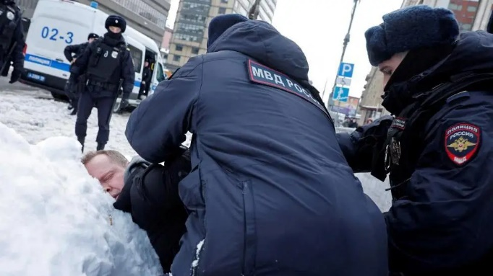

**At last month’s speaker meeting, Barrie Hay delivered a briefing on the state of human rights in Russia.** Since then, [a new UN report has highlighted a severe deterioration in human rights in Russia](https://www.bbc.co.uk/news/articles/c8el72ldpr4o) since the full-scale invasion of Ukraine, culminating in a systematic crackdown on civil society. There will be a day of action in London on 30 October to mark the Day of Remembrance of the Victims of Political Repression in Russia. **For information about this and to keep informed about human rights in Russia and Amnesty campaigns to defend them, email** [**barrie.hay@amnesty.org.uk**](mailto:barrie.hay@amnesty.org.uk) **or** [**iona.fletcher@amnesty.org.uk**](mailto:iona.fletcher@amnesty.org.uk)**.**

**LINKS WITH LOCAL MPs: ADVOCATING FOR HUMAN RIGHTS**

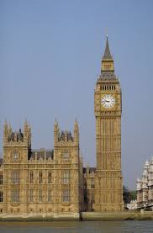

Since the General Election, we have contacted many of the 20 MPsin our area calling on them to commit to supporting and defending human rights in this country and internationally, both in parliament and more widely. Responses have been slow in coming, especially from the many MPs who were elected for the first time and have much to do in setting up their offices, recruiting staff etc.

On 11 October, we had our **first face-to-face meeting since the election**, when members of the Maidstone, Medway and Swale Group met Maidstone MP, **Helen Grant**, in her constituency office. We raised **Israel / Palestine**, the **Prevent** duty and **Alaa Abdel Fattah**, a British national who has been unjustly imprisoned in Egypt for the last five years. Helen agreed to write to the government about all three issues.

**If you would like to help us to establish or strengthen links with your local MP, please email me.**

You can still access Amnesty’s course on [**People, Power, and Politics: Influencing Political Decision-Makers on Human Rights**](https://www.futurelearn.com/courses/people-power-and-politics-influencing-political-decision-makers-on-human-rights)**,** which will help you to develop your knowledge of human rights and British politics and learn key strategies to influence and advocate for human rights.

**ISRAEL AND ITS NEIGHBOURS**

The spread and scale of violence we are now seeing in this region is having a devastating impact on civilians. Almost one year on from the terrible October 7 attacks and subsequent onslaught directed at Gaza, Israeli authorities have now escalated attacks in Lebanon, as Israel and the occupied Palestinian territory have also faced regional missile attacks.  Fears for the safety of civilians in Lebanon are growing, as air strikes continue and now a ground invasion is adding to widespread terror, traumatic injuries and deaths. Hundreds of thousands of civilians have also been displaced as they flee the violence.  **Amnesty has repeated its** **calls for an immediate ceasefire and the unconditional immediate release of civilian hostages held by Hamas and other armed groups and all Palestinians unlawfully detained by Israel.**

**ARMS TRANSFERS TO ISRAEL**

Last month, the UK government suspended roughly 30 arms export licences to Israel out of a total of 350 – but stopping some arms isn’t enough.   With the International Court of Justice warning of a risk of genocide against Palestinians by the Israeli authorities, continuing to allow some arms transfers is not in line with international legal standards. **There should be no UK arms to Israel.** **Please sign the petition at the link below.**[**Stop the UK from transferring all arms to Israel. Take action now.**](https://email.amnestyuk.org.uk/c/12nhs3eX6MII4EhCJuPb5UU5RnV2)

AMPLIFY: A NEW HUMAN RIGHTS FESTIVAL ON 7 DECEMBER

On 7 December, Amnesty will be holding a Human Rights Festival, Amplify, at Woolwich Works.   
Amplify will bring Amnesty members and supporters together with leading thinkers, community organisers and changemakers to celebrate achievements, hear from inspiring success stories and explore next steps.   
  
The event will offer:

* Leading campaigners and activists in conversation
* Creative workshops
* Family-friendly activities
* Live music
* Opportunities to come together, meet and share stories
* An inspiring, energising and fun day out!

This event, to be held just across our border, is a great opportunity for Network members and supporters to meet each other in person, as well as other participants in the fight for human rights. It is also an opportunity to raise the profile of our Network and attract new members to it.

[For full details and to book tickets, click here](https://email.amnestyuk.org.uk/c/12nhvtY7ieNzWByDJBK8F9VET32e).  
 **ALAA ABDEL FATTAH**

**Alaa Abdel Fattah** is serving a five-year sentence in Egypt on trumped-up charges of “spreading false news” after a grossly unfair trial. On **Tuesday 22 October at 7-9pm**, Amnesty will host a free evening event celebrating Alaa Abdel Fattah’s book, [You Have Not Yet Been Defeated](https://email.amnestyuk.org.uk/c/12nOBLYw4pu9YmpxD4yTRYNHjgzN), ahead of its special edition launch this month. The book is a selection of his essays, social media posts and interviews from 2011 until the present. Many of the pieces in the book were written during his years in prison. As well as the book reading, there will be a Q&A session with a member of Alaa’s family. You will also be able to purchase the book at the event. [Get your free ticket here.](https://www.eventbrite.co.uk/e/alaa-abdel-fattahs-book-you-have-not-yet-been-defeated-reading-and-qa-tickets-1038797690857?aff=oddtdtcreator)

**WRITE FOR RIGHTS**

Amnesty’s annual **Write for Rights Campaign** will take place as usual during November and December. So far, three public activities are planned in our area: a stall at **Faversham street market on 16 November,** another one at the **Christmas Fayre at Aylesford Priory on 23 November**, both organised by the Maidstone, Medway and Swale Group, and a card writing session at **St Thomas’s Church, Groombridge on 10 December,** organised by a group of local Amnesty members. For fuller details, see the upcoming events section below. The organisers would be very pleased to see you at any of them. Some of our partner organisations will also be having card-writing sessions at their meetings. **If you would like to suggest other places where we could promote the campaign, or if you would like to help out at one of the events, please email me.**

**AMNESTY UK YOUTH CONFERENCE 2024**

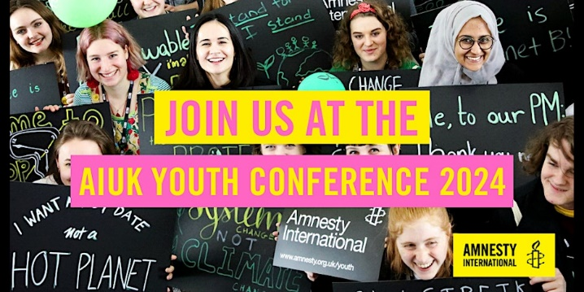

AIUK's Youth Conference, led and organised by the Children's Human Right's Network will take place at the Human Rights Action Centre in London on **Friday 22 November**. The conference is open to secondary school age school groups. Attending the Youth Conference will give young Amnesty activists the opportunity to meet other youth activists from across the country and gain knowledge, practical skills and confidence to take action on human rights in the UK and around the world.

**[Book here.](https://www.eventbrite.co.uk/e/aiuk-youth-conference-tickets-1012813340967)**



**Tuesday 15 October online at 7:30pm to 8:30pm: Kent Network speaker meeting with Paul Bridges from Amnesty UK’s Anti-Death Penalty Project. Email** [**maclixby@gmail.com**](mailto:maclixby@gmail.com) **for a link.**

**Tuesday 22 October at 7:00 – 9:00pm**, Event celebrating Alaa Abdel Fattah’s book, [You Have Not Yet Been Defeated](https://email.amnestyuk.org.uk/c/12nOBLYw4pu9YmpxD4yTRYNHjgzN), ahead of its special edition launch. event. [Get your free ticket here.](https://www.eventbrite.co.uk/e/alaa-abdel-fattahs-book-you-have-not-yet-been-defeated-reading-and-qa-tickets-1038797690857?aff=oddtdtcreator)

**Wednesday 6 November at 1:00pm. Monthly Close Guantanamo Vigil in London. Email** [**maclixby@gmail.com**](mailto:maclixby@gmail.com) **for details.**

**Monday 4 November at 7:30pm. Maidstone, Medway and Swale Group meeting at Maidstone Community Support Centre, 39-48 Marsham Street, Maidstone ME14 1HH.** **Email** [**mmands.amnestygroup@gmail.com**](mailto:mmands.amnestygroup@gmail.com) **for details.**

**Saturday 16 November at 9:00am to 4:00pm. Write for Rights stall at Faversham Market. Email** [**mmands.amnestygroup@gmail.com**](mailto:mmands.amnestygroup@gmail.com) **for details.**

**Friday 22 November. Amnesty UK's Youth Conference, led and organised by the Children's Human Rights Network.** [**Book here.**](https://www.eventbrite.co.uk/e/aiuk-youth-conference-tickets-1012813340967)

**Saturday 23 November at 9:00am to 4:00pm. Write for Rights stall at Christmas Fayre at Aylesford Priory.** **Email** [**mmands.amnestygroup@gmail.com**](mailto:mmands.amnestygroup@gmail.com) **for details.**

**Thursday 5 December. Opening of Guantanamo exhibition at Rich Mix, 35-47 Bethnal Green Road, London E1 6LA. Email** [**dominique.oneil@outlook.com**](mailto:dominique.oneil@outlook.com) **for details.**

**Saturday 7 December. Amplify Human Rights Festival, organised by Amnesty UK.** [For full details and to book tickets, click here](https://email.amnestyuk.org.uk/c/12nhvtY7ieNzWByDJBK8F9VET32e).

**Tuesday 10 December: Human Rights Day**

**Tuesday 10 December from 7:00pm to 9:00pm: Write for Rights card writing session at St Thomas’s Church, Groombridge. Ring 07752960007 for information.**

All the best

Graham