**AMNESTY UK KENT NETWORK NEWSLETTER: JUNE 2024**

**HIGHLIGHTS**

This month you can

* **Join our speaker meeting on 18 June** to hear about Amnesty UK’s work on **anti-racism**
* **Read Amnesty’s General Election manifesto** and **participate** in our **approaches to candidates in our area.**
* **Support** us at the **Hastings Sanctuary Festival** on 23 June, the **Dover Multicultural Festival** on 29 June and/or the **Chatham Carnival** on **6 July**
* **Ask your local pub** to support Amnesty Feminists’ campaign to **stop violence against women during the Euros**
* **Call** for **Toomaj Salehi’s execution** to be stopped
* **Watch the video** of the exhibition by **Anoosheh Ashoori** about his experience inside **Evin prison**
* **Call** for the **release of political prisoners in Hong Kong**
* As part of Refugee Week, **participate** in an **evening of shared art and celebration** at the William Morris Gallery on 20 June
* **Participate** (online or in person) in **Amnesty UK’s AGM** on 22 June
* **Apply** to join Rise Up, Amnesty’s **free campaign training programme** for 16-24 year-olds
* **Apply** to join Amnesty’s **Youth Activism Coaches Programme**

**SPEAKER MEETING: ANTI-RACISM**

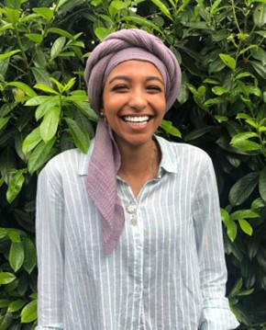

**Join us on 18 June at 7:30pm** to hear **Duaa Abdulal** of Amnesty UK’s Anti-Racism Network talk about **Amnesty’s work on anti-racism**. The network contributes to the work of the many people in the UK working to bring down racist structures and systems by promoting campaigns against racism in all its forms, including Amnesty’s campaign on the Government's Prevent agenda. **Please email** [**maclixby@gmail.com**](mailto:maclixby@gmail.com) **for a link to the meeting**.

**GENERAL ELECTION**

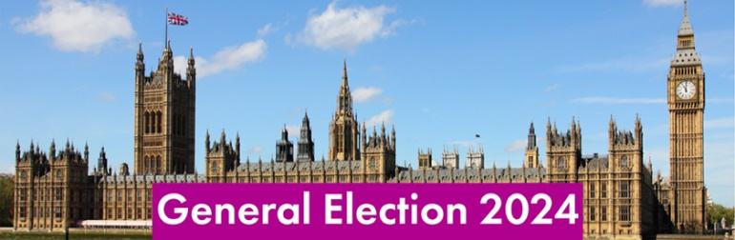

The general election has been called for 4 July. Since the last general election in 2019, we have seen **a huge rollback in human rights protections in the UK**. From the Police, Crime, Sentencing and Courts Act to the Illegal Migration Act, the Judicial Review and Courts Act to the Public Order Act, our fundamental rights have been chipped away, often in contradiction to the UK’s obligations under international law. The denial of structural inequalities, scapegoating of minorities and denigration of those fighting for a better world in the public sphere have fostereda climate of fear and hostility.

**A fundamental change of direction is needed** and a general election provides an opportunity for this to take place. Amnesty is calling on all parties to put human rights at the centre of their agenda. Whoever forms the next government, we want those in power and in opposition to understand, value and defend human rights. To understand our specific asks and demands on the next government, [please read Amnesty’s manifesto here](https://www.amnesty.org.uk/files/2024-06/AIUK%20manifesto%20full%20June%202024%20final.pdf?VersionId=J3LMsuzmE96OuPmg_uBgk1hlN2ysNzxN).

We have written to one of our Network members in each constituency in our area asking them to **coordinate an approach to their local candidates** to ensure that the voices and priorities of Amnesty are heard and to show candidates that local people want to see human rights at the top of their agendas. **If you want to be involved and have not yet been invited to do so, please email me.**

**UPCOMING KENT NETWORK EVENTS**

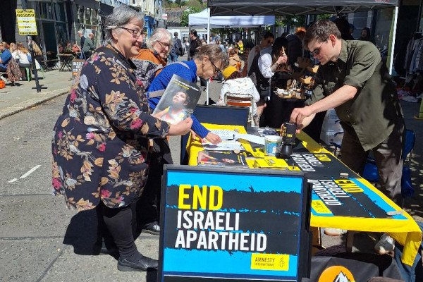

Once again, we have a busy schedule of activities this summer to raise awareness of human rights and the profile of Amnesty International in our area. We shall have a presence at the following events in the coming month and would greatly welcome any support that you can offer**. If you can help, please email the address indicated**.

**23 June: Hastings Sanctuary Festival.** [**amnestyhastingsrye@gmail.com**](mailto:amnestyhastingsrye@gmail.com)**.**

**29 June: Dover Multicultural Festival.** [**maclixby@gmail.com**](mailto:maclixby@gmail.com)

**6 July: Chatham Carnival.** [**graham.minter@amnesty.org.uk**](mailto:graham.minter@amnesty.org.uk)**.**

**DOMESTIC ABUSE**



Domestic abuse reports rise by 26% when the English national team plays, win or lose. That is a pretty alarming statistic and one that is particularly important in light of the Euros, which started this weekend. Amnesty wants to raise awareness of the risk that some women in the UK are facing during this period and do something about it. **The Amnesty Feminists Network have created a set of beer mats and posters (for bathroom cubicles) to be gifted to pubs across the country showing The Euros.** The mats and posters not only highlight the situation, but also have a QR with resources to support and offer help to those suffering or those who feel they are at risk of perpetrating.

The Feminists Network is looking for help in placing these beer mats and posters in pubs across the country. **If you can help with this, please email** [**amnestyfeminists@email.amnestyuk.org.uk**](mailto:amnestyfeminists@email.amnestyuk.org.uk)with your address and they will send you a set of beer mats and posters (but please don’t leave the posters or mats at pubs without their permission).

**IRAN: TOOMAJ SALEHI**



**Toomaj Salehi** is an Iranian rapper and hip-hop artist. **He has been sentenced to death** by the courts in Iran after being detained for over a year in connection with his music and posts on social media denouncing the unjust practices of the Iranian government. Through his music, Toomaj, a vocal supporter of the Woman Life Freedom protests to end abusive forced veiling for women, called for freedom and an end to the violent repression of protestors by Iranian authorities. [**Click here**](https://www.amnesty.org.uk/actions/free-toomaj?utm_content=150311&utm_campaign=MEMA5603S_ACT_IAR_ToomajUpscale_11June&utm_medium=email&utm_source=amnestyuk#client_id=1317924&guid=3099a1df59384d75) **to call for his execution to be stopped.**

**IRAN: SURVIVING EVIN EXHIBITION**

This month, Amnesty hosted an **exhibition by Anoosheh Ashoori** about his experience inside Evin prison, from being abducted in the street by the Iranian regime, to his return to the UK and his incredible work fighting to free all unjustly imprisoned British nationals abroad. **You can watch a short video of Anoosheh and the exhibition** [**here**](https://www.facebook.com/watch/?v=836720815021769)**.**

**CHINA**

The Reading Amnesty Group are campaigning for the **release of political prisoners in Hong Kong**. They have produced a petition which they plan to hand in to 10 Downing Street at the end of the year. To support this campaign, please **download the attached petition**, collect signatures and return it to the Reading Group by 30 October.

**REFUGEE WEEK**



As part of Refugee Week, Amnesty is co-hosting an evening of shared art and celebration at the William Morris Gallery, Forest Road, London E17 4PP. The show will explore home, journeys and solidarity and is facilitated by artist Tasnim Mahdy. All are welcome. You can [book here](https://www.eventbrite.co.uk/e/amnesty-international-x-refugee-week-tickets-910669395677).

**AMNESTY UK ANNUAL GENERAL MEETING 2024**

There is still time to join Amnesty UK’s AGM on Saturday 22 June. This is a great opportunity for a day of learning about Amnesty’s work, AGM business, speakers, networking and shaping the Amnesty movement as you make your voice count. The AGM enables Amnesty members to get together, share plans and discuss ideas, so that we can build an even more powerful human rights movement in the UK. The event is FREE and will be held in Sheffield at Sheffield Hallam University.

You can attend in-person or online. For those attending in-person, tickets include event entry, refreshments, lunch and an optional evening get-together with entertainment and food. [Book here](https://www.eventbrite.co.uk/e/amnesty-international-uk-agm-2024-registration-876744796287?aff=oddtdtcreator).

**RISE UP**



Rise Up is Amnesty’s free campaign training programme for 16-24yr olds from across the UK who want to lead change on the issues that matter most to them. From housing rights to refugee rights to LGBTQ+ rights, this programme **equips and empowers young people with the skills, knowledge and confidence they need to win Human Rights in their communities**. Apply [here](https://www.amnesty.org.uk/rise-up-application-form?utm_content=149720&utm_campaign=MCFR1282S_LG_MM_May_24&utm_medium=email&utm_source=amnestyuk).

If you are over 24 and work with young people, **please share this opportunity**. Amnesty especially welcomes applications from marginalised groups, without existing access to resources, funding or training opportunities. If you’d like to learn more about the programme, [click here](https://www.amnesty.org.uk/rise-alumni?utm_content=149720&utm_campaign=MCFR1282S_LG_MM_May_24&utm_medium=email&utm_source=amnestyuk) for past participants’ experiences.

**YOUTH ACTIVISM**

An exciting voluntary role has opened at Amnesty to help build new youth and student groups and follow them on their activism and campaigning path. 12 posts have been created in Amnesty’s Human Rights Education team under its Youth Activism Coaches Programme. Successful applicants will be matched with a participating Further Education college over the next academic year and trained and supported to offer tailored coaching.  For further details, see [here](https://www.amnesty.org.uk/youth-activism-coach).



**(Please see the attachment for a full list of our planned activities)**

17 - 23 June: Refugee Week

18 June at 7:30pm: Kent Network speaker meeting: Duaa Abdilal of Amnesty UK’s Anti-Racism Network. Email [maclixby@gmail.com](mailto:maclixby@gmail.com) for a link.

20 June at 6-9 pm: Amnesty International UK x Refugee Week, William Morris Gallery, London. In person. [Book here](https://www.eventbrite.co.uk/e/amnesty-international-x-refugee-week-tickets-910669395677).

22 June at 9.30 am-7:30 pm: Amnesty International UK Annual General Meeting, Sheffield Hallam University. In-person and online options. [Book here](https://www.eventbrite.co.uk/e/amnesty-international-uk-agm-2024-registration-876744796287?aff=oddtdtcreator).

23 June at 12 noon - 6pm: Hastings Sanctuary Festival stall. Email [amnestyhastingsrye@gmail.com](mailto:amnestyhastingsrye@gmail.com).

29 June at 10am-5pm: Dover Multicultural Festival stall. Email [maclixby@gmail.com](mailto:maclixby@gmail.com).

1 July at 7:30pm: Maidstone, Medway and Swale Group meeting at The Chiltern Hundreds, Penenden Heath Road, Penenden Heath, Maidstone ME14 2DG. Email [mmands.amnestygroup@gmail.com](mailto:mmands.amnestygroup@gmail.com).

3 July at 1pm-3pm: monthly Close Guantanamo vigil at Parliament Square, London.

6 July at 10am-4pm: Chatham Carnival stall. Email [graham.minter@amnesty.org.uk](mailto:graham.minter@amnesty.org.uk).

All the best

Graham