**NEXT GROUP MEETING**

**Thurs. MAY 18th. 7pm-9pm**

**15-17 Nora St. Howley. Community Rooms**

**WAI 2JG**

**THE TRUST FALL: Julian Assange**

A new highly acclaimed documentary film will be screened at Odeon cinemas across the UK - 8 May 2024 (for one day only) including The Odeon Westbrook @7.30 pm

**Saturday Mothers – Turkey**

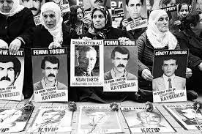

* ‘Saturday Mothers’ is a group of human rights defenders including families of victims of enforced disappearances which took place during the 1990s.
* In **May 1995** they gathered in Galatasaray Square in Istanbul for the first time, holding up photos of their loved ones and laying red carnations while calling for an end to enforced disappearances, seeking information on the whereabouts of those who were forcibly disappeared and demanding justice for the victims.
* They continued to meet regularly until **1999** when the group had to cease due to persistent attacks by security forces.
* Ten years later, on **31 January 2009**, Saturday Mothers were not allowed to gather in Galatasaray Square but they resumed their peaceful gatherings without any disruption but outside the Human Rights Association office in Istanbul.
* **25th August 2018** marked their 700th week of protests.
* On **30 August 2022**, fourteen members of the group were detained while attempting to make a press statement at the ‘*Graveyard for the Unidentified’* to mark the International Day of Victims of Enforced Disappearances, and later were charged with violating the law on ‘Meetings and Demonstrations’ under the Turkish Penal Code. However, the police had not given them reasonable time to leave and had acted illegally by stopping them making their press statement.

The 1,000th vigil of the Saturday Mothers will take place in Turkey on 25 May, and Amnesty is hoping to stage a global day of action on or around that day to publicise this case. One of the main targets is to collect 1,000 messages of solidarity to be delivered to the Saturday Mothers and shared in a ‘blitz’ on social media on the day of the vigil, 25 May. Saturday Mothers have been demanding truth and justice for victims of enforced disappearances since May 1995.

**WARRINGTON GROUP**

On **Saturday 11 May at 10.00 am** we will meet to take a photo of members standing in front of the Golden Gates in Warrington town centre, holding a banner with a message of solidarity. The photo will be sent to Amnesty to be collated with others from across the world.

**MEXICO**

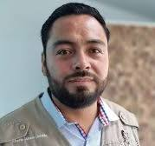

**Alberto Amaro Jordán**, the founder of La Prensa de Tlaxcala, has lived under state protection for five years and suffered an array of threats and attacks by police officers and cartel members. But Mexico's federal mechanism for the protection of journalists tried to have his bodyguards removed last year, having inexplicably deemed him no longer at risk. Alberto won an injunction to maintain his bodyguards but his future - and that of his family - remains uncertain.

**We have received this reply to our appeal for Abero’s existing protection measures to continue and for any further action that is needed to guarantee his safety.**

*Thank you for reaching out regarding the recent events concerning Alberto Amaro Jordán, director of "La Prensa de Tlaxcala," and the reported attacks against him.*

*We would like to inform you that the Mechanism for the Protection of Human Rights Defenders and Journalists (the Mechanism) has confirmed that Mr. Alberto Amaro Jordán is enrolled in their program. As such, he benefits from an active protection plan provided by the Mechanism.*

**HONG KONG**

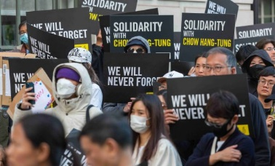

**No matter where we are, human rights should be universal.**

**People in Hong Kong are facing an increased crackdown on their rights to freedom of expression. The UK government must act now to protect Hong Kongers in the UK.**

**What is happening in Hong Kong?**

Since the 2019 citywide protests erupted, the**suppression of human rights in Hong Kong**has been taken to another level. Countless repressive laws, including “[Article 23](https://www.amnesty.org.uk/press-releases/hong-kong-passing-article-23-law-extends-iron-fist-china-hongkongers-anywhere-world)”, the latest home-grown [National Security Law](https://www.amnesty.org.uk/press-releases/uk-government-must-push-china-scrap-brutal-hong-kong-national-security-law), are designed to stifle criticisms of the Hong Kong and Chinese authorities within the city and globally. Both of these laws are extraterritorial laws.

**What are "extraterritorial" laws?**

Extraterritorial laws are laws which are meant to apply outside of the country they are made in. These laws because whether people are inside China, Hong Kong it leaves **no one safe from being labelled a threat**to Hong Kong’s national security. This means someone in the UK could be targeted by these laws, which makes everyone and every organisation advocating for human rights in Hong Kong susceptible to its chilling effect.

These laws are a devastating blow to the **entire civil society.**In 2023, there were reports of a [Chinese “police station” in Belfast](https://www.amnesty.org.uk/press-releases/belfast-reports-chinese-operated-police-station-must-be-thoroughly-investigated), showing that the crackdown on Hong Kongers inside the UK is very real and puts their human rights at risk.

**Why are repressive laws being passed in Hong Kong?**

The lack of accountability and abuse of public powers, including the Security Bureau and law enforcers, have led to a total crackdown on protests and freedom of expression inside Hong Kong. Dissenting protestors and lawmakers were arrested en masse.