**AMNESTY UK KENT NETWORK NEWSLETTER: MARCH 2024**

**HIGHLIGHTS**

This month you can

* **Join our online speaker meeting tonight** to learn about protecting the **right to protest** in **Russia**
* **Study our list of planned 2024 activities** and **aim to support** as many of them as you can
* **Update** yourselves on efforts to secure a **ceasefire in Gaza**
* **Sign Amnesty’s petition** to **protect protest in the UK**
* **Understand** why Amnesty is campaigning for a **global treaty to regulate “less lethal” weapons**
* **Hear** what our Network is planning to **challenge the Prevent strategy** and **promote anti-racism**
* **Hear** about Amnesty’s plans to campaign for the **right to adequate housing, food and healthcare in the UK**
* **Read** about the latest developments on the **Rwanda bill** and **support Sevenoaks Welcomes Refugees fundraising events on 27 April**
* **Join** the protest and vigil in London on **20 May** to **oppose Julian Assange’s extradition**
* **Join** the webinar on **24 April** on how we can stop states obstructing attempts by the UN to **end mass atrocities**
* **Learn** more about the UK **Human Rights Act** and **download learning materials** on other human rights issues
* **Apply** to be an Amnesty **Activism Representative**
* **Familiarise** yourself withAmnesty’s **safeguarding** policy

**SPEAKER MEETING: RUSSIA**

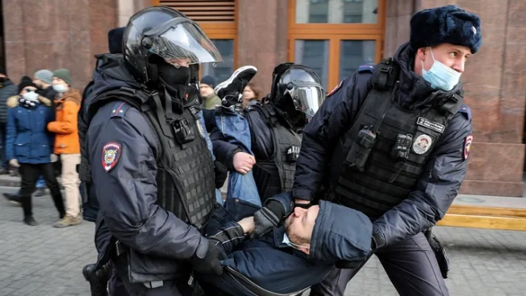

**Join us tonight at 7:30pm** to hear Barrie Hay, Amnesty UK’s Russia Coordinator, talk about **protecting the right to protest in Russia**. Russia’s war against Ukraine has been accompanied by **severe repression of Russians protesting against the war.** Peaceful protests have been dispersed, often forcibly, and **those speaking out face prosecution and imprisonment** following unfair trials. New legislation restricts protests and the activities of NGOs and civil society activists. To learn more, **please** **email** [**mark@markclixby1.plus.com**](mailto:mark@markclixby1.plus.com) **for a link to the meeting.**

**OUR PROGRAMME IN 2024**

We have a **busy programme planned** for the rest of this year. **I attach the latest version**. Our ability to undertake all the planned public events will depend on having enough volunteers to support them, so **please consider whether you can help** with at least one of them, even if it is only for an hour or two. Beyond the value of the events in raising local awareness of human rights issues and building our Network membership, they are also **an opportunity to get to know other Network members**.

**GAZA**

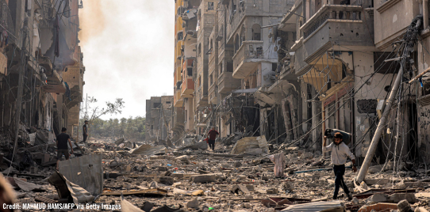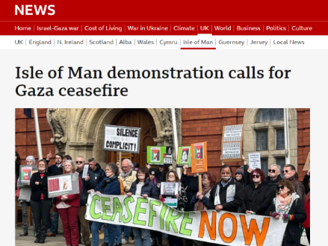

**On 25 March, the UN Security Council finally** [**adopted a resolution calling for an immediate ceasefire**](https://reliefweb.int/report/occupied-palestinian-territory/human-rights-council-adopts-resolutions-text-calling-immediate-ceasefire-gaza-urging-states-prevent-continued-forcible-transfer-palestinians-within-or-gaza-and-calling-states-cease-sale-or-transfer-arms-israel#:~:text=In%20a%20resolution%20adopted%20by,of%20international%20humanitarian%20law%20and) “for the duration of the month of Ramadan leading to a lasting sustainable ceasefire” as well as the immediate and unconditional release of hostages and greater humanitarian access to Gaza. However, **a ceasefire remains elusive** and talks are continuing in Cairo. Amnesty continues to call for **an immediate sustained ceasefire by all parties,** a complete **lifting of Israel’s illegal blockade, the release of hostages** held in Gaza and of **arbitrarily detained Palestinians,** and a **halt to all arms transfers**. Amnesty groups around the country, including the Isle of Man Group (above), have organised events to hammer this message home

[The United Nations Special Rapporteur on the Occupied Palestinian Territories has concluded](https://www.amnesty.org.uk/press-releases/israelopt-un-experts-report-genocide-gaza-must-lead-international-action) that there are “**reasonable grounds to believe the threshold indicating Israel’s commission of genocide is met**”.  Enabling the sufficient provision of humanitarian aid to Palestinians in Gaza is **a legally binding demand of the International Court of Justice** which has ordered Israel to [take additional measures to prevent genocide](https://www.icj-cij.org/sites/default/files/case-related/192/192-20240328-pre-01-00-en.pdf). More than 33,000 Palestinians have already been killed in Israel’s relentless bombardment and at least 31 have starved to death, 28 of them children.

Israel has announced approval of the **opening of two humanitarian routes** into the occupied Gaza Strip, but [Amnesty has made clear that](https://www.amnesty.org.uk/press-releases/israelopt-opening-aid-routes-gaza-urgently-needed-israels-announcement-long-overdue) **this is insufficient to tackle the scale of the catastrophic humanitarian crisis**.

Despite allowing the latest UN Security Council resolution to pass, President Biden has since authorised the [**transfer to Israel of 1,800 MK84 2,000-pound bombs**](https://www.washingtonpost.com/national-security/2024/03/29/us-weapons-israel-gaza-war/) that one senior administration official said ‘can destroy entire blocks’ and media reports have indicated that the President may soon approve the [**sale of $18 billion F-15 fighter jets**](https://edition.cnn.com/2024/04/01/politics/biden-administration-f15-fighter-jets-israel/index.html) to Israel. On 5 April, the UN Human Rights Council adopted a resolution calling for a halt to all arms sales to Israel.

**PROTECT THE PROTEST**

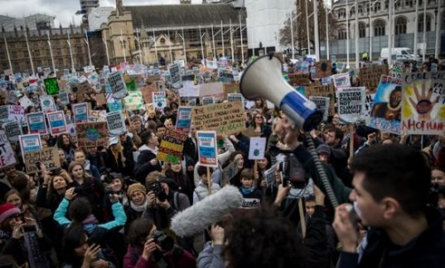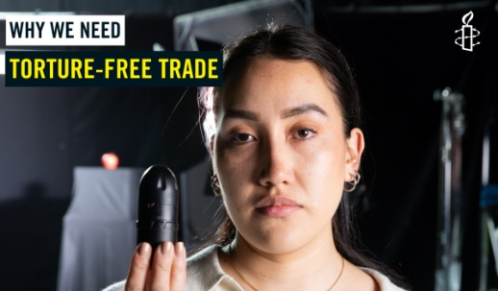

In the UK, the Criminal Justice Bill, which seeks to introduce **yet more restrictions on protest,** is continuing its journeythrough the House of Commons. [Sign Amnesty’s petition here](https://www.amnesty.org.uk/actions/scrap-new-anti-protest-laws).

However, this month we focus on the repression of protest in other countries, where hundreds of people have life-changing injuries from police misuse of crowd control weapons during protests, including weapons which can be produced in the UK or by UK-based companies.

In 2021, **Leidy Cadena** (above), a 24-year-old political science student, was **blinded by rubber bullets** fired by the Colombian Mobile Anti-Riot Squad in Bogotá during a peaceful protest against inequality. You can **hear her story on** [**Instagram**](https://www.instagram.com/reel/C5Sz2isNiDH/)**,** [**Facebook**](https://www.facebook.com/watch/?v=1093394795115573) **or** [**X**](https://twitter.com/AmnestyUK/status/1775450379611726153). *Content warning: contains scenes of injury and police violence.* Along with many others, including Amnesty, Leidy is campaigning for **a global treaty to regulate “less lethal” weapons**, which are not currently covered by any international law.

**ANTI-RACISM AND PREVENT**



[Amnesty’s new campaign to **challenge the Prevent strategy**](https://www.amnesty.org.uk/prevent) was launched at the Human Rights Action Centre on 23 March. Amnesty’s research found that Prevent has a **racist and discriminatory impact** and that society’s **most vulnerable and marginalised people are the worst affected**. Our Network has begun work on the campaign. We are raising our concerns with MPs throughout our area. Many thanks to those who have already written to their local MP. Beyond this, we are starting a **conversation with community members and those involved in Prevent’s implementation** so that we have a **better understanding of its local impact** and to raise **awareness of the human rights issues** uncovered by Amnesty’s research.

Amnesty’s Anti-Racism Network has produced an **Anti-Racism Pocket Guide** and we have ordered copies to hand out at the events that we have planned for this year.

**ECONOMIC, SOCIAL AND CULTURAL RIGHTS IN THE UK**

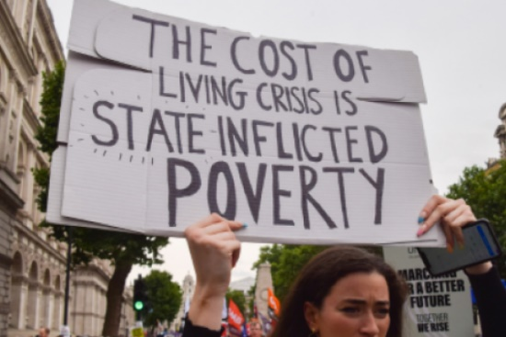

Amnesty UK are placing new emphasis on the promotion of certain rights that have not hitherto received the attention that they should here in the UK – **the right to adequate housing, food and healthcare**. In the UK, millions of families and individuals cannot access what they need to live. This is not a result of a lack of resources. It comes from political choices that drive inequality. To show this reality, Amnesty UK have worked with actors Olivia Colman and Adrian Lester to show what is happening before our eyes.

Amnesty are developing their campaigning to ensure that these rights are addressed alongside the issues that already feature in Amnesty’s priorities. More information will follow, but meanwhile **you can** [**watch Amnesty’s new “trailer**](https://www.amnesty.org.uk/before-our-eyes?utm_content=145987&utm_campaign=MCFR1280S_LG_MM_March_24&utm_medium=email&utm_source=amnestyuk) **for a drama series that sadly is not drama”**. *Another content warning: the violations that it describes include the death of a baby.*

**RWANDA BILL AND SUPPORT FOR REFUGEES**

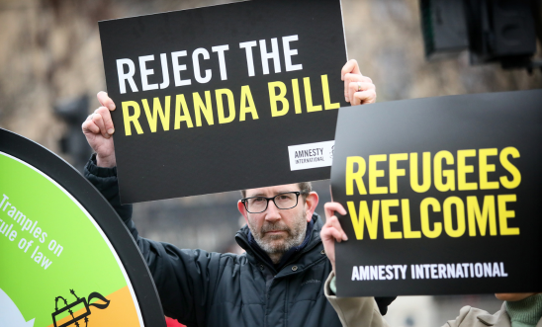

**The House of Commons have returned** **the Rwanda Bill to the House of Lords again in the latest step of what is known as “parliamentary ping-pong”.** Before the Easter recess, the Commons voted to reject all the amendments proposed by the Lords and returned the Bill to the Lords for approval in its original form. The Lords were clearly unimpressed by this and **sent the Bill back to the Commons with a further series of amendments that were remarkably similar to the first set**, including amendments introducing **safeguards for victims of modern slavery and human trafficking** and provision for a court to consider **whether Rwanda is a safe country** for the individuals whom the government wants to send there. It remains to be seen what the Lords will do now but, as the unelected chamber, there is a limit to how far they will feel they can go to block the bill.

[Amnesty continues to call for the Government to **abandon the Bill altogether**](https://www.amnesty.org.uk/press-releases/uk-lords-should-stand-firm-and-oppose-shameful-rwanda-bill), describing it as “**a deeply flawed but also immoral way to treat people fleeing conflict and persecution”**.

**Sevenoaks Welcomes Refugees** are holding two events on **27 April** to raise funds to support refugees in the Sevenoaks area. Details [here](https://stagsevenoaks.co.uk/film/our-little-house-captain-fantastic/) and [here](https://stagsevenoaks.co.uk/film/our-house-elektra-violin-duo-squeeze-a-crowd/).

**JULIAN ASSANGE**

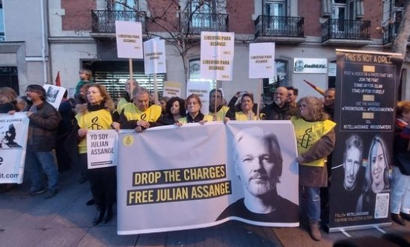

Julian Assange has been detained at HMP Belmarsh in south-east London for five years, as he fights an extradition request from the US authorities. As a result of bringing to light revelations of alleged war crimes committed by the USA, he faces prosecution there under the Espionage Act of 1917, a wartime law never intended to target the legitimate work of publishers and journalists. He could face up to 175 years in jail. **On 26 March, the UK High Court adjourned** to give the USA an opportunity to file fresh diplomatic assurances over Assange’s treatment if he is extradited. On **20 May**, the court will reconsider Assange’s request to appeal his extradition to the USA.

[**Amnesty have called on the US authorities to drop all the charges against Assange**](https://www.amnesty.org.uk/press-releases/ukusa-fresh-call-us-government-drop-charges-against-julian-assange)**,** noting that the charges pave the way to a **disastrous precedent for worldwide media freedom. On 20 May from 9:00am**, Amnesty members will protest and hold a vigil outside the Royal Courts of Justice. If you go, look out for Kent Network member Helen Marting who will be holding up an Amnesty banner.

**PREVENTING MASS ATROCITIES**

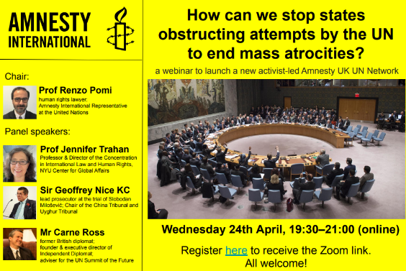

**A new activist-led Amnesty United Nations Network will be launched on 24 April.** To mark the occasion, the network will **hold a webinar from 8:30pm to 9:00pm** on **“****How can we stop states obstructing attempts by the UN to end mass atrocities”.** [**Register here**](https://us02web.zoom.us/meeting/register/tZAqd-yprTotHNOVid6yLFih3rJSQR8ehqki#/registration)**.**

**LEARNING ABOUT HUMAN RIGHTS**

The British Institute for Human Rights continue to produce useful **simple explainers** about key human rights issues. [This one](https://www.bihr.org.uk/get-informed/what-is-the-human-rights-act) is about the **Human Rights Act**.

The Peace Education team have just released Teach Peace Secondary which offers over **50 cross-curricular lessons** from a range of organisations including Amnesty International, as well as Values Based Education, Scientists for Global Responsibility, Facing History & Ourselves, Corrymeela, and War Child. Topics include challenging antisemitism and Islamophobia, conflict transformation, religion and peace, the human rights effects of the arms trade, how to nurture inner peace and many more. **Download every lesson for free from The Peace Education Network shop via TES.com** [**here**](https://www.tes.com/teaching-resources/shop/peace_edu_network_uk)**.**

**RECRUITING FOR ACTIVISM REPS**

**Amnesty UK are recruiting new Activism Reps** for several UK regions, including **the South East, where there has been no Rep for many years.** You can find information aboutthe role of an Activism Rep [here](https://www.amnesty.org.uk/activism-representatives?utm_content=145987&utm_campaign=MCFR1280S_LG_MM_March_24&utm_medium=email&utm_source=amnestyuk)**. The new Reps will be elected by Local Groups,** who will each have one vote.For these purposes, the Kent Network is treated as a Local Group. You can nominate yourself or someone else for the role [here](https://amnestyuk.wufoo.com/forms/activism-representative-nominations-2024). **Nominations close on 30 April.** The election will commence on 6 May and conclude on 7 June. Voting can be done [through this form](https://amnestyuk.wufoo.com/forms/activism-representative-voting-2024) – the link will be accessible from 6 May. The elected representatives will be announced on 17 June. The term of office will be 2 years.

**SAFEGUARDING**

The Amnesty UK **safeguarding policy and procedure have been updated.** You can find details and resources on the safeguarding page of the website [here](https://www.amnesty.org.uk/issues/safeguarding?utm_content=145987&utm_campaign=MCFR1280S_LG_MM_March_24&utm_medium=email&utm_source=amnestyuk).



**(Please see the attachment for a full list of our planned 2024 activities)**

16 April at 7:30pm: Kent Network speaker meeting with Barrie Hay on protecting the right to protest in Russia. Email [mark@markclixby1.plus.com](mailto:mark@markclixby1.plus.com) for a link.

24 April from 7:30pm to 9:00pm: webinar “How can we stop states obstructing attempts by the UN to end mass atrocities?”.

27 April at 10:30am and 7pm: two Sevenoaks Welcomes Refugees fundraising events at the Stag Theatre, Sevenoaks. Details [here](https://stagsevenoaks.co.uk/film/our-little-house-captain-fantastic/) and [here](https://stagsevenoaks.co.uk/film/our-house-elektra-violin-duo-squeeze-a-crowd/).

4 May from 9:30am to 4:30pm – Market stall at Kings Road, St Leonards. Email [pal.luthra@btinternet.com](mailto:pal.luthra@btinternet.com) for details

12 May : Dover and Folkestone meet the members from 2pm. Venue to be confirmed. Email [sarakilian95@gmail.com](mailto:sarakilian95@gmail.com) for details

13 May at 7:30pm – Maidstone, Medway and Swale Group meeting at the Chiltern Hundreds, Penenden Heath Road, Penenden Heath, Maidstone ME14 2DG`. Email [mmands.amnestygroup@gmail.com](mailto:mmands.amnestygroup@gmail.com) for details.

17 May at 2pm – Maidstone, Medway and Swale Group meeting with Helen Grant MP. Email [graham.minter@amnesty.org.uk](mailto:graham.minter@amnesty.org.uk) for details.

20 May from 9:00am – Julian Assange protest and vigil outside Royal Courts of Justice, London.

All the best

Graham