Creative, Cultural &
Colourful Fitzrovia
Sunday May 26 at 14:30
Meet at Tottenham Court Road concourse downstairs between exits 2 & 3
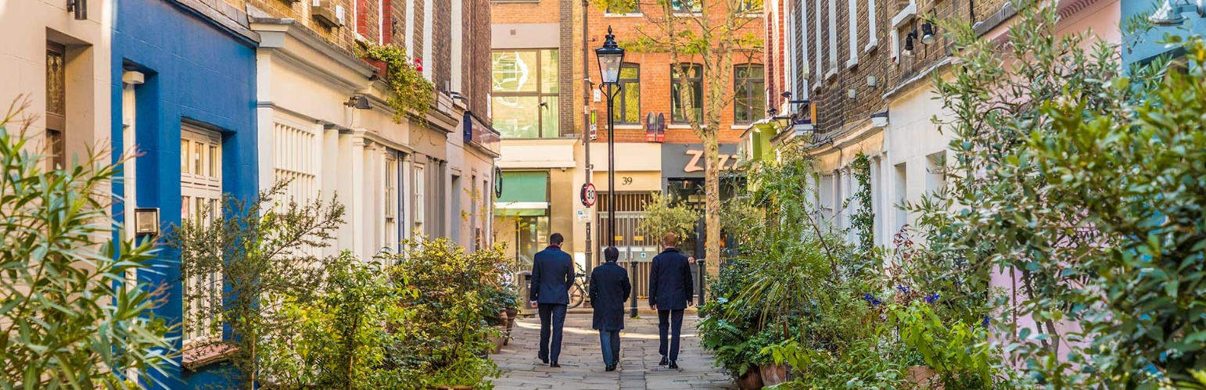
Fitzrovia is an area to savour and where better to spend a Spring Sunday afternoon than exploring its elegant squares, Georgian streets and cosmopolitan feel? See some truly outstanding architecture from the 18th, 19th, 20th and even 21st centuries. Walk through secret pocket parks. Hear stories of the diverse communities that have lived and worked in Fitzrovia and how it has changed and transformed over time. Learn about the recent improvements in public realm brought about by the West End Project. Meet some of the extraordinary individuals who have lived in the area including Olaudah Equiano, Mary Prince, Lady Ottoline Morrell, the colourful habitués of the Fitzroy Tavern and many more. All proceeds from this walk will go towards the work of Amnesty International to fund their work supporting prisoners of conscience and campaigners for democratic rights around the world. Please give generously!
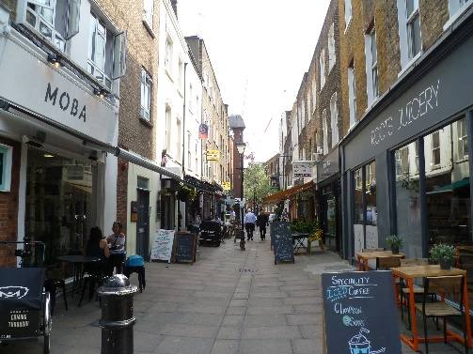
To join this walk please follow this link: https://www.eventbrite.co.uk/e/creative-cultural-and-colourful-fitzrovia-tickets-886152474907
Please give as generously as you can as there is no upper limit to your contributions!

