stockport
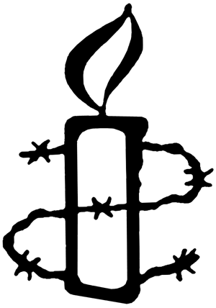
AmnestyMarch 2024
Do One Thing:
Protect anti-corruption human rights defenders in Africa
We need your help to demand that States in West and Central Africa protect anti-corruption human rights defenders by taking immediate measures to ensure they can report acts of corruption and other wrongdoings in an open manner, without fear of reprisals, and in accordance with the rights to freedom of expression and access to information.

What’s the problem? Corruption is a scourge that hampers the economic, social and political development of our states and has a negative effect on human rights. Anti-corruption human rights defenders and whistle-blowers work courageously to expose and combat corruption, contributing to the creation of a more just and equitable society.
However, in West and Central Africa, those who expose corruption are often confronted with repression, intimidation, and harassment by the authorities. Laws against defamation and the spreading of «fake news», disproportionate fines, arbitrary arrests, threats, and physical violence are all tools used to silence activists and journalists who denounce dishonest practices.
For example, in Cameroon, journalist Martinez Zogo, director of the private radio station Amplitude FM, was abducted by unidentified men on 17 January 2023. His mutilated body was found on a vacant lot on the outskirts of the capital, Yaoundé, on 22 January. Before his abduction, he investigated and published information about the alleged embezzlement of hundreds of billions of CFA by political and business figures close to the Cameroonian government.
Follow this link to take action: https://www.amnesty.org/en/petition/protect-anti-corruption-human-rights-defenders-in-africa/

PREVENT CAMPAIGN LAUNCH
There will be a launch event in Manchester for Amnesty UK’s report about the Prevent programme, This Is The Thought Police: The Prevent duty and its chilling effect on human rights. https://www.amnesty.org.uk/prevent.
The event will take place on Saturday 6th April, 2- 5pm at The Friends’ Meeting House in the city centre. It will include a briefing on the new report and the human rights impacts of Prevent. There will also be an opportunity for campaign planning for the Greater Manchester area. We will be inviting organisations and individuals who may have been affected by Prevent as well as those working for services that are required to implement the programme. If you are interested in attending the event, tickets are available here:
Join the guestlist – Prevent Campaign Launch -
Manchester – Friends Meeting House, Sat 6 Apr 2024
2:00 PM - 4:30 PM (tickettailor.com)

FOR YOUR DIARY
We will be holding stalls in June:
Stockport Pride Sunday 2nd June 11am - 4pm
Cale Green Summer Fair Sunday 30th June 12 - 4pm

Please get in touch if you can support us with these events

Silent vigils for Palestine and Israel

Amnesty International, Manchester invites you to join us in our weekly silent vigil calling for a ceasefire and the protection of all civilians in Palestine and Israel.

Ever FRIDAY 5pm – 6pm St Peters Square, Manchester
Meet from 4.50pm in front of Central Library
Please wear black or dark colours (and please dress warmly!)
No placards / No banners / No flags / No chants

Simple placards will be provided bearing the messages, we will also provide tealights
Passersby will have the opportunity to leave a message of support

Please join us

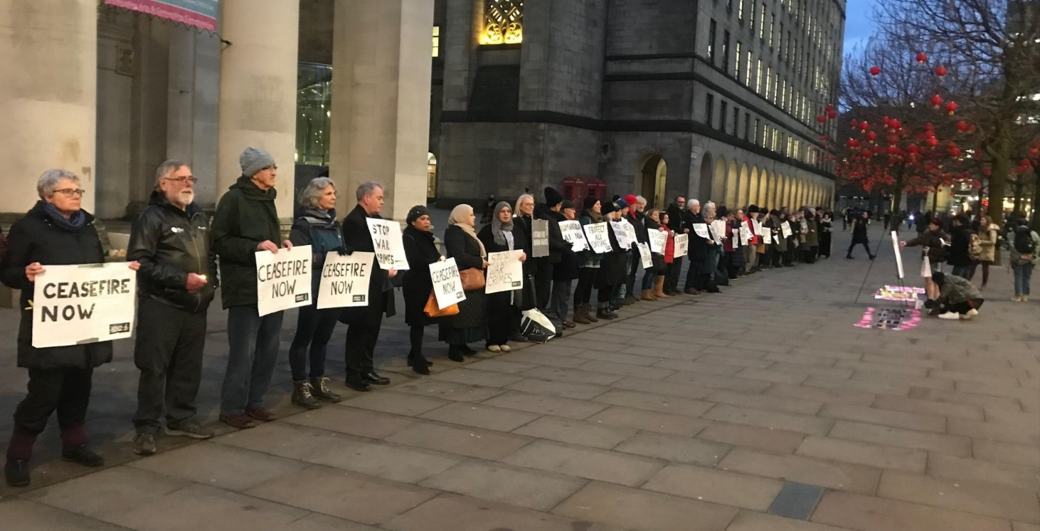

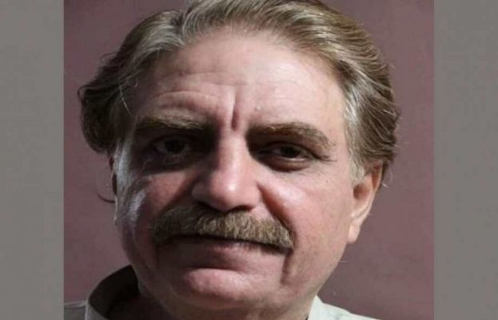
IDRIS KHATTAK Our Individual at Risk
Idris is a human rights worker who has been held at an unknown location by the military in Pakistan since he was forcibly abducted in November 2019. We believe he has now been tried by a military court on charges of treason and sentenced to 14 years in prison. We are one of a number of groups who write regularly to the government in Pakistan on behalf of Idris and his family.
Please write (email) to the following addresses using the sample letter below or your own words:
Prime Minister Shehbaz Sharif
Prime Minister’s Office
Constitution Avenue G-5/2
Islamabad
Pakistan
info@pmo.gov.pk
H.E. Mohammed Faisal
Pakistan High Commissioner in London
34-36 Lowndes Square,
London,
SW1X 9JN
phclondon@phclondon.org

Your Excellency Prime Minister,
I am writing to express my deep concern about Muhammad Idris Khattak who forcibly disappeared on 13 November 2019. I understand Idris Khattak has been sentenced by a military court to 14 years imprisonment for allegedly passing on official secrets to foreign agents. ​
The UN Human Rights Office of the High Commissioner has described Mr. Khattak’s reported sentencing as "an attack against the human rights community in Pakistan". As a civilian, he should be tried by a civilian court.​
I call on you to ensure the full restoration of Mr. Khattak's human rights, including unrestricted access to lawyers, a full medical assessment, his right to a civilian trial in full compliance with due process and his right not to be detained arbitrarily.

PANUSAYA SITHIJTRAWATTANAKUL (RUNG)
Rung – which means “rainbow” in Thai – became politically active while studying sociology and anthropology at university in the capital, Bangkok. She bravely took part in protests for social and political change throughout 2020. By August, she had become a protest leader. Watched by thousands, Rung called for equality, freedom of expression and – what is a highly sensitive topic in Thailand – the reform of the monarchy. Accused of provoking unrest, she was arrested in March 2020 under a lèse-majesté law that outlaws criticism of the monarchy. She was imprisoned for 60 days during which she was diagnosed with Covid-19. The authorities denied her bail six times. In defiance, she went on a 38-day hunger strike and was released on 30 April 2021. Rung faces dozens of charges against her and, if found guilty, life imprisonment. “Once you step into the prison; you will no longer feel that your humanity is still intact,” she says.
Please send this message to the following emails:
prforeign@gmail.com prforeign@prd.go.th rtelondon@thaiembassyuk.org.uk
Prime Minister Srettha Thavisin, Office of the Prime Minister, Pitsanulok Road, Bangkok 10300, Thailand
Dear Prime Minister
I call upon you to immediately drop all the criminal proceedings against Panusaya (Rung) Sithijirawattanakul and others charged solely for peacefully exercising their rights to freedom of peaceful assembly and expression.
I look forward to your government stating that they will comply with my request.

FUNDRAISING
Amnesty International is entirely independent and funded mainly by subscription and fundraising.
We are Planning a stall at a car boot sale in August 2024. If you are able to help with this with donations of goods please drop us an email to amnestystockport@gmail.com
If monthly meetings aren’t your thing, one of the best ways you can support our local group is to help arrange a fundraising event. We are open to ideas and will be able to access official Amnesty International materials such as buckets, posters and sashes.
And of course we can attend, help or promote any event you do on our behalf.

