AMNESTY UK KENT NETWORK NEWSLETTER: MARCH 2024
HIGHLIGHTS
Join us on Tuesday for an update on the current situation in Gaza and on the latest developments in the campaign to End Israeli Apartheid. There are plenty more opportunities this month to update your knowledge of key human rights issues on which Amnesty is campaigning, as well as ways to support these campaigns. You can
- Sign Amnesty’s petitions calling for an immediate ceasefire in Israel and Gaza and to Protect the Protest
- Join an online panel to discuss impacts, human rights and routes to peace in Israel and Gaza
- Register for an online briefing on Amnesty’s work in Ukraine
- Attend the launch of Amnesty’s new campaign to challenge Prevent, and join the campaign
- Register for Amnesty’s webinar to present its research on Economic, Social and Cultural Rights in the UK and its forthcoming campaign
- Learn more about the European Convention of Human Rights
- Apply to join the committee of the Rainbow Network
- Join the next Close Guantanamo vigil
ISRAELI APARTHEID AND GAZA
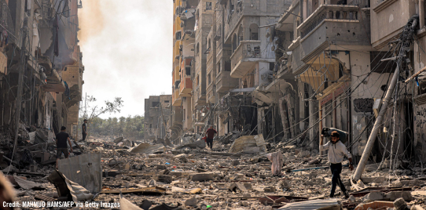
At next Tuesday’s online speaker meeting at 7:30pm, Garry Ettle, Amnesty UK's Country Coordinator for Israel and the Occupied Palestinian Territories, will provide an update on both the current situation in Gaza from a human rights perspective and the latest developments on Amnesty's campaign to End Israeli Apartheid. Please email me for a link.
Just two days later, on 21 March, the Central England Network are hosting an online panel discussion on Israel-Gaza: impacts, human rights and routes to peace. Themes will include the political and practical context of the conflict, the mental health crisis affecting Palestinians and consideration of possible routes to peace. You can register here.
Demand an urgent ceasefire here.
INTERNATIONAL WOMEN’S DAY

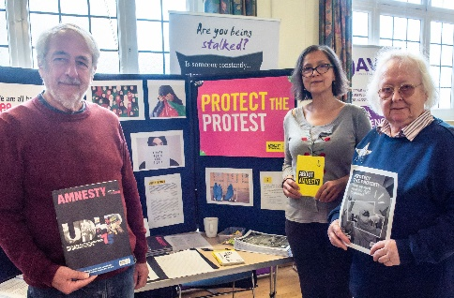
Credit: Luke Clampitt
On 10 March, our Tunbridge Wells team participated in an event to mark International Women’s Day. The stall focused on the rights of Afghan women and the team collected 24 signatures for a letter to the Afghan authorities calling for the release of Manizha Seddiqi, a prominent human rights defender who has been arbitrarily detained in a Kabul prison since December. The event itself, organised by the local branches of Soroptimist International and the United Nations Association, focused primarily on women’s rights to safety from stalkers.
PROTECT THE PROTEST
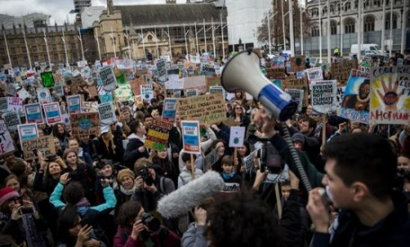
Through its new Criminal Justice Bill, currently passing through the House of Commons, the UK government is planning to introduce yet more restrictions on protest. In a press release, Amnesty said that “it’s vital that the rights to freedom of peaceful protest and expression are upheld - this is absolutely fundamental to any free and fair society”. Sign Amnesty’s petition here.

UKRAINE
In 20 March at 1:00pm to 2:00pm, Amnesty will present a special online briefing, hosted by CEO Sacha Deshmukh, about its work in Ukraine. It is 10 years since Russia's initial invasion of Ukraine, which started with the occupation of Crimea in February 2014. The full-scale invasion in February 2022 was a violation of the UN Charter and an act of aggression, a crime under international law. As anticipated, the invasion has had horrific consequences for human lives and human rights. Register here.

ANTI-RACISM AND PREVENT
On 23 March at the Human Rights Action Centre, Amnesty’s Anti-Racism Network will launch a new campaign to challenge the Prevent strategy. Sessions will include a briefing on Amnesty’s research findings and campaign planning for across London and the South of England. Book here.
The Prevent strategy defines certain indicators of ‘radicalisation', but through speaking to interviewees, Amnesty found that decisions about who to refer to Prevent ultimately rely on ‘gut feeling’. This has led to Prevent having a racist and discriminatory impact. In many cases, those worst affected are among society’s most vulnerable and marginalised people. The reasons why people have been referred to Prevent are often shrouded in secrecy and there is no clear way to challenge referrals. Join the movement to challenge Prevent here.
ECONOMIC, SOCIAL AND CULTURAL RIGHTS IN THE UK
If you have been to the cinema recently, you may have seen a trailer for a drama that sadly is not a drama, but reality. Working with actors Olivia Colman and Adrian Lester, Amnesty UK have produced a video which the chilling reality that here in the UK, millions of families and individuals cannot access what they need to live, from safe shelter to healthcare, food and more. Amnesty UK researchers have spent the last six months meeting people living in poverty and experiencing rights violations in the UK to find out how the Amnesty movement can work to end these violations.
Amnesty’s new Economic, Social, and Cultural Rights Lead, Jen Clark, and Campaign Manager, Laura Trevelyan, will be running a webinar to talk through the finding of this research and Amnesty’s upcoming campaign plans on Tuesday 2 April from 7pm. Register here.
RWANDA BILL
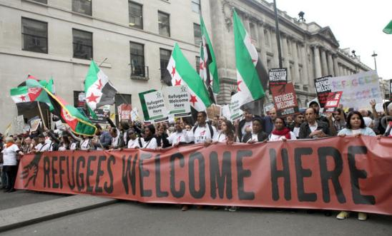
The House of Lords have returned the Rwanda Bill to the House of Commons with a series of key amendments, passed by a large majority, including some introducing safeguards for victims of modern slavery and human trafficking and provision for a court to consider whether Rwanda is a safe country for the individuals whom the government wants to send there. The House of Commons are due to consider the Lords amendments this Monday.
EUROPEAN CONVENTION OF HUMAN RIGHTS
The British Institute for Human Rights have produced a useful simple explainer about the European Convention of Human Rights and the European Court of Human Rights.
RAINBOW NETWORK
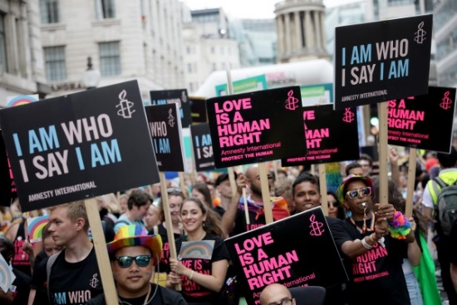
Amnesty UK’s Rainbow Network is looking for new committee members. The Network fights for the rights of LGBTQ+ individuals and organisations worldwide. In Uganda last year, MPs passed the “world’s harshest anti-LGBTQ+ bill”, but Uganda is just one of 64 countries that criminalise homosexuality and are far from alone in allowing the death penalty. In the UK, there are growing attacks on LGBTI+ people in political narrative and the media. To apply, please send a short expression of interest, explaining why you would like to get involved and what you’d like to bring to the network committee. Email here.
STUDENT CONFERENCE
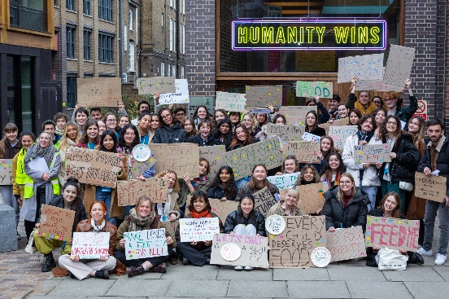
On 10-11 February, the Student Action Network Committee organised a very successful Student Conference at the Human Rights Action Centre in London. More than 110 students came together to celebrate student activism. Attendees had the opportunity to hear from campaign experts, learn new skills and take action together.
19 March at 7:30pm: Kent Network speaker meeting with Garry Ettle on Israel and the Occupied Palestinian Territories. Email graham.minter@amnesty.org.uk for a link.
21 March at 7:00 pm to 8:30 pm: Amnesty Central England Network: Israel-Gaza: impacts, human rights and routes to peace. Online. Sign up here.
23 March at 2:00 pm to 5:00 pm – Amnesty Anti-Racism Network Prevent Campaign Launch. Human Rights Action Centre, 25 New Inn Yard, London EC2A 3EA. In person. Sign up here.
2 April at 6:00 pm to 7:30 pm - What are Economic and Social rights and why is Amnesty working on them? Online. Sign up here.
3 April: Close Guantanamo vigil in London. Email maclixby@gmail.com or dominique.oneil@outlook.com for details.
8 April at 7:30pm – Maidstone, Medway and Swale Group meeting at Maidstone Community Support Centre, 39-48 Marsham Street, ME14 1HH. Email mmands.amnestygroup@gmail.com for details.
All the best
Graham

