AMNESTY UK KENT NETWORK NEWSLETTER: FEBRUARY 2024
HIGHLIGHTS
A bumper edition this month reflecting how much is going on. This month you can
- Join Tuesday’s speaker meeting to find out more about what’s going on in China.
- Find out Amnesty UK’s priority campaigns for 2024.
- Watch and share Amnesty’s new video about the cruel Rwanda bill.
- Find out more about the campaign to protect the protest and sign Amnesty’s petition.
- Share Amnesty’s latest video about Israel’s abuses of international humanitarian law in Gaza and sign the petition calling for an immediate ceasefire.
- Learn more about the system of apartheid in the Israeli-occupied Palestinian territories.
- Attend the launch of Amnesty’s campaign to scrap the Prevent strategy on 23 March.
- Join the protest against Julian Assange’s extradition on 20 and 21 February.
- Join the next Close Guantanamo vigil on 6 March.
- Read Amnesty’s human rights manifesto for the next UK government.
- Learn more about Anti-Racism and Human Rights and Confronting and Countering Gender-Based Violence.
Don’t despair that you can’t do everything. Just do what you can!

CHINA
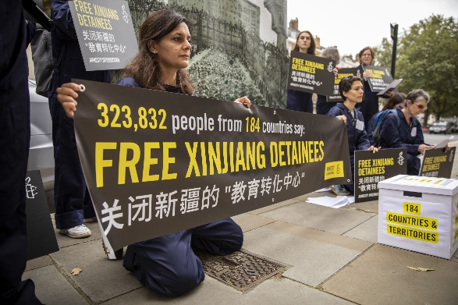
Join us online at 7:30pm this Tuesday 20 February to discuss human rights in China with Nabila Hanson, Amnesty UK’s Country Coordinator for China. This will be an opportunity to hear about and discuss some of the many concerns about the Chinese government's human rights performance, including its repression of ethnic minorities, the arrest and detention of human rights defenders, journalists and members of Hong Kong's pro-democracy movement, and its increasingly pervasive online censorship. If you want to join the call, please email me for a link.
This year will mark the 35th anniversary of the June Fourth Tiananmen crackdown. This provides an opportunity to shed light on these oppressions. It is important not only to pay tribute to those who have lost their lives and freedoms, but also to celebrate the courage and creativity of activists who are continuing their fight for rights.

PRIORITY CAMPAIGNS
Amnesty UK have notified us of their priority campaigns for 2024. They are:
End Israeli Apartheid
Prevent
Economic, Social and Cultural Rights (details to follow)
General Election
Bring them Home - British Nationals detained abroad
Write for Rights 2024
Protect the Protest
China, including the 35th Anniversary of the Tiananmen Square massacre
We have reported regularly on most of these issues in our newsletters and will continue to do so, encouraging you to get involved in actions to support the goals of these campaigns. Our Network will also continue to campaign for the rights of refugees and people seeking asylum.

RWANDA BILL
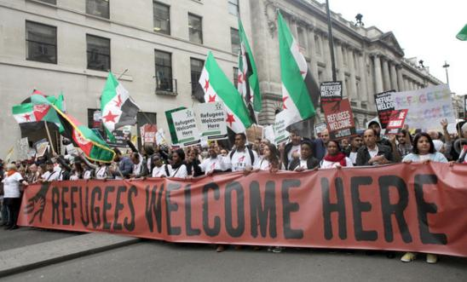
The cruel Rwanda Bill returned to the House of Lords on 12 February. Based on lies and misinformation, the Bill threatens to strip basic human rights from people seeking safety. It’s immoral, dehumanising and callous. Cruelty is the very point. Many politicians believe passing this Bill would be a disaster. Voices of dissent are rising. Parliamentarians are publicly condemning this Bill.
Amnesty have compiled a powerful video featuring just some of the remarks from Members of the House of Lords who have spoken out with stark criticisms of the Bill. Their words cut through the political noise to reveal the truth about this callous legislation. Please watch and share the video. On Facebook. 📸 Share on Instagram. 🐦 Tweet. Share video on YouTube.

PROTECT THE PROTEST
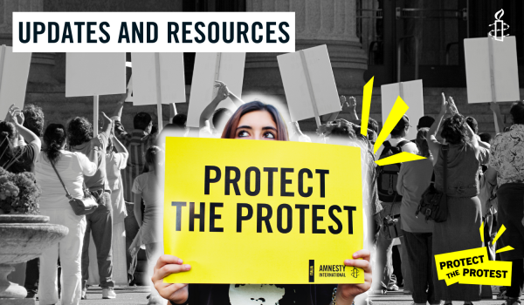

On 1 February, Greta Thunberg was on trial in London. She is one of scores of activists to be caught up in the UK’s alarming crackdown on climate protesters. Thunberg has been charged along with four other protesters with an alleged public order offence at a climate crisis protest outside an oil and gas industry conference in London on 17 October 2023. The charges against Thunberg and all the activists highlight everything that’s wrong with the policing of protests in the UK today. Police are increasingly using their expanded powers to silence legitimate protests.
Thank you to all those who signed the action in last month’s newsletter to demand that the UK Government scrap the new anti-protest laws which restrict the right to protest in England and Wales. If you haven’t signed it yet, you can still do so here. Here you can watch a video, produced in partnership with Liberty, which captures the public’s response to learning about these new powers.
Since the start of October 2023, there have been weekly protests around the world calling for an immediate ceasefire in Gaza. In England and Wales, these protests have faced increasingly severe police restrictions, with hundreds of people arrested. Amnesty’s partners at the Network for Police Monitoring are preparing a report on the policing of Palestine protests and are calling for first-hand testimony from protesters. If you have participated in any of the protests, you can contribute here to the report here.
For more information, explore here Amnesty’s interactive world map showing where protests are repressed, read more about the UK’s Public Order Act here, and find out here why Amnesty is campaigning for a Torture Free Trade Treaty to protect the right to protest.

GAZA
Distressing content warning
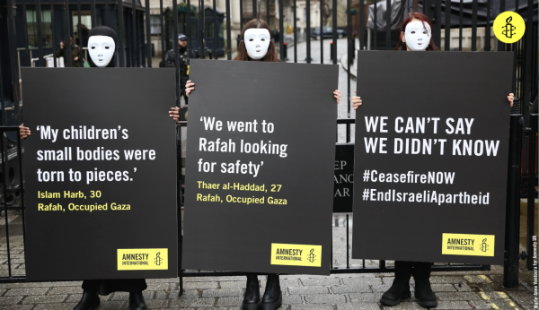
Trigger warning: distressing description/content
Fresh evidence of deadly unlawful attacks in Rafah show how Israeli forces are flouting international humanitarian law in their military assault on Gaza. Amnesty has carried out a detailed investigation into four separate Israeli attacks in Rafah, supposedly Gaza’s “safest” area. Three of the attacks occurred in December after the ‘humanitarian pause’ ended, and one in January. Last week, an Amnesty team went to Downing Street to amplify the voices of Palestinian survivors in Rafah, where unlawful attacks by Israeli authorities have already devastated entire families, with total impunity. Please share the video on Facebook here, on Instagram here and on X here.
Amnesty continues to call on the Prime Minister to demand an immediate ceasefire. If you haven’t already, please take action now.

END ISRAELI APARTHEID
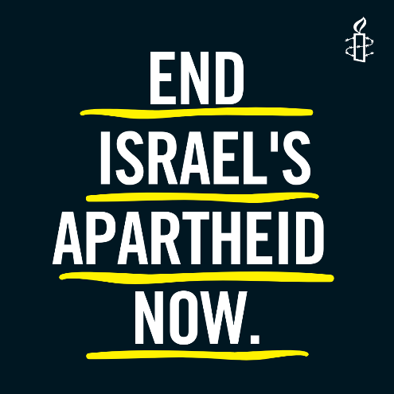

The current crisis in Gaza, Israel and the West Bank is the product of decades of apartheid inflicted by the Israeli authorities against Palestinians. As well as campaigning for an immediate ceasefire in Gaza and calling for all parties to the crisis to adhere to international humanitarian law and for all violations of international law to be urgently investigated by the International Criminal Court, Amnesty is continuing to focus on the root causes of the current crisis – including dismantling Israel’s racist system of apartheid – are addressed, in order to prevent endless cycles of violence. Find out more here.

PREVENT
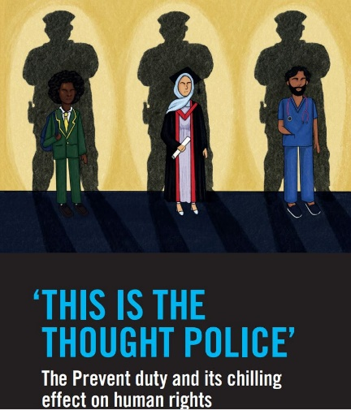
After the publication of Amnesty UK’s report on Prevent (‘This is the Thought Police’) in November 2023, the associated campaign will be launched in London on 23 March and thereafter in other cities around the country. The campaign will initially seek to raise awareness and understanding of the human rights impacts of Prevent and then to mobilise people to take local- and national-level action to challenge it.
Amnesty UK is calling on the UK government to develop counter-terror and national security policies that are human rights respecting and proportionate and to engage constructively with, rather than vilify, civil society organisations and community groups critical of Prevent. It is calling on the UK government to scrap the Prevent strategy, provide access to sufficient and effective remedy to people impacted, and refrain from using overly broad definitions of extremism.

JULIAN ASSANGE
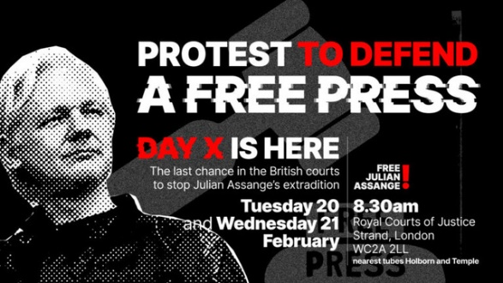
Julian Assange’s final appeal against extradition will take place this week at the Royal Courts of Justice, Strand, London WC2A 2LL. If he loses he faces 175 years imprisonment in the USA, for publishing documents exposing war crimes . The AIUK campaign for press freedom & Julian Assange will be present from 8:30am to 4:30pm on 20 and 21 February with an Amnesty banner to welcome all members. On the day, text Beckenham Amnesty activists on 07956 512 892 to find out where to meet up.

GUANTANAMO
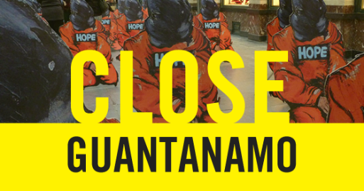
The next Guantanamo Vigils are scheduled for 6 March and 3 April in London. All are welcome. For more information, contact Dominique on dominique.oneil@outlook.com or Mark on maclixby@gmail.com. Here is a very interesting article about some of the men still held there, even though they have been approved for release.

GENERAL ELECTION
The next UK general election must take place before 28 January 2025. Since the last time the UK went to the polls in 2019, there has been a significant rollback in human rights domestically and globally. A fundamental change of direction is needed and the election provides an opportunity for this to take place. If the UK is to be seen again as a champion of human rights, the next government must be elected on an ambitious and progressive mandate regarding rights protections.
Amnesty UK has developed a Human Rights Manifesto for the next UK government, which covers a broad range of human rights issues across home and foreign affairs. It calls on the new government to adopt a range of human rights commitments that expand and protect people’s rights in all parts of the UK, including the strengthening of women and girls’ rights, the rights of the LGBTI+ community and other minority groups, improving the asylum system and creating safer communities, as well as championing human rights throughout the world through a principled foreign policy. Much of the work in the lead up to the election will be focused on driving commitments from political parties to adopt and deliver these calls should they form the next UK government.

LEARN MORE ABOUT HUMAN RIGHTS
This month, Amnesty UK’s Human Right's Education team is highlighting two courses: Anti-Racism & Human Rights and Confronting & Countering Gender-based violence.
Racism is deeply engrained in the structures of our society. Challenging these systems and the ideologies that reinforce them is key to human rights progress. This free short course has been created as a first step for anyone who wants to learn about racism, practice anti-racism and contextualise its impact on human rights in the UK and around the world. It will help you to understand, confront, and meaningfully challenge racism, discrimination, inequality and disempowerment. Access the course here.
Gender-based violence is a global pandemic that disproportionately affects women, girls and gender-nonconforming individuals. Learn about the various forms of violence that constitute this crime against humanity and explore strategies for preventing and addressing it. Access the course here.

20 February at 7:30pm: Kent Network speaker meeting with Nabila Hanson on China. Email graham.minter@amnesty.org.uk for a link.
20 - 21 February from 8.30 am to 4.30 pm: Stop Julian Assange’s extradition at the Royal Courts of Justice, The Strand, London, WC2A 2LL GB. More info here. On the day, text Beckenham Amnesty activists on 07956 512 892 to find out where to meet up.
4 March at 7:30pm: Maidstone, Medway and Swale Group meeting at The Chiltern Hundreds, Penenden Heath Road, Maidstone, ME14 2DG. Email mmands.amnestygroup@gmail.com.
6 March: Close Guantanamo vigil in London. Contact dominique.oneil@outlook.com or maclixby@gmail.com.
8 March: International Women's Day
10 March from 2:00pm to 4:30pm: Event to mark International Women’s Day, in partnership with Soroptimist International, at King Charles the Martyr Church, 3 Warwick Park, Tunbridge Wells, TN2 5TA. Email dominique.oneil@outlook.com.
23 March from 2:00pm to 5:00pm: launch of the Prevent campaign at the Human Rights Action Centre, 25 New Inn Yard, London EC2A 3EA. Register here.
All the best
Graham

