AMNESTY UK KENT NETWORK NEWSLETTER: JANUARY 2024
HIGHLIGHTS
This month you can
- Join our online speaker meeting on 16 January to learn more about Amnesty’s Protect the Protest Campaign
- Sign an online action demanding that our government scrap anti-protest laws.
- Sign an online action in support of journalists and human rights defenders in Kashmir suffering from government repression.
- Help at or visit our stall at Royal Victoria Place, Tunbridge Wells, on 3 February (see upcoming events)
- Learn about Amnesty’s Prevent Campaign at the Maidstone, Medway and Swale Group meeting in Maidstone on 5 February (see upcoming events)
- Join a memorial meeting in Broadstairs for Joe Arthur, founder member of our Network, who has sadly passed away.
- Join the Close Guantanamo march and rally in London on 20 January (see upcoming events)
- Apply to become a Country Coordinator
- Send us your views about our plans for our Network in 2024, including any suggestions for events or other action.

PROTECT THE PROTEST
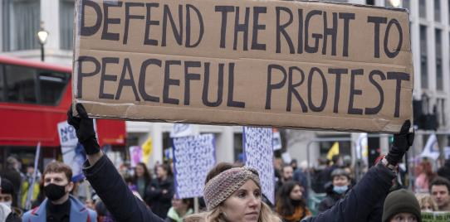
For this month’s speaker meeting on 16 January at 7:30pm, we shall be joined by Lydia Parker, Amnesty UK’s Campaign Manager responsible for work on freedom of expression and the right to protest. Right now, our right to protest is under attack in the UK and around the world. The meeting will enable us to learn more about the campaign and how we can all support it to help keep this fundamental freedom safe. We shall explore specific actions that our Network can take to this end during 2024.
Meanwhile, you can sign the action here to demand that the UK Government scrap anti-protest laws. Since 2022, the government has passed two different anti-protest laws to clamp down on everyone’s ability to protest peacefully in England and Wales. At the same time, they have demonised and scapegoated protesters. The anti-protest restrictions in the Policing, Crime, Sentencing and Courts Act 2022 and the Public Order Act 2023 must be scrapped.
KASHMIR
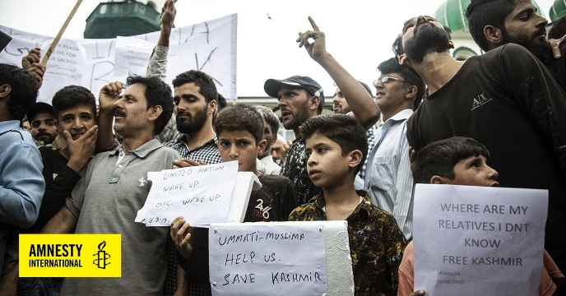
In the four years since the Indian government imposed direct rule over the disputed territory of Jammu & Kashmir, the repression of human rights in the region has intensified, particularly freedom of speech by journalists and human rights defenders. Amnesty is calling on the Indian High Commissioner in London to urge the Indian authorities to drop all charges against Kashmiri journalists and human rights defenders arrested and detained for exercising their right to freedom of expression, and to release those arbitrarily detained. Please support the campaign by signing the action here.
JOE ARTHUR
We are very sorry to report that Joe Arthur, a founder member of our Network and member of our Core Team, passed away in November. Joe worked hard to keep Amnesty’s voice alive in Thanet, often in challenging circumstances. We shall miss him. Broadstairs Quakers will hold a memorial meeting to remember his life on Saturday 27 January starting at 3pm at Broadstairs Quaker Meeting House. It will be a Quaker service, based on silence. Attendees will sit for 40 minutes and anyone who feels moved to do so can stand and share memories of Joe. Afterwards there will be refreshments and a chance to chat. Amnesty members who knew Joe will be very welcome. If you would like to attend, please let me know.
WRITE FOR RIGHTS 2023
Congratulations to the small Groombridge Amnesty team who had their best Write for Rights event so far sending 110 cards and 20 appeal letters. This is in addition to the other activities reported in last month’s newsletter.
COUNTRY COORDINATORS STILL WANTED!
AIUK’s Country Coordinator Forum is looking for new members to join the team. The deadline has been extended to 31 January. The voluntary role requires 7-9 hours of commitment each week. To find out more about the individual roles, click here. If you have any questions, please email rachel.obrien@amnesty.org.uk.
FACEBOOK
Our Facebook page has been blocked since November. We have appealed and still await the outcome. Meanwhile, we are posting occasionally on the Maidstone, Medway and Swale Group page, which you can find here.
OUR PLANS FOR 2024
Our Core Team will meet shortly to discuss our plans for the coming year. In 2024, our aim is to continue to raise human rights awareness in our local area and the profile of the Kent Network and of Amnesty International more generally.
This year, we want to develop more collective action throughout the area and this depends greatly on the willingness of our members to get involved. Even if your time is limited by other commitments and responsibilities, how about setting a New Year’s Resolution to participate in at least one collective action in your area (or more widely) during 2024? If every one of our 150 members and supporters did this only once in 2024, our impact would be so much stronger!
We shall continue to campaign on refugee and migrant rights and freedom of assembly (the right to protest). We expect also to become more engaged on anti-racism issues. We shall continue to raise our voice about apartheid in the Occupied Palestinian Territories and call for a ceasefire in the Israel / Gaza conflict; and on other international issues as they arise. We shall also continue to support the campaigns to close the Guantanamo detention centre and to tackle human rights violations in Kashmir.
The forthcoming General Election (whenever it happens) will have an impact on our advocacy work. Before the election, we shall aim to make contact with all the main candidates in each constituency to ask where they stand on key human rights issues. After the election, we need to build (or rebuild) our relations with, and seek to influence, those who are elected; and hold them to any undertakings that they made to us during the campaign.
We shall also be aiming to build and strengthen our links with other like-minded organisations across our area, including through joint events or by supporting events that they are organising.
We shall be increasing our contacts with local schools and other educational establishments and, where appropriate, promoting the creation of more local school groups. We shall continue to offer our support to the Amnesty club at University of Kent Canterbury.
We shall continue to organise monthly online speaker meetings. Our ability to attract high calibre speakers depends on the level of attendance at these meetings, so please join them if you can.
We welcome any views about these plans and any suggestions that you may have about possible activities in your area or more widely.
16 January at 7:30pm: Kent Network online speaker meeting with Lydia Parker on freedom of assembly and the right to protest. Contact graham.minter@amnesty.org.uk for a link.
20 January at noon: Close Guantanamo march and rally starting at Old Palace Yard, London. Contact dominique.oneil@outlook.com.
3 February at 11:00am to 2:00pm: stall at the Royal Victoria Place, Tunbridge Wells to highlight the 75th anniversary of the UN Declaration of Human Rights and the AI campaign to Protect the Protest. Contact dominique.oneil@outlook.com.
5 February at 7:30pm: Maidstone, Medway and Swale Group monthly meeting at Maidstone Community Support Centre, 39-48 Marsham Street, Maidstone, ME14 1HH: campaigning on Anti-Racism. Contact victoria.gascoine@btinternet.com.
All the best
Graham

