**Amnesty Europe Newsletter January 2023**

Dear Amnesty Activists and supporters

The Europe team is wishing you a happy 2024 and lots of energy: we will need it. There is a lot to do.

On 14th December Amnesty International released the report into the causes of the shipwreck at Pylos, where hundreds of people died. It makes very disturbing reading. Please find the full report attached.

We have more shocking news : the El Hiblu 3, three young boys who translated between 100 refugees and the captain of the El Hiblu, negotiating the rescue of the refugees on board, are now charged with crimes that could lead , if prosecuted to life-long prison sentences. Amnesty International is campaigning for the charges to be dropped. Please sign and share the petition!

[Demand justice for the El Hiblu 3 - Amnesty International](https://www.amnesty.org/en/petition/w4r-2020-malta-el-hiblu-3/)

We are looking for groups to adopt this Individual at Risk case. Please email me if you are interested in working on this case. Best regards Ulrike [Ulrike.schmidt@amnesty.org.uk](mailto:Ulrike.schmidt@amnesty.org.uk)

For campaigning and information on Turkey please contact Chris Ramsey [chris.ramsey@amnesty.org.uk](mailto:chris.ramsey@amnesty.org.uk)

For campaigning and information on Western Europe please contact Jovana Bosnjak [jovana.bosnjak@amnesty.org.uk](mailto:jovana.bosnjak@amnesty.org.uk)

For Central Europe , the Balkans and the Eastern Mediterranean Ulrike Schmidt [Ulrike.schmidt@amnesty.org.uk](mailto:Ulrike.schmidt@amnesty.org.uk)

Content

|  |  |
| --- | --- |
| New Amnesty research into the shipwreck at Pylos killing hundreds of people | Page 2-4 |
| The El Hiblu Case | Page 5-6 |
| Poland Justice for Justyna | Page 7 |
|  |  |

**Greece**

On 14 June 2023, of a boat with 750 people from Syria, Pakistan and Egypt off Pylos, Greece. Only 104 survived and only 82 bodies were recovered. Survivors said that the Hellenic Coast Guard towed their boat, causing it to capsize, and was slow to activate rescue operations. Investigations have made little progress, while survivors’ testimony points to potential procedural shortcomings. Over 500 are missing and presumed dead.

On 14th December Amnesty International released the report into the causes and circumstances of this tragedy. It makes shocking reading.

Amnesty International and Human Rights Watch interviewed 21 survivors, 5 relatives of 5 people still missing, and representatives of the Hellenic Coast Guard, the Greek police, nongovernmental organizations, United Nations and international agencies and organizations.

They found that in the 15 hours between receiving the first alert that the Adriana was in their search-and-rescue region, and when it capsized, Greek authorities failed to mobilize appropriate resources for a rescue. The authorities were clearly aware of indicators of distress, such as overcrowding and insufficient food and water, on the Adriana, and, survivors said, knew about corpses on board and requests for rescue.  Survivors’ testimonies also challenge the authorities’ claim that people on the Adriana did not want to be rescued, which in any event would not have relieved the Hellenic Coast Guard of its obligation to take all measures necessary to ensure safety at sea. Survivors consistently said that they pleaded repeatedly for rescue, including to the Coast Guard itself.

Survivors said that a Coast Guard patrol boat attached a rope to the Adriana and pulled, causing the boat to capsize. They also alleged that, after the boat capsized, the Coast Guard boat was slow to activate rescue operations, failed to maximize the number of people rescued, and engaged in dangerous manoeuvres.

<https://www.amnesty.org/en/latest/news/2023/12/greece-6-months-on-no-justice-for-pylos-shipwreck/>

Please find the full report in the separate attachment. Please also see the video with the account of a survivor on our Amnesty Europe Facebook page : <https://www.facebook.com/AmnestyUKEurope>

I organised a vigil outside the Embassy of Greece for the 14th of December and handed the Amnesty report to the Embassy.

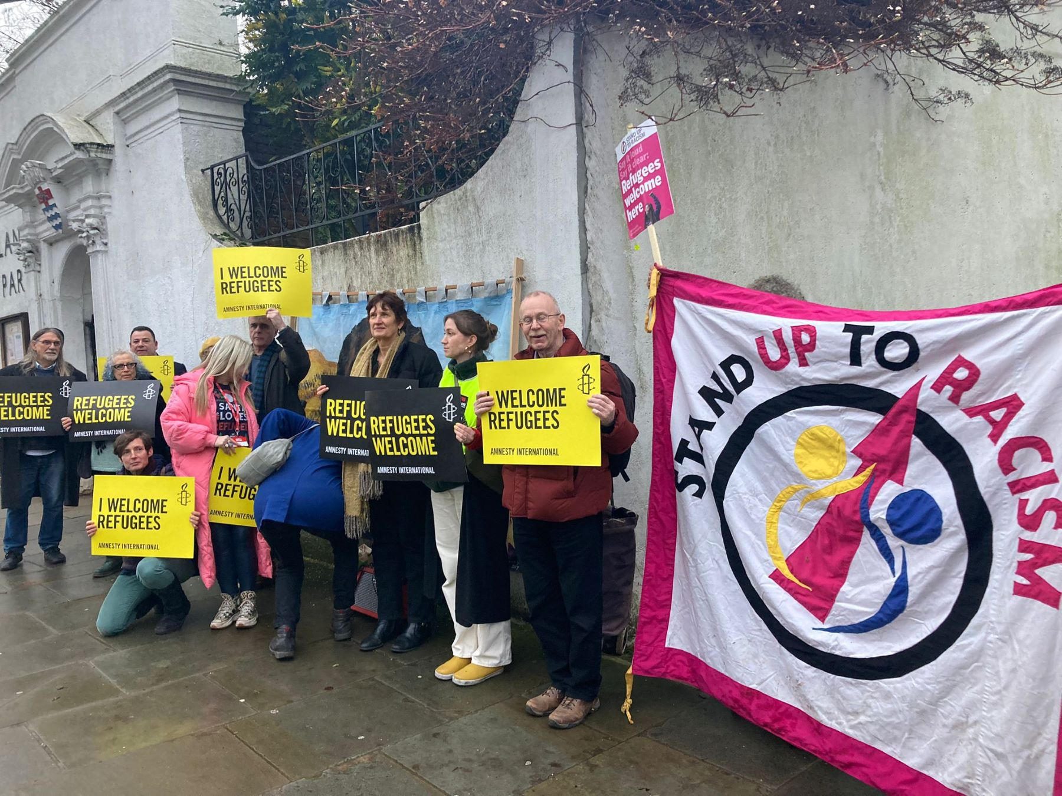



Unfortunately this tragic loss of life is not unique. The Mediterranean Sea has become a graveyard for desperate people trying to find safety in Europe. After the horrors of the Holocaust and the second world war the United Nations came together to formulate the Universal Declaration of Human Rights. Of which Article 14 reads: *Everyone has the right to seek and to enjoy in other countries asylum from persecution.* Now just 75 years on European countries including the UK try to keep refugees out at all cost. Refugees and migrants are dying in the forests bordering Poland, Lithuania and Lativia. Refugees are drowning in the sea and NGO’s and individuals who are trying to save lives are criminalised. The European policies of preventing refugees from seeking asylum in Europe include collaborating with perpetrators of grave human rights abuses:

**“Frontex uses planes and drones to spot any people trying to reach safety in Europe by crossing the Mediterranean, before then alerting the Libyan coastguards. As a results, refugees and migrants are routinely intercepted by Libyan coastguards and returned to Libya, where they face arbitrary detention and torture on a mass scale.”**

Matteo de Bellis Amnesty International Researcher and Campaigner

**The El Hiblu 3 case**

Before they were known as the El Hiblu 3, they were three teenagers with a passion for football and basketball. Aged 15, 16 and 19 at the time, they wanted what we all do: a safer, better life.  
  
That common goal brought them from Guinea and Côte d’Ivoire to Libya. Desperate to escape the violence and torture cells reserved for refugees and migrants there, they boarded a dinghy with over 100 others bound for Europe.  
  
The dinghy soon ran into trouble and was rescued by the El Hiblu, an oil transporter. The El Hiblu’s crew then tried to return those rescued to Libya –which was unlawful –despite promising that they wouldn’t.  
  
A protest broke out. The three youths were asked to help calm the situation. Acting as interpreters, they defended the right of those rescued not to face torture again in Libya. The crew turned the ship towards Europe.  
  
However, as it entered Malta’s waters, the Maltese authorities stormed the ship, claiming the three had taken it by force. They charged the youths with offences so serious that they could be jailed for life. This despite finding almost no evidence to support the charges.  
  
The three youths had simply tried to defend their safety and to protect those rescued with them. Now they’re in the dock.

Now after 4 years the Attorney General of Malta has indicted the three young men with charges that could see them convicted to life imprisonment.

<https://www.amnesty.org/en/latest/news/2023/11/malta-indictment-of-el-hiblu-3-the-worst-possible-decision/>

[**https://www.maltatoday.com.mt/news/court_and_police/126340/bill_of_indictment_filed_against_el_hiblu_3**](https://www.maltatoday.com.mt/news/court_and_police/126340/bill_of_indictment_filed_against_el_hiblu_3)

Amnesty is fighting for their release. New campaigning guidelines will be issued soon by the International Secretariat. The El Hiblu 3 are our Individuals at Risk case and we are inviting groups to sign up to campaign for their release.

**Please take Action !**

**Please sign and share the petition for the charges to be dropped !**

[Demand justice for the El Hiblu 3 - Amnesty International](https://www.amnesty.org/en/petition/w4r-2020-malta-el-hiblu-3/)

For more in depth information read :

[FreeEH3_book.pdf (elhiblu3.info)](https://elhiblu3.info/FreeEH3_book.pdf)

For further information please contact [ulrike.schmidt@amnesty.org.uk](mailto:ulrike.schmidt@amnesty.org.uk)

On 20th of December the European Parliament agreed the new Pact on Migration and Asylum . It is another nail in the coffin carrying the universal human right to asylum from persecution. The fight must go on. I will keep you updated.

<https://www.amnesty.org/en/latest/news/2023/12/eu-migration-pact-agreement-will-lead-to-a-surge-in-suffering/>

**Poland**

After the elections a new government was sworn in with Donald Tusk of the Civic Platform party the new Prime Minister. There is a lot of hope for women’s reproductive rights, the right to protest and the independence of the judiciary to be reinstated after 8 years of undermining and suppressing civil rights and the judiciary by the former ruling PIS party.

On 2. December we held a demonstration outside the Embassy of Poland in support of Justyna Wydrzynska and the right of women to access safe and legal abortions. Please continue to sign her share the petition for Justyna’s prosecution to be overturned.

<https://www.amnesty.org.uk/actions/JusticeforJustyna>