AMNESTY UK KENT NETWORK NEWSLETTER: DECEMBER 2023
HIGHLIGHTS
We send our best wishes to all our readers as we enter the festive season. This month you can still
- call on the UK government to support the call for a ceasefire in Israel / Gaza
- take part in Amnesty’s Write for Rights Campaign
You can also apply for one of the vacancies in AIUK’s Country Coordinator Forum. We update you on refugee and migrant rights, the Protect the Protest Campaign, the Close Guantanamo Campaign and commemoration of the 75th Anniversary of the Universal Declaration of Human Rights.

ISRAEL / GAZA
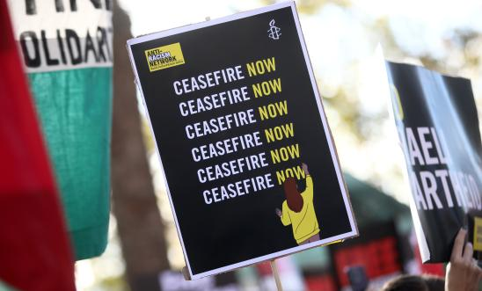
On 12 December, the UN General Assembly overwhelmingly passed a non-binding Resolution calling for an immediate humanitarian ceasefire, with 153 votes in favour, 10 against and 23 abstentions. The US voted against and the UK abstained. The vote came on the heels of a failed resolution in the UN Security Council, which also called for a humanitarian ceasefire, but which was vetoed by the US.
The call for the UK Government to support the call for a ceasefire is still on the AIUK website. Please sign it if you haven’t already done so. We have reached replies from 11 of the 14 Kent MPs to whom we wrote on the issue.

REFUGEE AND MIGRANT RIGHTS
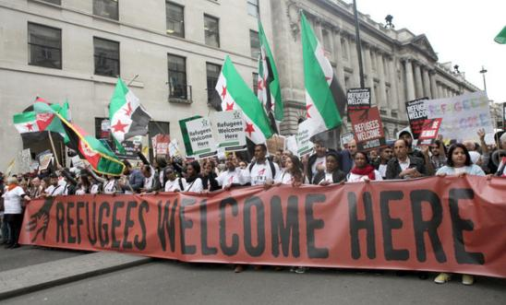

The Government’s new Rwanda bill passed its second reading in the House of Commons on 12 December. Sacha Deshmukh, AIUK’s Chief Executive, said: “It was wrong that this bill was introduced and has now progressed. This bill is a sad assault on the rule of law and the protection of human rights in this country. Stripping people of their rights and shipping them off to Rwanda when they’re seeking asylum in the UK is a clear dereliction of this country’s responsibilities toward some of the world’s most desperate people. It is an attack on the basic principle that human rights are universal.”
The Hastings Online Times have published an article reporting that a group of local Jewish people have approached local MP Sally-Ann Hart to express their feelings of revulsion at the widespread killing and devastation wreaked by Israeli forces in Gaza in their response to the atrocities committed by Hamas. The MP agreed to forward their call for a ceasefire to the UK Foreign Secretary. The article also referred to Amnesty’s open letter to Sally-Ann Hart.
WRITE FOR RIGHTS 2023

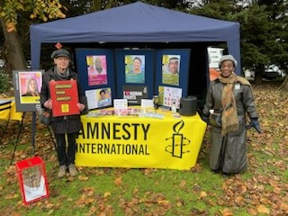

The 2023 Write for Rights campaign continues for the rest of this month. Visitors to the Maidstone, Medway and Swale Group’s stand at the Christmas Fayre at Aylesford Priory signed 63 greetings cards with messages to the people featured in this year’s campaign. Thanks, as always, to the local Soroptimists club for their help with this. Students at Maidstone Grammar School wrote and signed 142 greetings cards and appeal letters, thanks to great work by the school’s Amnesty group. We await news of the several other initiatives by our local supporters, including at other local schools and Soroptimist clubs.
There is still time for you to take part in the campaign by adding your voice to the thousands who have already sent solidarity messages and appeals. You can do it here.

PROTECT THE PROTEST
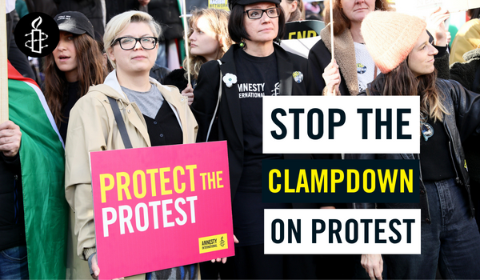
The UK government continues to attack the rights to protest and freedom of expression in its attempt to restrict challenges to their actions. In the last two years the government has passed anti-protest laws, like the Policing, Crime, Sentencing and Courts Act and the Public Order Act, to clamp down on everyone’s ability to peacefully protest in England and Wales. They’ve done this alongside scapegoating protesters. Peaceful protests have wrongly been labelled “hate marches” and “mobs”. These dystopian distortions are extremely dangerous for our society and everybody’s fundamental right to peacefully speak out for what they believe in.
But people across the UK continue to come together in peaceful protest to protect human rights for all. In reality, the UK has a long and important history of street protest - from anti-apartheid protests, marches for climate action, and not-in-my-name anti-war marches. Protests show how people feel when the government of the day has been on the wrong side of history. We must not allow the government to continue to clamp down on our rights to speak up for what we believe in.
In 2024, our Network will explore ways in which we can do more to support the Protect the Protest Campaign.
HUMAN RIGHTS DAY AND THE 75TH ANNIVERSARY OF THE UN DECLARATION OF HUMAN RIGHTS
Events took place across the world on 10 and 11 December to commemorate Human Rights Day and the 75th Anniversary of the Universal Declaration of Human Rights. In a statement at a high-level United Nations event, Amnesty noted that the 75th anniversary coincided with a world with a world that appeared to be unable to prevent or address grave violations that shock the conscience of humanity. It said that this anniversary was a wake-up call for the world to ask itself whether it has what it takes to meaningfully address today’s crises.
GUANTANAMO
A Close Guantanamo Procession will take place in London on 20 January, meeting at Old Palace Yard at 11:30am, setting off to Parliament at noon and returning at about 3:00pm. Exact details to follow.
COUNTRY COORDINATORS WANTED!
AIUK’s Country Coordinator Forum is looking for new members to join the team. The voluntary role requires 7-9 hours of commitment each week. The deadline for applications is Friday, 5 January 2024. To find out more about the individual roles, click here. If you have any questions, please email rachel.obrien@amnesty.org.uk.

There’s not much happening for us in terms of local events over the holiday season, so we are taking a much-needed rest! Please save the date, though, for our next speaker meeting on 16 January at 7:30pm. We hope to be able to announce the speaker soon.

All the best for the festive season ahead
Graham

