Fundraising Quiz Night
Saturday 28th October
7pm (quiz to start at 7.30)
The Old School, Cuckfield (easy parking close by)
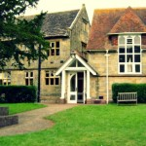

Veggie curry, pud and quiz £15
Bring your own drinks
Cash raffle

Teams of 6, but welcome as a smaller group.
6 bottles of good wine for winning team!!

To book contact hhamnesty@gmail.com
Hosted by Haywards Heath AI Group, supporting Amnesty’s work internationally

