GROUP MEETING
Thurs. 20th July 7pm to 9pm
Nora Street Community House

Friday 7th July - PRESENTATION - Israel’s Apartheid Against Palestinians
We were very happy with the attendance on Friday night and more than pleased that so many people who were genuinely interested in the subject turned up on such a hot and balmy evening. Their thoughtful questions showed a genuine interest in the presentation.

For every person attending our screenings we are hoping that possibly 3 times as many will get the message passed on by their family or friends. In this way we hope to be able to reach more people. This may turn out to be an excellent way for the message to be spread. The more people that hear and understand the message the quicker the movement to end Israel's Apartheid Against Palestinians will grow.
Thank you Gill for organising the evening including the refreshments and preparing the hall and thanks to Mike for all the time and effort needed to prepare and give the presentations.
It very encouraging to have successfully completed our first event for this campaign. We hope to try to arrange further similar events to publicise this campaign. If anyone is able to invite us to a group or organisation interested in hosting the presentation, please contact me on benkin64@talktalk.net.

SCRAP THE ‘TROUBLES’ bill
Northern Ireland Troubles (Legacy and Reconciliation) Bill
Murder is murder, whether it happened 5, 15 or 50 years ago in Northern Ireland or anywhere else. Torture is a crime with absolute prohibition under international law. The UK Government is trying to let people off with murder, torture and other serious crimes through the Northern Ireland Troubles (Legacy and Reconciliation) Bill.
Over decades, there has been a piecemeal approach to dealing with the past. Many victims are still waiting for justice. The UK Government is now betraying those victims by permanently removing any chance of truth, justice and accountability. The Bill protects perpetrators and means that if they give an account of conflict related events best to their knowledge and belief, that they will be given immunity from prosecution.
If the Bill comes into place, it will:
Give impunity to murderers, and those responsible for torture
Block victims from accessing justice via legal action
Be a significant interference in the justice system
Breach the Good Friday Agreement
Go against existing agreements between the UK and Irish Governments and NI Political Parties on legacy
Create a two-tier justice system in the UK
Fail to deliver human rights compliant investigation
Set a concerning international precedent - signalling to other States that they too can ignore their human rights obligations.

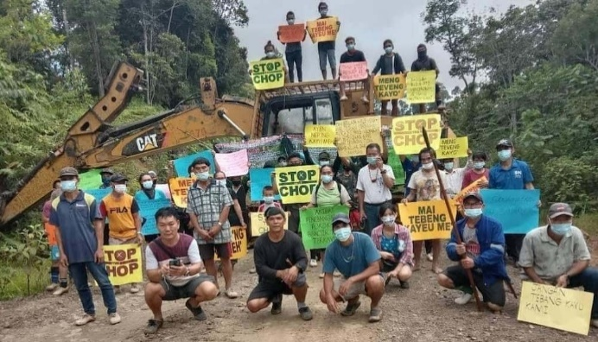
BORNEO
Global timber giant Samling is deforesting huge swathes of rainforest in Borneo, destroying Indigenous land, fuelling climate chaos and pushing endangered gibbons and pangolins toward extinction.
When a local, four-person NGO exposed the destruction, the timber giant slapped them with a $1.8 million lawsuit to silence them!
The family that owns Samling is worth over $400 million and can pay high priced lawyers to bully these forest defenders indefinitely. But the tiny NGO doesn't need millions to defeat Samling, just enough to pursue a smart legal strategy that gets this bogus lawsuit thrown out.
Now they have a new court date that's coming up fast, and their legal costs are mounting. They’re asking for our help – and if enough of us chip in, we can give this brave group the cash they need with no red tape.
CASA NEWS- Guapinol Defeneders

Criminalisation of the Guapinol defenders became a landmark case for human rights defenders who are persecuted for protesting against extractive projects that contribute to local conflict and environmental degradation. The whole community is threatened with displacement due to contamination. The water is increasingly brown and unsuitable for bathing or drinking.

MYANMAR (BURMA)

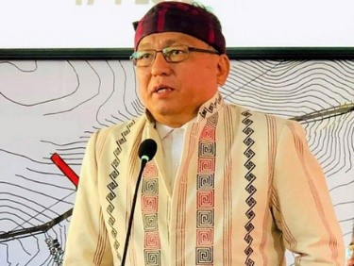

More than 22,000 people have been arrested by the Burmese military in the past two years. The vast majority of them remain in jail. Many have faced torture, rape and sexual violence. All are kept in appalling conditions without access to proper food or medical care.
Reverend Hkalam Samson is one of those political prisoners.
Hkalam Samson is the Chairman of the Kachin National Consultative Assembly and is a prominent and outspoken Christian leader in Burma. He is also a well-respected community leader and the former President of the Kachin Baptist Convention.
Hkalam Samson was arrested at Mandalay International Airport in December 2022 on his way to get medical treatment in Thailand. He was charged with criminal defamation, unlawful association, and charges under the Counter-Terrorism Law. He is now serving six years in prison.

The address to write to is:
Reverend Hkalam Samson
C/O The Governor of Myitkyina Prison
Myitkyina Prison
Myitkyina
Kachin State
Myanmar (Burma)

Try to include information about yourself to make your letter personal. If you have cheerful/uplifting news to include this would cheer him up.

