AMNESTY UK KENT NETWORK NEWSLETTER: MAY 2023
HIGHLIGHTS
Join us online at 7:30pm tomorrow for an update on Amnesty’s End Israeli Apartheid campaign. Please consider whether you can help at one of our four planned stalls in June: in Hastings, Faversham and Dover. Please also look out for our letter to the local media about the killing of Shireen Abu Akleh. You can still sign the petition to stop the Illegal Migration Bill. We also provide updates, and opportunities to get involved, on Guantanamo and this year’s Pride events.
END ISRAELI APARTHEID: MONTHLY SPEAKER MEETING
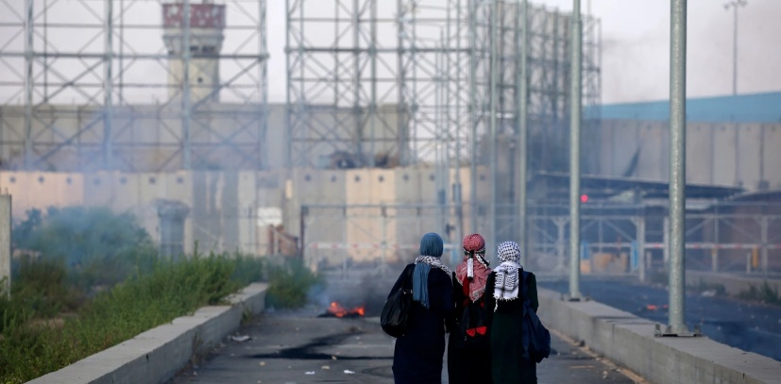
At this month’s speaker meeting, tomorrow Tuesday 16 May at 7:30pm, Tom Guha, who leads AIUK’s work on the Stop Israeli Apartheid campaign, will provide an update on the End Israeli Campaign, followed by a discussion about what more our Network can do to support it. Email me for a link.
Last month, MPs debated human rights protections for Palestinians. MPs from across the House called on the UK government to hold Israel to account for human rights abuses against Palestinians and multiple MPs referenced Amnesty’s report on Israeli apartheid. You can watch the debate here and read a transcript here.
11 May marked a year since the distinguished Al Jazeera journalist Shireen Abu Akleh was shot dead by Israeli soldiers. Shireen was one of a staggering 146 Palestinians killed by Israeli forces in the occupied West Bank last year, the highest number for decades. We have written to the editors of local media across our area highlighting that the Government needs to stop shielding the Israeli authorities, who are undermining international law and insulting the memory of Palestinians like Shireen Abu Akleh. If you find the letter in your local paper, please let me know.
We have other actions planned for the coming months. The campaign will be the main theme on our stall at St Leonard’s Market, Hastings, on 3 June, where we shall have a petition for passers-by to sign. The exhibition of Palestinian Art, to be held in partnership with Nucleus Arts and the PalArt Collective, will take place in Chatham later this year.
KENT NETWORK EVENTS
We recently sent you an email seeking volunteers to help at public events we have planned over the coming months. These events are important to raise awareness of human rights issues in our area and also help us to attract more members and supporters. Four of these are in June.
- 3 June: stall at St Leonard’s (Hastings) Market. Email pal.luthra@btinternet.com
- 10 June: stall at Faversham Market. Email annabelle_clayton@hotmail.co.uk
- 17 June: stall at Dover Multicultural Festival, Pencester Gardens. Email maclixby@gmail.com
- 25 June: stall at Hastings Sanctuary Festival. Email pal.luthra@btinternet.com
Sadly, we may not be able to staff a stand at the Dover Multicultural Festival due to a lack of volunteers, so please consider whether you can help, even if it is only for a couple of hours.
ILLEGAL MIGRATION BILL
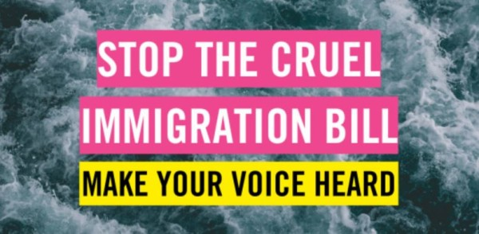
This cruel bill is continuing its passage through parliament, but is facing widespread criticism. The next step is the House of Lords Committee Stage, which will sit on 24 May, 5 June and 7 June. To help you to speak out about the bill, there is a handy blog on the AIUK website setting out five reasons to oppose it.
There is a petition on the AIUK website calling on the Prime Minister to stop the bill. Please sign it if you haven’t done so already.
Thank you to those who have written to their MP. Please continue to send me any replies that you receive.
Our campaign against the bill will be the main theme on our stalls at Faversham market on 10 June and at the Hastings Sanctuary Festival on 25 June, where we shall of course have a petition for passers-by to sign as well as other awareness-raising materials. We are still hoping also to have a stall at the Dover Multicultural Festival if we have enough volunteers (see above). Please offer to help if you can!
PRIDES
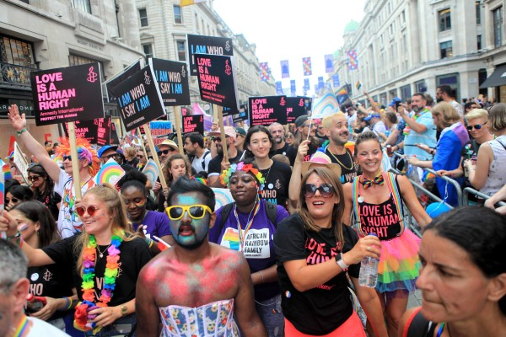
Amnesty UK’s Rainbow Network are developing new resources and campaign actions in readiness for this year’s Pride events. Much of Amnesty’s focus this year will be on taking action in solidarity with Prides that are at risk in some parts of the world and protesting the repression of LGBTI+ communities.
We are hoping to have a presence at some of the Pride events in our area this year. At present, we are prioritising Medway (19 August) and Dover (26 August), but much will depend on how many of us volunteer for each event.
If any of you would like to get more involved in Amnesty’s work on Gender, Sexuality and Identity rights, please let me know and I’ll link you up with the right people.
GUANTANAMO
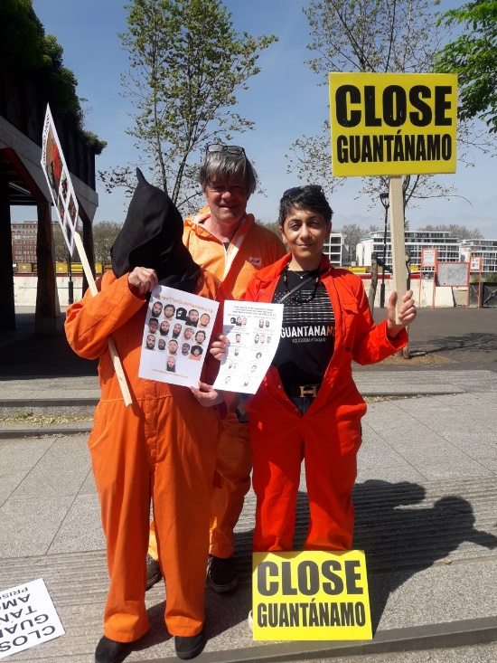
The newly-established All Party Parliamentary Group for Closing the Guantanamo Bay Detention Facility had its first meeting in the House of Commons on 24 April. The group’s stated purpose is “to urge the US Administration to close the Guantanamo Bay detention facility, to ensure the safe re-settlement of all those approved for release, and to ensure that due process is expedited for all the remaining prisoners”.
The UN Working Group on Arbitrary Detention has released a report on the treatment of Guantanamo detainee Zayn Al-Abidin Muhammad Husayn (Abu Zubaydah), declaring that his detention has no lawful basis and calling for his immediate release, adding that the systemic deprivation of liberty at Guantanamo may “constitute crimes against humanity”. This is the first time that an international body has referred to conditions at Guantanamo as a potential crime against humanity. More information here.
The Mauritanian, based on the story of ex-detainee Mohamedou Ould Salahi, was shown on 14 May on BBC. It is available for 30 days on iplayer. Here is a link to a 20-minute documentary “My Brother’s Keeper” which recounts the unlikely friendship between Mohamedou and his guard at Guantanamo.
The monthly vigils to close Guantanamo continue outside the Houses of Parliament. The next one is on 7 June (see below).
UPCOMING EVENTS
20 May: Sevenoaks Welcomes Refugees fundraising concert at Walthamstow Hall Senior School, Holly Bush Lane, Sevenoaks TN13 3UL. Details here.
3 June: stall at St Leonard’s (Hastings) Market. Email pal.luthra@btinternet.com
5 June at 7:30pm: Maidstone, Medway and Swale Group meeting at Maidstone Community Support Centre, 39-48 Marsham Street, Maidstone, ME14 1HH. Email victoria.gascoine@btinternet.com
7 June at 1pm to 3pm: monthly Guantanamo vigil in Parliament Square. Email Dominique.oneil@outlook.com
10 June: stall at Faversham Market. Email annabelle_clayton@hotmail.co.uk
17 June: stall at Dover Multicultural Festival, Pencester Gardens. Email maclixby@gmail.com
19-25 June: Refugee Week
24 June from 10:00am to 5:00pm: Amnesty UK’s Annual General Meeting at the Human Rights Action Centre, 17-25 New Inn Yard, London EC2A 3EA, and online. Details here.
25 June: stall at Hastings Sanctuary Festival. Email pal.luthra@btinternet.com

