WALK THE
WALBROOK
Meet outside Shoreditch High Street TfL station
Sunday May 14 at 1.00 pm
We follow the Walbrook, the shortest and most mysterious of London's hidden rivers, from its source in Shoreditch right down to the Thames. This fascinating walk starts in an area that once had a reputation as one of London’s darkest slums, the fearsome Old Nichol, but is now undergoing rapid regeneration through high-tech start-ups and its night-time economy. Shoreditch once housed the open-air theatres that flourished in the golden age of Elizabethan drama outside the city limits and then became a tough industrial area of workshops and warehouses. As we follow the course of the river into the City of London the buildings get bigger and grander as we pass the Broadgate Centre, London Wall, the Bank of England, the Temple of Mithras and a wonderful array of the architecture of many different eras. This is truly one of the most contrastive and fascinating walks you can do in London - a true cross-section of our city's history.
This walk is a fundraiser for the Amnesty International Justice for Ukraine Appeal. Your donation will help investigators document human rights abuses and finance technology to expose the war crimes being committed during Russia's barbaric war in Ukraine. Please be as generous as possible. There is no upper limit to your contributions.
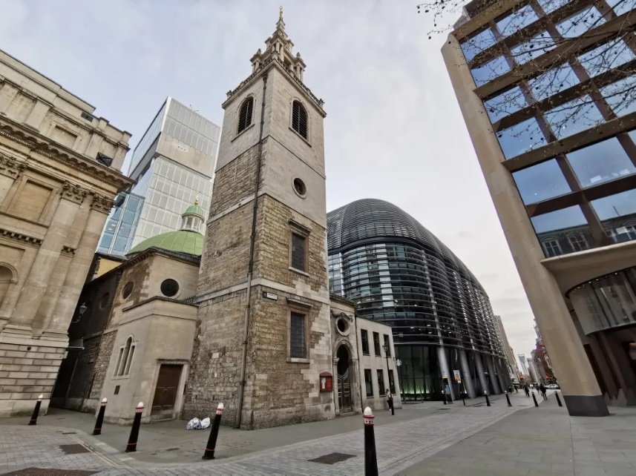
Booking by Eventbrite
HERE
Richard Cohen is a City of London guide and is passionate about the social and political history of London and the story of the lives of Londoners over the centuries. He wants to share his passion for London with you and show how every corner of this city connects us with the past.

