AMNESTY UK KENT NETWORK NEWSLETTER: MARCH 2023
HIGHLIGHTS
Our monthly meeting on 21 March is a chance to examine the government’s draconian Illegal Immigration Bill and discuss how we can fight it. Email me for a link. If you were sorry to miss last month’s meeting about Amnesty’s plans to fight racism in the UK, you can still email me for the PowerPoint presentation. There is also an action to stop the execution of at least 14 protesters in Iran. We update you on Amnesty’s campaign to stop Israeli apartheid and the UK Government’s attempt further to restrict our right to protest.

REFUGEES AND PEOPLE SEEKING ASYLUM
Join us this Tuesday 21 March to hear about the government’s latest legislation aimed at stopping people from seeking asylum and what we can do fight it. If you want to join the call, email me for a link.
Thank you to all those who have already written to their MP to speak out against the “Illegal Immigration Bill” and its attack on people seeking safety from persecution or exploitation. The bill’s title is deliberately misleading: it aims to stop people from reaching this country to seek asylum by implementing harsh and punitive policies that will come at a huge cost. Arriving in a country to seek asylum, by whatever route, is not illegal. For most of those making this dangerous journey, there is no other route to seek asylum in the UK. The government is using lies and hate-filled language that will stoke flames of division and hatred and could end with more violence. For those who haven’t taken action yet, the link is here.

ANTI-RACISM AND PREVENT
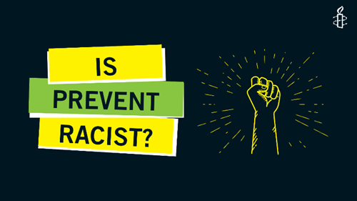
Those of you who joined our last speaker meeting with Ilyas Nagdee, Amnesty UK’s Racial Justice lead, or watched the recording will now be better informed about Amnesty’s plans to campaign against racism, including its current research on the damaging impact of Prevent. The outcome of this research is due to be published in the summer and will mark the launch of a major new campaign focusing on Prevent. Meanwhile, we have written to a number of local organisations asking that they encourage their members and supporters to complete Amnesty’s recent survey questionnaire on the issue. If you would like a copy of Ilyas’s PowerPoint presentation, please email me.

ISRAELI APARTHEID
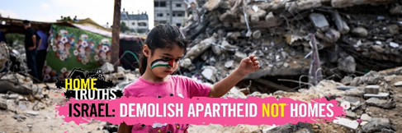
Last week was Israeli Apartheid Week. We are still hoping to hold one or two joint private screenings, with local branches of the Palestine Solidarity Campaign, of one of two films (Farha or Tantura) that explore the Nakba (catastrophe) when hundreds of thousands of Palestinians were ethnically cleansed and forced to flee their lands in 1948, with a view to a possible joint action to mark the 75th anniversary of the Nakba on 15 May.
Here you can see some highlights from Amnesty’s End Israeli Campaign so far. But we are still at the very beginning of this multi-year campaign. The election of a far-right government in Israel has led to even further crackdowns on Palestinian rights. You can get further info about the campaign here.
A new BBC documentary, The Holy Land and Us, seeks to present a balanced and sympathetic picture of the experiences of both Jews and Muslims in the aftermath of the Holocaust and the creation of Israeli in 1948 with the grave cost of this to Palestinians. There is a Guardian review here and you can watch the documentary on iPlayer here.

IRAN
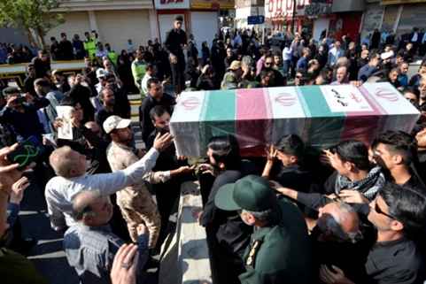
At least 14 individuals are at grave risk of execution in Iran in connection with the nationwide protests, including for acts not involving “intentional killing”, in violation of Iran’s obligations under international law. The authorities have violated their fair trial rights and subjected several to torture and other ill-treatment, including floggings, electric shocks, death threats, rape and other forms of sexual violence. Since December 2022, they have arbitrarily executed at least four young men in connection with protests following similarly grossly unfair trials. You can take action here.

AFGHANISTAN
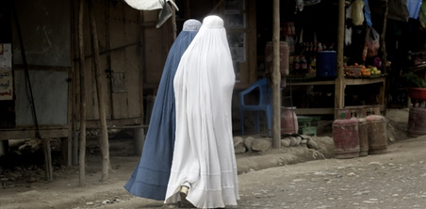
Tomorrow 20 March at 8:00pm to 9:00pm, the Banbury Amnesty Group are hosting a talk with Q&A on the dire human rights situation in Afghanistan and related current Amnesty campaigning. The talk will be given by Nigina Istanakzai-Zarifi, AIUK Country Coordinator for Afghanistan, who spoke at one of our meetings a few months ago. The meeting link is here.

RIGHT TO PROTEST
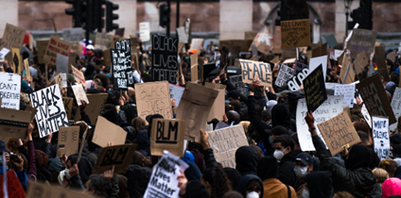
This Wednesday 22 March (while most people’s attention is likely to focus on Boris Johnson’s appearance before the Privileges Committee) MPs will look at Lords amendments to the Public Order Bill, which is now ping-ponging between the two Houses. In their most recent debates, peers voted to raise the rank required to authorise stop and search without suspicion to Chief Superintendent and remove intentional public nuisance as a criterion. Amnesty’s joint briefing signed by 74 different partners can still be found here.
UPCOMING EVENTS
20 March at 8:00pm: Talk on Afghanistan organised by Banbury Amnesty Group. See above for link.
21 March at 7:30pm: Kent Network online meeting about the Illegal Immigration Bill. Email me for a link.
3 April at 7:30pm: Maidstone, Medway and Swale Group meeting at the Maidstone Community Support Centre, 39-48 Marsham Street, Maidstone, ME14 1HH. Email victoria.gascoine@btinternet.com.
24 June from 10am to 5pm: Amnesty UK’s Annual General Meeting at the Human Rights Action Centre, 17-25 New Inn Yard, London EC2A 3EA, and online. Details to follow.

Graham Minter
graham.minter@amnesty.org.uk

