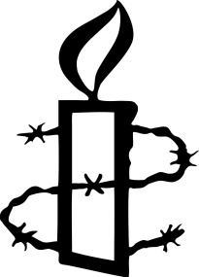

Mayfair and Soho Group

ACT OF WITNESS

Thursday 15 December 2022 at 7.00 pm, at Central YMCA, Great Russell Street WC1

Every day, all over the world, people are being imprisoned simply for protesting. People like Chow Hang-Tung in Hong Kong, seeking to remember Tiananmen Square, Vahid Afkari in Iran and Aleksandra Skochilenko in Russia, opposing the war in Ukraine. On 15 December the Mayfair and Soho Group will be remembering by name these and hundreds of other people who have suffered violence, imprisonment and other human rights abuses. Please sponsor us generously for the number of names we read, so that Amnesty can continue its vital campaigns for the victims of human rights violations throughout the world.

NAME AMOUNT

We have a justgiving page - http://www.justgiving.com/fundraising/Amnesty-Mayfair-and-Soho-Group1/
Please see www.amnesty.org.uk for our privacy notice.

