Amnesty International Blackheath & Greenwich
Group monthly meeting newsletter
Date & time: November 8th 2022, 7:30pm – 9:00pm
Location: Crypt at St Margaret’s Church, Lee Terrace, London SE13 5DL

- Introductions/welcome/apologies
Present: Graham (chair), Angela, Brigitte, Ann H, Roger, Tony, Ken, Tony (+ friend),
Anne F (newsletter writer), Tigony Phillips (AIUK Regional Coordinator, West & Central
Africa), JT (technical support)
Apologies: Rachel, David Wi, David We, Amanda, Jennifer

- Guest speaker - Human rights in west and central Africa
Graham welcomed Tigony Phillips - the only one on the West & Central Africa desk at the moment.
Tigony then gave a very informative presentation on the situation in two countries in West & Central Africa, namely Cameroon and CAR (Central African Republic). Her talk was accompanied by a series of illustrations on Power Point.

Cameroon
- Tigony focussed on Dorgelesse Nguessan (whose case is highlighted in the Write for Rights campaign). A lot of information on her case can be found in the Write for Rights campaign document. In December 2021, following her participation in a protest, Dorgelesse was sentenced to 5 years in prison.
- Future action: December 7th – there will be a demonstration outside the Cameroon embassy. Address: 84 Holland Park, London W11 3SB

Tigony then took questions. She was asked about the origins of the problems in Cameroon, and she stated that the roots of the problem could be traced back to colonialism.

Central African Republic (CAR)
- CAR gained independence in 1960 and since then has been in constant turmoil.
- There was a civil war in 2004.
- The rise of the rebel group Seleka has contributed to the problems, as well as fighting between Muslims and Christians.
- The violence has taken a huge toll on the population.
- The Russian Wagner group (notorious for its tactics) has been invited in to CAR by the current government.
- The problem is one of justice.

Very few countries in the region have properly functioning administrations, the exception being Senegal. Future campaigns will focus on the DRC and Sierra Leone.

The group thanked Tigony for her very interesting presentation.

- Country campaigns updates from Country Contacts
China/Hong Kong (Angela)
No change from last month. Chow Hang-tung, imprisoned after marking the anniversary of the massacre at Tianmen Square.
Action: Resend the letter previously circulated (possibility of having copies at the booksale too).

Central America (Roger)
Mexico
Ayotzinapa investigation flounders President Lopez Obrador’s first executive order was to create a commission to investigate the disappearance of the 43 students. The government’s eventual report disclosed that drug traffickers working with the police and the military had killed the students. Many arrest warrants followed. But the case is unravelling as the commission’s head admitted that much of the new evidence couldn’t be verified. Arrest warrants for military suspects were revoked and the lead prosecutor, who had gained the trust of the students’ families, resigned.
Guatemala
Updates on human rights in Guatemala published
The Washington Office on Latin America, an advocacy NGO for human rights (WOLA), has published three new reports on Guatemala.
The first highlights the assault on journalists and indigenous human rights defenders. https://tinyurl.com/yc8yhr7k
The second investigates the broken justice system. Twenty-five judges and prosecutors, including the nation’s lead anti-corruption prosecutor, have fled the country into exile. https://tinyurl.com/mrydjvth
The third report explains how all these elements combine in a downward spiral of the rule of law in the country. https://tinyurl.com/y7wv3x8p
Amnesty's Americas Regional Office will take part in COP27 through #livingsolutions, a tactical campaign focusing on taking action to respect the human rights of Indigenous peoples and rural communities.
Nicaragua
The OCHR issued a new report on Nicaragua and is concerned about the arbitrary detention of at least 195 people in connection with the socio-political crisis. Fifty of them were held around the 2021 presidential elections. Some were sentenced for up to 13 years’ imprisonment – in breach of the right to due process. At least 28 or 29 are still detained in reportedly inhuman conditions. https://tinyurl.com/whah9d84
Please share the following quote on Twitter or Facebook during Cop 27

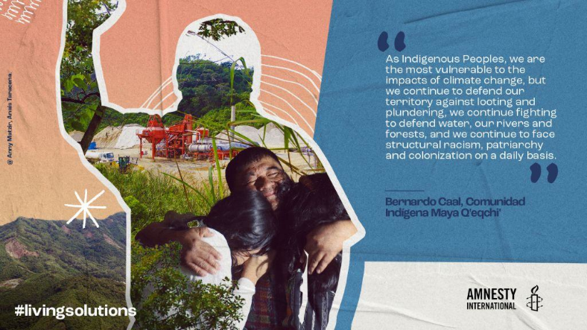
Iran (Graham)
Obviously Iran is very much in the news at the moment.
See this link – End the bloodshed in Iran now.
https://www.amnesty.org.uk/actions/embassy-iran-end-bloodshed-iran-now-LG

Action: Sign the petition on the website

Europe (Brigitte)
No updates

- AIUK matters (standing item)
AIUK November conference cancelled because of train strikes.

AIBG participation/representation at next AIUK AGM – the working group met and David Williams drew up a summary of the discussion: see below
Discussion covered the following:
Tony suggested emailing a questionnaire to all members for feedback.
Roger suggested checking the feeling of the group at the next meeting/AGM
Graham/Angela said that a nucleus of people was needed to commit themselves to AI meetings
Graham – hard to contact AIUK. Not much contact with or from country coordinators, esp on China and Iran. Cutting back on campaign materials sends a signal that they aren’t important.
Brigitte – we could/should contact other groups in London for their views.

Anti-racism network online launch is on Tuesday 15th November at 6:30pm, but this clashes with preparations for the booksale.
See this link for more info:
https://email.amnestyuk.org.uk/q/11mnhHOQ62gzuj5CrlQHXyY/wv

- Booksale Saturday 19th November 10 - 4pm
The group discussed the points on the agenda, mostly a reminder of what needs to be done and when.
Ann H has requested supporting materials, but they will only be general materials, no posters.
Angela & Brigitte will agree on which cases to promote on the day.
A rep from AIUK will attend, possibly two – Rosie C and David Blakeley

Preparing the church for the sale will happen on Tuesday 15th November.

- Future fundraising initiatives
(To go on the agenda for the next meeting)

- Arrangements for future meetings
AIBG AGM – Jan 2023 Please consider putting yourself forward for one of the roles

- AOB
All covered in the main part of the meeting

FUTURE EVENTS
Saturday 19th November 2022 – Booksale
Location: Church of the Ascension, Dartmouth Row, Blackheath, London SE10 8AN
Time: 10am to 4 pm
Tuesday 22nd November 2022 – Letter Writing
Location: The Greenwich Tavern, Dartmouth Row, Greenwich, London SE10 9JH
Time: 7:30pm – 9pm

Tuesday 13th December 2022 – December meeting
Location: Crypt at St Margaret’s Church, Lee Terrace, London SE13 5DL
Speaker: Daren Nair Subject: Hostage Diplomacy
(Anne F to chair)

Speakers/events tbc
Sotez Chowdhury, AIUK anti-racism network

NB The January 2023 meeting will be the AGM. All posts will become vacant, and we need people to stand.

