**Twitter storm with other Amnesty groups for Ahmed Mansoor’s 54th birthday on Saturday October 22nd 2022.**

Ahmed Mansoor is a human rights defender, an engineer, a poet, a writer, and a father of four. He was unjustly imprisoned for his human rights work, shining a light on the human rights abuses in the UAE. He has been in prison for 5 ½ years in solitary confinement. Prolonged solitary confinement is considered a Cruel, Inhumane and Degrading Treatment in International Law.

This Saturday, 22nd October, 2022, is Ahmed’s 54th birthday, and together with other Amnesty groups, we want to create a twitter storm, urging the UAE leaders to release Ahmed from solitary confinement. Please tweet and retweet on 22nd October around lunchtime.

Please compose your tweet and then upload one of Ahmed’s poems attached as images and in text-boxes below. If you have time to record yourself reading a poem that is even better.

Please use the following in writing your tweet: #FreeAhmed

**We call on:** @HHshkMohd @MohamedBinZayed @SaifBZayed

**in the** #UAE **to release** @Ahmed_Mansoor

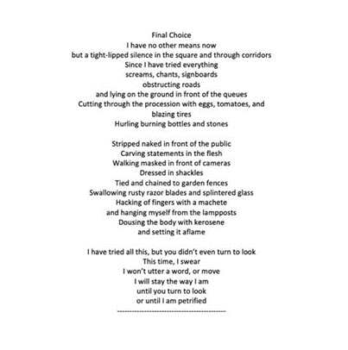

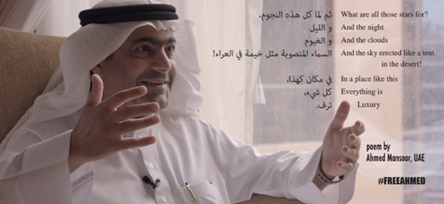

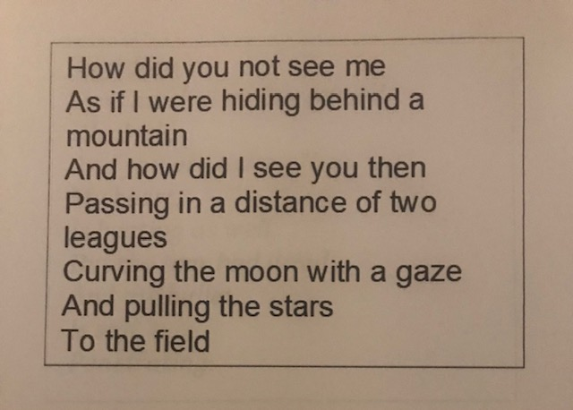

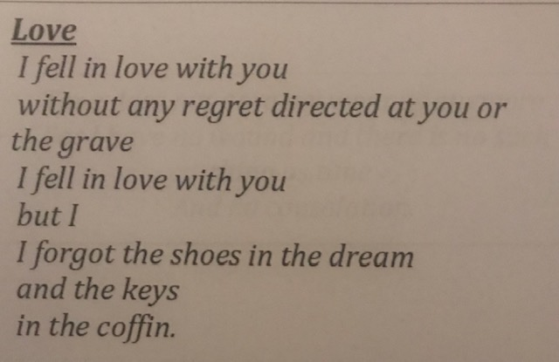

How did you not see me

As if I were hiding behind a mountain

And how did I see you then

Passing in a distance of two leagues

Curving the moon with a gaze

And pulling the stars

To the field

*Time does not gore my wounds anymore*

*For I have no wound and there is no such thing as time*

*And no consolation.*

***Boredom***

*How much time has passed,*

*Oh clock,*

*And you are ticking?!*

*My heart,*

*Is beating as well,*

*But the tear had dried*

*And the bullet,*

*Is still,*

*Penetrating.*

***Love***

*I fell in love with you*

*without any regret directed at you or the grave*

*I fell in love with you*

*but I*

*I forgot the shoes in the dream*

*and the keys*

*in the coffin.*

***Final Choice***

*I have no other means now*

*but a tight-lipped silence in the square and through corridors*

*Since I have tried everything*

*screams, chants, signboards*

*obstructing roads*

*and lying on the ground in front of the queues*

*Cutting through the procession with eggs, tomatoes, and*

*blazing tires*

*Hurling burning bottles and stones*

*Stripped naked in front of the public*

*Carving statements in the flesh*

*Walking masked in front of cameras*

*Dressed in shackles*

*Tied and chained to garden fences*

*Swallowing rusty razor blades and splintered glass*

*Hacking of fingers with a machete*

*and hanging myself from the lampposts*

*Dousing the body with kerosene*

*and setting it aflame*

*I have tried all this, but you didn’t even turn to look*

*This time, I swear*

*I won’t utter a word, or move*

*I will stay the way I am*

*until you turn to look*

*or until I am petrified*