Manchester Amnesty Refugee Month activities.

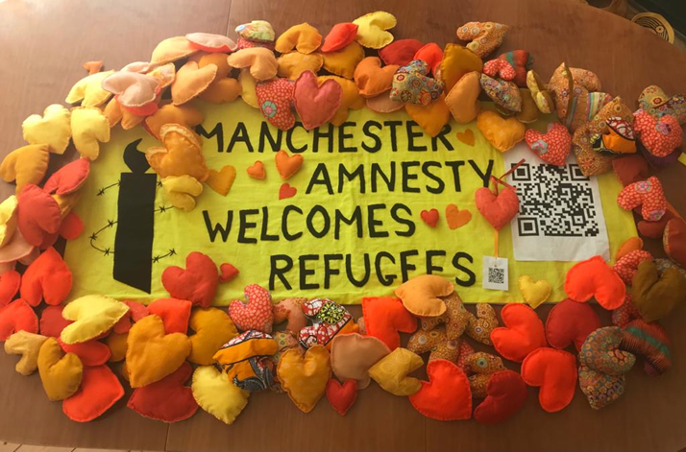

During May and June, in our Craftivism group and with the help of friends and family members, we made a large number of orange hearts from felt and scraps of material. Each heart bore a QR code linking to some information about our work standing up for the rights of refugees. We also made a banner saying Manchester Amnesty Welcomes Refugees, again bearing the QR code. The banner was displayed three times at various events during June, and the hearts tied up on trees and railings for people to find. One of the events we supported was an open garden fundraiser for Freedom for Torture, which was very successful this year. We had some lovely comments, and have enough orange hearts left over to distribute on a walk through the city centre in August.

