GROUP MEETINGS
Our next Group Meeting will be on Thursday 16thJune at 7.30 pm @Nora Street Community House, Howley, WA1 2JG

Plant and Book Sale in aid of Amnesty International
Held on Sat. 14th May
357 London Road, Appleton WA4 5HP
Thanks to Gill and Bryan for organizing, and hosting a plant and book sale in their driveway. It was particularly appreciated as they were due to fly to USA a few days later.
The magnificent sum of £358.71 was raised on the day and a generous donation of £100 was also received bringing the total to £458.71

MAY MEETING - ACTION AND DECISIONS
Nationality and Borders Bill
Jane’s letter to the Warrington Guardian about the Nationality and Borders bill was printed on 5th May.
A walk in the Park
Group members hope to have the first of our planned social events - a visit to the café in Walton Gardens and a walk to the Amnesty tree. This will be held on Friday 24th June, time to be arranged. If you would like to join us email me and I will confirm the time.
Members were emailed an action on the State of Emergency in El Salvador
Responding to reports of gang-related homicide the state of emergency was renewed and more than 25,000 people have been arrested and widespread human rights violations have been reported. Please sign the petition on line. El Salvador: Thousands of people detained arbitrarily and in extreme conditions. - Amnesty International.
The Balfour Project’s latest report - Copies were given out & also sent to Andy Carter MP.
Action for Nigeria
Members emailed the Embassy in London re.
Mubarak Bala, accused of blasphemy.
Members’ News
Jane shared articles on forced clearances of ‘firing zone’ villages in the West Bank and in El Salvador the sentencing of a woman to 30 years in prison for having a miscarriage.
Evelyn brought Asylum Link Merseyside’s illustrated newsletter summarising their work during 2021.

HUMAN RIGHTS DEFENDER RELEASED
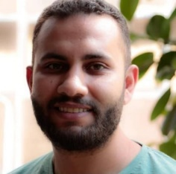
Human rights defender and researcher at the Egyptian Commission for Rights and Freedoms Ibrahim Ezz el-Din was released on 26 April 2022, after 34 months in arbitrary detention, stemming from his peaceful human rights work. He was neither tried nor charged but held pending investigations into baseless accusations of “membership in a terrorist group”. He was subjected to enforced disappearance for 167 days, during which time he said he was tortured and his health deteriorated. He was denied adequate specialized healthcare for his multiple health conditions. Amnesty International considered him to be a prisoner of conscience, detained solely for his human rights work.
His release follows sustained global interventions and public campaigning. Ibrahim Ezz el-Din said:
“My colleagues, defenders of human dignity and the right to a decent life. Throughout the almost three years I spent in prison, I felt that every day I was losing a part of my soul, and losing hope of returning to life again, to freedom. The only thing that enlightened my days and gave me hope was the news that people still remember me and demand my freedom. In the darkest moments of despair the news of the campaigns calling for my release was my only motivation to keep going and have hope. I would like to thank everyone who contributed to campaigning and defending me from inside and outside Egypt.
I especially thank Amnesty International employees and members: you were the rays of sun in pitch dark. Words of thanks cannot express my gratitude to all of you. Thank you.”

The Council of Europe Commissioner for Human Rights, called on Priti Patel not to extradite Julian Assange. 19 May 2022
Dear Home Secretary, I am writing to you regarding the case of Mr Julian Assange, since a decision will soon be made about his extradition to the United States. I wish to convey my views to you directly. I have been following the developments in Mr Assange’s case with great attention. In the judicial proceedings so far, the focus has mainly been on Mr Assange’s personal circumstances upon his possible extradition to the United States. While a very important matter, this also means, in my opinion, that the wider human rights implications of Mr Assange’s possible extradition, which reach far beyond his individual case, have not been adequately considered so far. In particular, it is my view that the indictment by the United States against Mr Assange raises important questions about the protection of those that publish classified information in the public interest, including information that exposes human rights violations. The broad and vague nature of the allegations against Mr Assange, and of the offences listed in the indictment, are troubling as many of them concern activities at the core of investigative journalism in Europe and beyond. Consequently, allowing Mr Assange’s extradition on this basis would have a chilling effect on media freedom, and could ultimately hamper the press in performing its task as purveyor of information and public watchdog in democratic societies. As I have previously stated, it is my position that, taking into account both these wider implications and the concerns raised by independent experts about Mr Assange’s treatment upon extradition, the government of the United Kingdom should not allow his extradition to the United States. I therefore call upon you to decide against the extradition of Mr Assange.

THAER KHALIL MOHAMMAD MASLAT
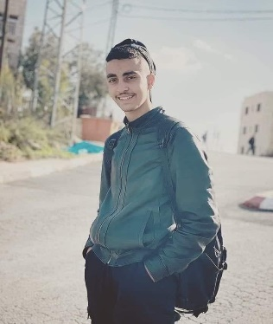
– On 11th May, the same day Israeli forces shot and killed journalist Shireen Abu Aqla —an Israeli soldier shot 16-year-old Thaer Khalil Mohammad Maslat (pictured) with live ammunition in the chest in the occupied West Bank city of Al-Bireh. Thaer was watching confrontations between Israeli forces and Palestinian youth just after leaving school for the day a few hundred meters away.
Thaer left school after his second class due to a teachers' strike. He and a friend approached an area about 200 meters (656 feet) away from the school where the confrontations were taking place. At least 12 Israeli soldiers were deployed nearby. Thaer arrived and stood next to a building watching the confrontations when an Israeli soldier shot him in the chest with live ammunition. Thaer did not pose any threat to Israeli forces when he was shot, according to information collected by DCIP.

Palestinian children should be able to safely attend school without fear of violence at the hands of Israeli forces. Instead, Israeli forces regularly deploy in or near schools, attacking Palestinian children and putting education under attack.

