Dates for your diary | Wednesday 8 June 2022, 17:30: No place like home: launch of the new Amnesty report on homelessness in England  Thursday 9 June, 19:30: Sanaa Seif discusses Alla Abdel Fattah, Brighton (in-person)  20 - 26 June 2022: Refugee Week  Saturday 25 June 2022 UK: Amnesty AGM (hybrid: online and in-person)

Dear writers

Local events
We hope to have a PUMBLE later this summer - watch this space!

Other events
Wednesday 08/06/2022, 17:30 No place like home: the impact of homelessness on human rights in England
- Join Amnesty for the launch of Amnesty International's new report on homelessness in England.
- For too long, homelessness in England has been explained as the failure of the individual to cope with the stresses and strains of life. Amnesty International's latest report highlights homelessness for what it is: a failure of the state to guarantee equality of opportunity, equal access to essential services to all and to ensure that no one is left behind. Amnesty’s new research highlights the key policies which have resulted in thousands of people being denied housing and finds that attempts to ration a severe shortfall in adequate, affordable housing is shutting people out of the system and leaving them destitute without any access to the scarce provision.
- Join members in London and the South-East for a lively discussion with a panel of researchers and people affected by homelessness, about why homelessness needs to be recognized as a human rights violation and how we can change the policies and practices that prevent people from accessing a safe and secure home.
- Speakers and timings to be announced. Light refreshments provided.
- Amnesty will be live streaming parts of the event for organisations and individuals based outside of London.
- Sign up to secure your place either in person or via the live stream: https://www.eventbrite.co.uk/e/no-place-like-home-the-impact-of-homelessness-on-human-rights-in-england-tickets-338001891757
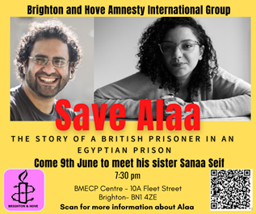
Thursday 09/06/2022, 19:30 Save Alaa: the story of a British prisoner in an Egyptian prison. The Brighton and Hove Amnesty Group host Sanaa Seif, sister of imprisoned British-Egyptian activist Alaa Abdel Fattah, for an in-person meeting. We are currently taking action for Alaa; his sister Sanaa is an activist and film-maker who is also a former political detainee in Egypt.
- If you are interested in attending, please contact Andrew Rose from the Brighton & Hove Group, here brightonandhoveai@gmail.com

Saturday 18/06/2022 Concert, Regis School of Music. Raising funds for Bognor Music Club, this is a concert by friends of Amnesty Rebecca, Steph, Charlie and Peter. Rebecca advises that this will be a repeat programme, for those of you who were unable to attend the February Concert for Amnesty in Chichester.

Sat 25/06/2022 10:00 - 18:00 2022 Annual General Meeting of Amnesty International United Kingdom Section
- This year's Annual General Meeting (AGM) will be held as a hybrid meeting on Saturday 25 June, at the Human Rights Action Centre (HRAC) in London at 17-25 New Inn Yard, London EC2A 3EA; it will however be primarily held virtually because there are a limited number of spaces available to join in-person.
- Information about attending can be found on the Amnesty website
- Save the date: practice run for online attendees. On Thursday 16/06/2022 between 18:00-19:00, Amnesty UK are holding a practice run to give you an opportunity to practice logging into the online AGM. The IT Team will be available to assist with any technical issue and answer any questions you have regarding joining the virtual meeting.

20/06/2022 - 26/06/2022: Refugee Week. The theme of this year’s Refugee Week is “Healing”. https://refugeeweek.org.uk/theme-of-refugee-week-2022-healing/
- Nearer the date, please check the Events Calendar for events taking place near to you.
- If you are involved in a local event and would like to share it with other Amnesty members, please let me know and we can promote the event in the next Group newsletter!
Carry on writing!
Bob Dewick, Amnesty

40 years as Group Secretary!
Group Chair Kath Shakespeare writes: Bob has been our Group Secretary for 40 years: I am not sure if this is the longest time that anyone has held a position in post around the Amnesty Groups in the UK, but it must be close to that record, and an amazing achievement. Bob has been the single constant hub around which the group has revolved, as other committee members have come and gone over the years: no mean achievement! I wrote a short tribute to Bob which I have sent to the Amnesty Groups magazine: I hope that this will be included so that we can share this great anniversary with other UK Groups. As always, I don’t know how much of my proposed copy will be used, so wanted to share the full text with the Group.

Bob Dewick celebrated 40 years as Group Secretary to the Bognor Regis, Chichester & District Group this year. His service as Group Secretary, friend, dispenser of facts and teller of (mainly terrible) jokes was celebrated by his fellow committee members at the 2022 Group AGM with a card and voucher for local independent brewery, following his re-election to the post and the start of his 41st year. As well as recording our discussions, organising our in-person meetings and updating us on the latest organisational requirements, Bob bravely volunteers each year to research the route and venue of our annual Pumble (Pub-Ramble): it's a tough job, but someone has to do it! Bob is also always game for activist action and has - over the years - worn a Guantanamo jumpsuit in chains, been a funeral director for our Pinochet/coffin demo, been a (very convincing) Grim Reaper against the arms trade and been imprisoned and has imprisoned others in numerous bamboo-cane cages.

We salute Bob for his long service and his outstanding support in the defence of human rights over the last 40 years.
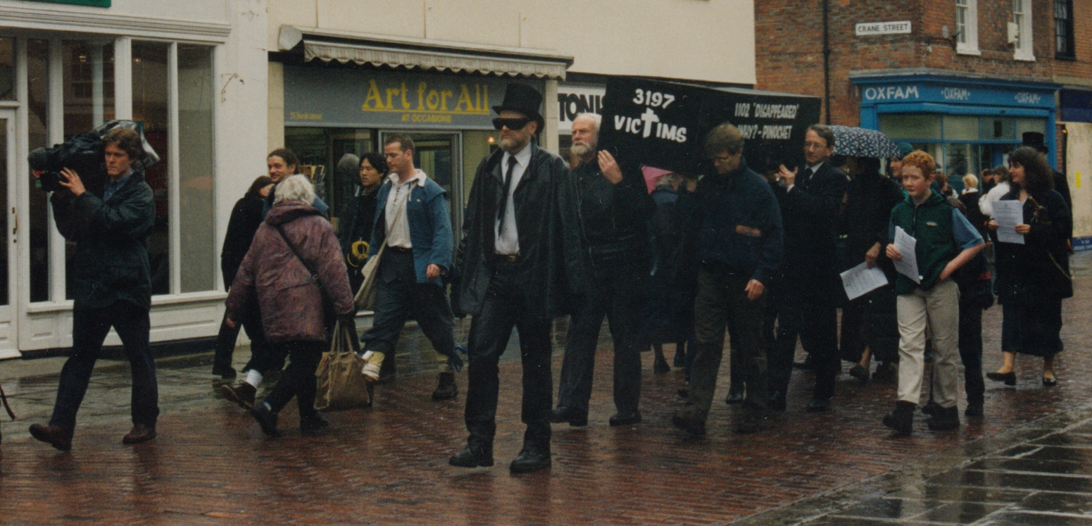
Bob in top hat leads the Pinochet Coffin demo, Chichester, 1999
Bob (second right) and group members, Guantanamo demo 2006
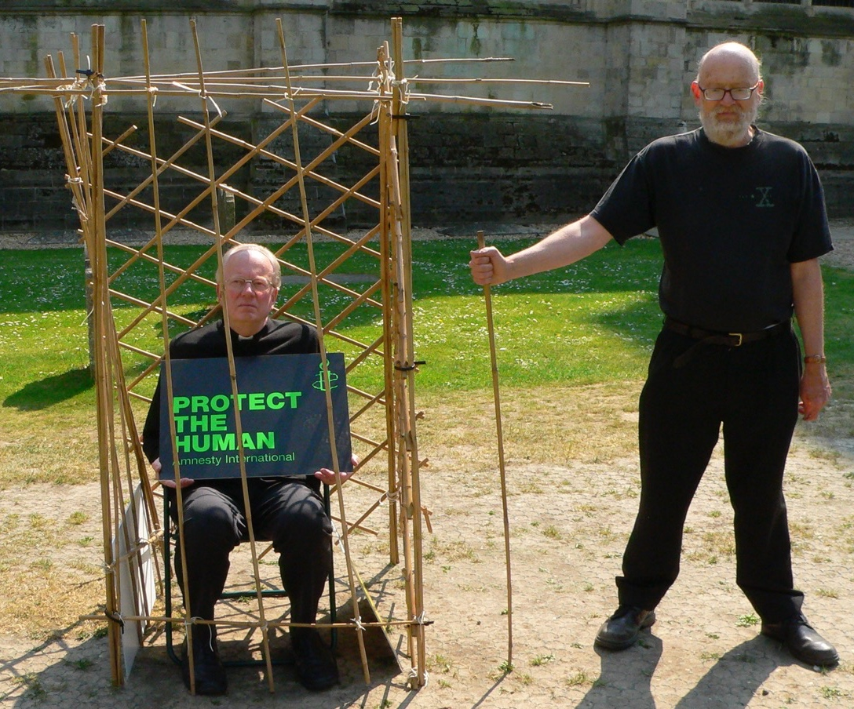
Cage at the Cathedral, 2011. Bob overseeing Dean Nicholas of the Cathedral
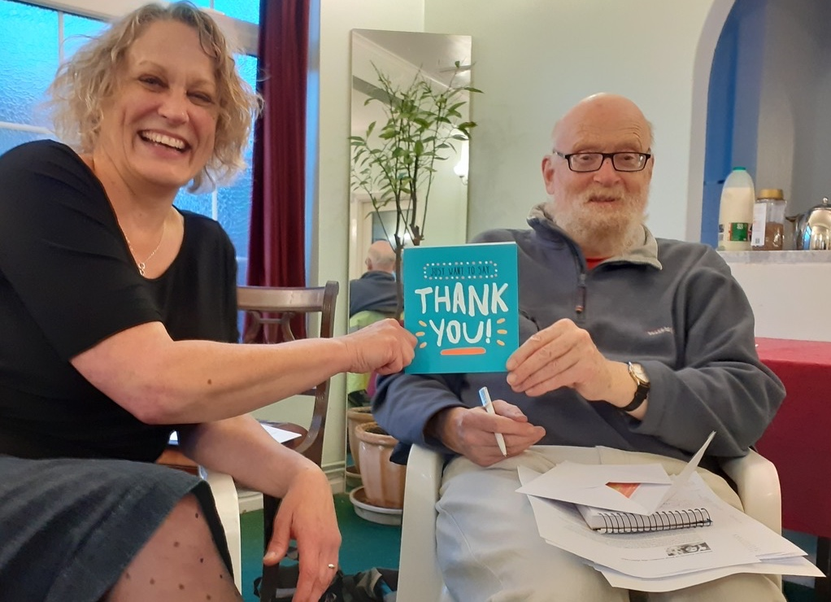
Bob receiving his "thank you" card, 2022

I have also put a copy of this on our Group website

Amnesty Action: campaigns & letter-writing

Egypt update from Margaret, our Campaign Co-ordinator

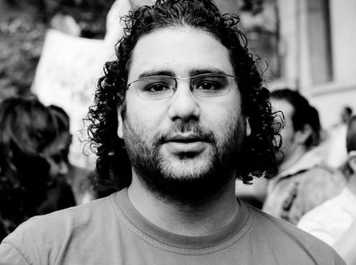
Alaa Abdel Fattah
Having agreed to adopt the case of Alaa Abdel Fattah, following the release of Ibrahim Ezz El-Din, we have immediately been plunged into urgent appeals for action, as a result of his desperate situation. He is now nearly 60 days into a hunger strike in protest against the conditions in which he is being held, so his situation is critical. His sisters, Mona and Sanaa (for whom we campaigned when she was detained because of lodging complaints about Alaa’s treatment) are working tirelessly to highlight his case and obtain his release before it is too late. He has recently been granted UK citizenship but, in spite of this, he has been denied consular visits. His family are campaigning urgently to engage the support of the Foreign Secretary on behalf of the UK government, in order to obtain his release or possibly deportation to the UK. We have also been emailed by Andrew Rose of the Brighton & Hove group to inform us of a second presentation by his sister, Sanaa Seif, at the next Brighton Amnesty meeting on 9 June: details for booking and venue can be found in the Other Events section, on page 1.

At a Zoom meeting on 19 May, his sister Mona and cousin Omar spoke passionately about the injustice and cruelty he has experienced and appealed to Amnesty members, urging them to appeal to the Foreign Secretary to raise his case with the Egyptian President.
- This has been emailed to all members so, if you have not yet responded, please do so if you can as it is now a critical moment for him.
- You can either click on the link for the online petition below: https://docs.google.com/forms/d/e/1FAIpQLSdIqWFlmB8AD04YQFJJb8Bb437cZF-MEKmteg_B-MZeqiQAYg/viewform (Alaa's family is circulating a letter to Foreign Secretary Liz Truss and United States Secretary of State Anthony Blinken, for signature. Please sign this online petition in an individual capacity, rather than as an Amnesty member).
- and/or send the following template message to the Foreign Secretary.

To: Foreign Secretary, Liz Truss fcdo.correspondence@fcdo.gov.uk

Dear Foreign Secretary

I am writing to you, as an Amnesty member, to draw your attention to the desperate plight of Alaa Abdel Fattah, a leading Egyptian intellectual and political thinker, who, until very recently, has been held in dire conditions in Tora Maximum Security prison in Cairo, simply because of his outspoken criticism of the Egyptian regime. I am sure that, as Foreign Secretary, you will wish to defend the rights of UK nationals currently held as prisoners of conscience and to support the campaign for his release led by a cross-party letter group of 10 MPs and 17 peers concerned about his case. An online petition signed by a wide variety of internationally recognised writers and human rights organisations is being circulated in support of the call for his freedom. As a result of international pressure, he has been moved from Tora Prison to another jail with better medical facilities. This is a promising sign that this might be a moment to effect improvement in his case.

Alaa is an award-winning author whose essays have recently been published in a collection entitled You Have Not Yet Been Defeated. For two and a half years he has been imprisoned in inhumane conditions, which not only breach international legal standards, but are also in direct contravention of Egyptian law. Until the last few weeks, he has been held in a cramped, insanitary cell, denied the right to leave his cell even for fresh air, sun light and exercise, not allowed books or radio or personal possessions and even deprived of bed or mattress to sleep on. He has also been restricted to one family visit per month, for twenty minutes without physical contact or privacy. A further abuse of his legal rights is the continued refusal of the authorities to allow consular access since he was granted UK citizenship. This is an act of defiance against the authority of the UK Government.

In protest against his treatment, he has launched a hunger strike to force the authorities to acknowledge this injustice and is now in critical condition after nearly 60 days into his hunger strike. You may have heard his sister speaking about his desperate situation on the BBC Today programme on 24 May and at a meeting chaired by Andrew Marr at the Frontline Club. In addition to the physical assaults he has endured while in prison, he has not received medical treatment and is now in a very weak state. This is a critical time and could result in the death of an innocent man, unjustly imprisoned simply for sharing a blog which highlighted the death of another prisoner in an Egyptian jail.

I call upon you to insist on his right to consular visits; to point out that Egypt is not only breaching international law but its own legal code; and to ask that he be allowed to leave Egypt and come to the UK. You will be aware that Egypt and the UK are joint partners organising the COP27 conference, so the UK could exert considerable influence on Egypt, reminding President al-Sisi of the damage to his international reputation if he persists in persecuting a renowned political writer and thinker. I urge you to take action immediately before it is too late.

Yours sincerely

Future Actions: Given the urgent situation Alaa is in, we are likely to receive urgent actions in between your regular Amnesty Group newsletter: so we will send these by email separately, as they are sent to us.

Ibrahim Ezz El-Din
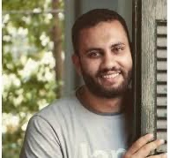
Last month I was delighted to report the release of housing activist Ibrahim Ezz El-Din. Thanks to all of you who took action on his behalf. We are very pleased to hear that he is enjoying his freedom and to pass on his direct thanks to all who campaigned for his release. Here is a short extract from his message to Amnesty members:
“Throughout the almost three years I spent in prison, I felt that every day I was losing a part of my soul, and losing hope of returning to life again, to freedom. The only thing that enlightened my days and gave me hope was the news I was receiving that people still remember me and demand my freedom. In the darkest moments of despair that I lived inside prison, the news of the campaigns calling for my release was my only motivation to keep going and have hope. I would like to thank everyone who contributed to campaigning and defending me from inside and outside Egypt. I especially thank Amnesty International, and all its employees and members: you were the rays of sun in pitch dark. Words of thanks cannot express my gratitude to all of you. We need to keep talking about the detainees, as it will give them hope of escaping the injustice inflicted upon them. Thank you all.”

His case is an inspiring example of how our actions produce results – so, please, keep on writing!

Want to do more?
We have also been asked to support two actions in support of: Idris Hasan and Mohamed Benhlima

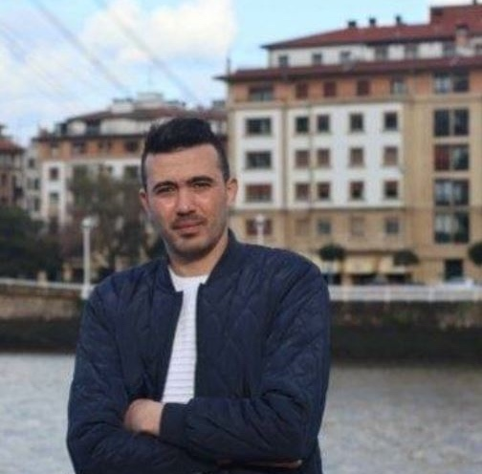
Mohamed Benhlima
Mohamed Benhlima is an activist, former military official and whistle-blower who exposed the corruption of high-ranking Algerian military officials online. Mohamed left Algeria in 2019 and sought asylum in Spain, but the Spanish authorities returned him to Algeria in March 2022 without due process or evaluation of his asylum claim. On his return he was sentenced to death in absentia on charges of espionage and desertion.
- Please use the link below to send an email appeal for his pardon and release. https://www.amnesty.org.uk/urgent-actions/quash-whistleblowers-death-sentence

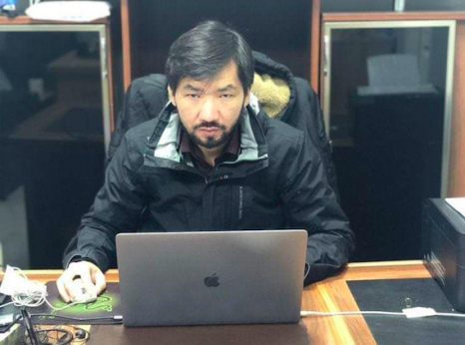
Idris Hasan
Idris Hasan is a Uyghur Muslim Chinese national, held in Morocco and currently threatened with deportation to China and almost certain detention and ill treatment.
- Please use this template message to send to the Moroccan embassy, for forwarding to the Moroccan government.

To: His Excellency Mr Abdesselam Aboudra ambalondres@maec.gov.ma

Please forward to:
Head of Moroccan Government
Mr. Aziz Akhannouch
Palais
Royal Touarga,
Rabat 10070, Morocco

Your Excellency

I am writing to express my grave concern for Idris Hasan (official name Yidiresi Aishan), a Uyghur Muslim Chinese national, who was arrested on the night of 19 July 2021 at Casablanca airport on the basis of an Interpol red notice issued at the request of the Chinese authorities. He was subsequently taken to a prison near the town of Tiflet, in northwestern Morocco.

The Chinese government reportedly considers him to be a “terrorist”, because of the work he had previously done for Uyghur organizations and requested Idris Hasan’s extradition based on an extradition treaty China signed with Morocco in 2016. Chinese law defines “terrorism” and “extremism” in an overly broad and vague manner which has been used to persecute Uyghurs and other Muslim ethnic minorities.

There is detailed testimonial and documentary evidence that the Chinese government has committed crimes against humanity of imprisonment, torture and persecution against Uyghurs and other predominantly Muslim ethnic minorities in Xinjiang on the basis of their religion and ethnicity.

If extradited to China, Idris Hasan will be at real risk of arbitrary detention and torture and his extradition would violate Morocco’s obligations under international law. I therefore urge you to cancel Idris Hasan’s extradition to China immediately.

Yours sincerely

