Are you 16-17* years of age?
Want to meet new people, have your views heard and share what matters most to you and other young people?
Join the Board of Amnesty International UK (AIUK) to help us stand up against unfairness and defend human rights for everyone.
Thank you for your interest in becoming a Board member at Amnesty International UK (AIUK). Young people are central to our work and helping us defend human rights now and in the future. We are keen to encourage as many young people as possible from all different backgrounds to get involved and support our work.
In this pack you will find:
- Information about Amnesty
- Young Board member role description
- Information about how to apply
Nomination Papers and Applications Forms must be finished and with us no later than 5pm on Friday 25 March 2022.
If you have any queries about your application or need additional information or help, please contact returningofficer@amnesty.org.uk.
Help us protect Human Rights around the world.
What are Human Rights? Have a look at our film that explains them here. Human rights are about a shared respect that helps us to create a better community, school, and world together.
Why become a Board Member?
By joining the AIUK Board, you’ll become part of a group of people who believe that human rights and making sure everyone has them is very important. You will share what matters most to you, other young people and be happy to influence and shape our work and what we do. Being a board member is a great way to contribute to a cause that you feel passionately about.
Becoming a Board member is a big commitment, but also very rewarding too. You will get to:
- Meet new people who also want to make a difference.
- Take part in new opportunities and experiences.
- Learn and develop new skills.
About Amnesty International UK
Amnesty International works to protect people wherever justice, freedom, truth, and dignity are denied. We work globally and are the world’s largest grassroots human rights organisation. We have received the Nobel Peace Prize for our life-saving work.

Amnesty International UK Section is one of sixty national bodies that make up the worldwide organisation. We help expose and draw attention to abuses in the UK and around the world, we educate, encourage the public and help to transform societies to create a safer, more just world.
As a Board member of AIUK, you will be expected to play a full role in our board, you will be jointly responsible for making sure we deliver our Vision, Mission, Role and Strategy.
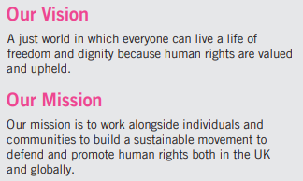
Our work falls into three strategic goals and six priority issues.
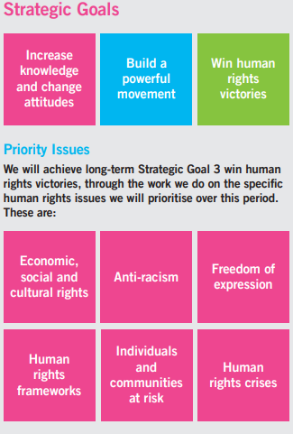

Board member/Director Role Description (16-17 years):
Role: This is a voluntary role, part-time for three years, with a commitment to attend ten meetings a year, roughly four hours a month.
Expectation and commitment needed:
- Being in the role for three years.
- Committed to attending 5 Board meetings over the year which normally happen on a Saturday at our office in Shoreditch, London.
- Willingness to travel throughout the UK, this might include an overnight stay and some evening commitments.
- Attendance at AIUK’s Annual General Meetings (held in June, various locations)
- Join one of our sub-committees (a group that works on a specific area of or theme). Approximately four additional meetings throughout the year, also held in the London offices.
- Take part in training and mentoring to support you in your role.
- There is always a lot of reading to do for Board meetings. It is your responsibility to prepare for each meeting, which means reading all the documents in advance so you can join in discussions and share your view.
What Skills and qualities will you need?
- Be aged 16 – 17* Years (we will need to see proof of your age if you are successful)
- Passionate and enthusiastic about Human Rights and raising the views and ideas of children and young people in Amnesty International UK.
- Make decisions and act in the best interests of AIUK.
- Make sure AIUK priorities and strategy are delivered on time and to budget.
- Monitor AIUK money to make sure we stay in good financial health.
- Have critical thinking skills – make sense of information, be able to explore and compare.
- Happy to share your views and ideas with Board members, trustees, and staff.
- Champion the voice of young people.
- Consider and challenge ideas in a fair and balanced way.
- Respect the views and ideas of others.
- Excellent listening and communication skills. You will make a positive contribution to discussions.
What are the benefits to taking part?
- You will be able to directly influence the work of AIUK
- Make a difference to human rights and the impact this has on children and young people.
- Meet new people, learn new skills, and develop your experience of working in a not-for-profit company.
- Gain experience to help you in your future and career.
What does it cost?
The Board member role is a voluntary one. Travel costs, hotels, and food to attend meetings will be paid.
You don’t need to have any previous experience of being on a Board, but you must have been a member of Amnesty for at least six months. Don’t worry if you’re not a member you can join here it costs £12 a year and we would love to have you involved in future opportunities.
What support will I get?
We recognise that this might be the first time you have ever sat on a Board and become a Board Director. We have lots of support available to help you in your role and throughout your time on the Board, including:
- A full induction so you understand your role, responsibilities, the work of the Board and Amnesty International UK.
- A mentor. Your mentor will hold regular update and support meetings with you to make sure that you are enjoying your role as Board member and have the support you need to do your role.
- Training and support so you feel equipped to undertake your role.
Safeguarding
AIUK believes all children should grow, develop, and thrive in a safe, caring environment. Protecting children from abuse is an integral part of our work. As a Board member we have a responsibility to protect you and other young people we work with. We will share our Safeguarding and complaint policy with you during your support meeting if you are successful in getting a place.
Background checks DBS
All Board members/Directors at AIUK must complete a ‘Disclosure and Barring Service’ (DBS). This service does a background check to see if you have a criminal record that might stop you taking on this role. AIUK is committed to the protection of children and young people, keeping them safe and looking after their welfare.
You can still apply if you have a criminal record, but we will need to talk to you and ask some additional questions to understand if it would discount you from being a Board member/Director.
How to apply
The first step is to fill out the application form so we can find out a bit more about you, why you want to apply and what you think you can bring to the role of Board member.
You will be applying for a reserved seat. There has been a seat saved for a young person 16 – 17 years. To stand for election to the Board you need get other Amnesty UK members to nominate you. To be put forward you must get 10 votes.
- By a Local Group (automatically gets you 10 votes).
- By a Student or Youth Group (automatically gets you 10 votes).
- By an Affiliate Member (automatically gets you 10 votes); or 5
- By ten Individual or Family Members (each Individual or Family Member gets you 1 vote).
You will need to get those voting for you to complete the Nomination papers form to show that the support your nomination. If you would like some help with this, just contact us on the email below.
We will need a parent/carer signature to confirm that they are happy for you to be a Board member and that they understand the time commitment to you being involved.
Nomination Papers and Applications Forms must be finished and with us no later than 5pm on Friday 25 March 2022.
If you have any queries about your application or need additional information or help, please contact returningofficer@amnesty.org.uk.

