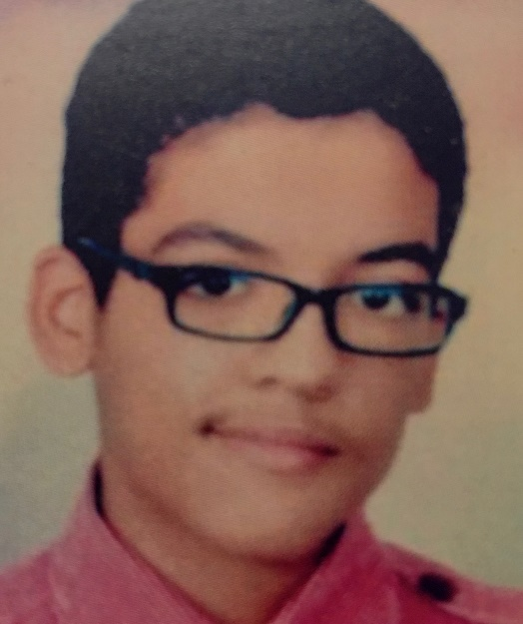
TEENAGER TORTURED AND IMPRISONED
EGYPT: ASER MOHAMED
Aser Mohamed was arrested in 2016 when he was just 14 years old, and subjected to enforced disappearance. Aser reports that he was subjected to torture in detention to force him to “confess” and he was placed in pre-trial detention, despite this being banned in Egypt for children under 15.
Aser faced a range of charges, including being a member of the banned Muslim brotherhood group and attacking a hotel on the basis of confessions made by the teenager under torture. In October 2019 Aser was sentenced to 10 years in prison.
On 12 January 2016 armed police and National Security Agency (NSA) officers raided 14-year-old Aser Mohamed’s home. Agents said they were taking him away for brief questioning, but he was gone for 34 days, during which nobody knew where he was or why he had been taken.
On 15 February Aser Mohamed appeared before the Supreme State Security Prosecution in New Cairo for questioning without his lawyer. The prosecutor charged Aser Mohamed with belonging to the Muslim Brotherhood and participating in a hotel attach on 7 January 2016. When Aser denied the charges, he alleged that the prosecutor responded: “It seems that you want to go back to the electric shocks again”, indicating that the prosecutor knew Aser Mohamed had been subjected to electric shocks torture in detention by the NSA to force him to ‘confess’. The prosecutor took no action to investigate or hold those responsible for torture to account.
Aser was held in pre-trial detention, even though this is banned for children under he age of 15. His trial began in August 2016, and after repeated postponements he was convicted and sentenced in October 2019.

Aser’s lawyer filed a cassation request to the criminal court and the first hearing was scheduled for 21st November 2021.
Amnesty International has called for the quashing of his sentence given the gross violations of his rights to a fair trial, including the use of confessions extracted under torture evidence against him.
Aser has spent nearly a quarter of his life in prison. He has been in prison for the equivalent of his GCSE and A level years, and his first year at university.
Aser suffers from a chronic allergy that causes respiratory difficulties, which puts him at particular risk of severe Covid-19 according to the World Health Organisation’s list of vulnerable groups.
We are calling for Aser’s conviction to be quashed, his immediate release and an investigation into his enforced disappearance and torture allegations.
TAKE ACTION:
Please write to the Egyptian Ambassador calling for Aser Mohammed’s release.

TEMPLATE LETTER

Tarek Ahmed Ibrahim Adel,
Egyptian Ambassador,
Embassy of the Arab Republic of Egypt,
26 South street
London
WIK 1DW

Your Excellency,
Case of Aser Mohamed
I understand that the ten year sentence imposed on Aser Mohamed is to be reviewed by the Court of Cassation.

I believe that Aser Mohamed has been unjustly sentenced to 10 years in prison on the basis of evidence obtained under torture when he was a child and I call on the Egyptian authorities to quash Aser's conviction and release him and launch an investigation into his enforced disappearance (for some 34 days) when he was just 14 years of age and torture allegations.

Pending his release Aser should be provided with the means to communicate with his family and lawyers and the authorities should take measures to protect Aser’s heath. Aser suffers from a chronic allergy that causes respiratory difficulties which puts him at particular risk of Covid 19 according to the World Health Organisation’s list of vulnerable groups.

I look forward to hearing from you further.

Yours faithfully and sincerely

