CUBA news 6th Nov 2021
- Rejection of request to protest is yet another example of intolerance of freedom of expression Amnesty press release Oct 22
In light of the Cuban government’s negative response to requests from civil society to hold a Civic March for Change, planned for 15 November, to call for the release of activists detained for exercising their rights, including following the historic protests of 11 July, as well for human rights to be respected and for differences to be resolved through dialogue, Erika Guevara-Rosas, Americas director at Amnesty International, said:
“Groups of people from various provinces around the country have been submitting requests in recent weeks to different local governments asking for authorization to carry out peaceful marches, organized in a clearly defined way in a legitimate exercise of their right to freedom of expression. Instead of guaranteeing these rights, President Miguel Díaz-Canel’s government has declared these civil society marches ‘illegal’ and ‘unconstitutional’, once again violating the right to peaceful protest in Cuba.” Read more: https://www.amnesty.org/en/latest/news/2021/10/cuba-rejection-request-protest-another-example-intolerance-freedom-expression/
ACTION - If you use social media, please spread this message on 15th November, the day of the Civic March for Change:
Peaceful protest must be allowed in #Cuba! All those still held after previous protests must be released now @DiazCanelB @AICaribbean @AIUK_NAMCAR @AmnestyUK #15NCuba

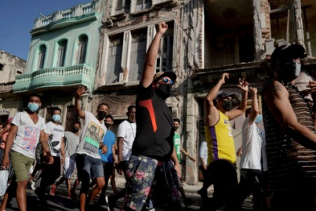 Havana, Cuba July 11, 2021. REUTERS/Alexandre Meneghini
- Cuba approves laws granting greater rights as criticism of protesters' arrests heats up
HAVANA, Oct 28 (Reuters) - Cuba's National Assembly on Thursday approved a raft of laws broadening citizens' legal rights even as the Communist-run country comes under fire at home and abroad for a crackdown on protests earlier this year.
The changes stem from the 2019 constitution, which required reforms to modernize Cuba's judicial and penal codes. But they address legal voids identified by activists, who allege authorities flaunted due process following unprecedented protests on the island in July.
Cuban lawmakers and judges said the new laws increase protection for those accused of a crime and should improve transparency. They require, for example, defendants be notified of potential charges against them, and that those detained be granted the right to an attorney within 24 hours.
Citizens will also be allowed access to their own court files and documents, according to the new law. Read more: https://www.reuters.com/world/americas/cuba-approves-laws-granting-greater-rights-criticism-protesters-arrests-heats-up-2021-10-28/

- Wendy Morton MP, Minister for Europe & Americas at the Foreign, Commonwealth & Development Office, tweeted this on 4th November:
Enjoyable meeting with Cuban Minister for Tourism @JuanCarlosGG. I heard about Cuba’s plans to reopen fully to tourists later this month, and raised important human rights concerns. GB looks forward to continuing work with Cuba to build partnerships and advance opportunities.

- WASHINGTON, Nov 5 (Reuters) - The White House has received recommendations for restarting remittances to Cuba but sent some back for further work to craft "innovative options" to ensure that money sent by Cuban Americans to families on the island does not fall into the hands of Cuba's government, a senior U.S. official said on Friday. Read more:
https://www.reuters.com/world/americas/biden-policy-cuba-remittances-needs-more-work-us-official-2021-11-05/

sue.bingham@amnesty.org.uk

