
Amnesty International

Blackheath and Greenwich

Newsletter

NOVEMBER 2021

Group Meeting Tuesday, 09.11.2021

- Introductions, Apologies, appointment of Newsletter Writer.
Present:
Amanda
Angela
Ann H
Anne F
Brigitte
David Wi
Geoff
Graham
Illona
Ken
Marcia
Nancy
Rachel
Roger

Apologies:
David We
Dee
Melanie
Olwen

Roger volunteered to be Newsletter writer. Introductions took place after the arrival of tonight’s speaker.

2. Marie-France Nguo gave an overview of the situation in the vast region that is West and Central Africa.
Nigeria Boku Harum are still kidnapping children and women in the NE of the country. This should be classified as a war crime. During Covid there has been an increase in gender based violence. Better news is that the government is seeking to abolish the death penalty. Action is for Imoleayo Adeyeum Michael. His case is featured in this year’s Write for Rights.
Sierra Leone Excessive force is being used against peaceful protests eg LGBT demos. Too many girls are not in school but the good news is that 3 months ago they abolished the death penalty.
Armed conflict continues in Burkina Faso.
Senegal Peaceful demos are repressed. 8 people died at a recent one.
Central African Republic War crimes are being commited by armed rebel groups. The death penalty has not been abolished but there have been no executions for 10 years.
Burundi Sexual violence used but Prisoner of Conscience Germain Rukuki has been released. He featured in last year’s Write for Rights campaign.
Rwanda Unfair trials and use of excessive force continues. We took action last month for Paul Rusesabagina.
Marie-France’s home country is The Democratic Republic of Congo which suffers from weak government with corruption common. The government signs up to international treaties but does nothing to implement them. It is believed to be the world capital of violence against women. It contains the second largest forest in the world after the Amazon but indigenous groups living there suffer from violence and displacement from various armed rebel groups. The DRC is the world’s largest source of cobalt used in batteries for electric cars, computers and mobile phones etc. Infrastructure projects are all to facilitate its extraction by multi nationals and little of the vast profits remain in the country and none trickle down to the population at large. Child labour is used in the mines. Covid has exacerbated problems of security and food shortages.

This wide ranging report prompted a strong response. There was a general feeling that more pressure should be put on companies involved in cobalt mining as there is a high level of involvement from the UK and the USA. The UK has passed the modern slavery act which could help to challenge companies profiting from child labour. Companies are required to produce environmental, social, and corporate governance reports (ESG) which can influence investors. We should lobby MPs and the All Party Parliamentary Group for Africa.
Marie-France suggested that priorities should be Rwanda and The Democratic Republic of Congo. She was warmly thanked for her highly informative presentation. Marie-France offered to return to provide more detailed information on a particular country or issue.

3. Donation to AIUK. The treasurer’s recommendation that we donate £4,500 to AIUK from the proceeds of the recent book sale was unanimously approved. Brigitte has received a donation of £25 from her theatre group.

4. Blueprint for All. BAME Forum 28 October 2021.
Roger reported on the meeting he attended.
Blueprint for All used to be known as The Stephen Lawrence Trust. I don’t know why the name was changed. Their main purpose is to support young ethnic minority people through mentoring and scholarships. It is quite a large organisation and the Lewisham BAME forum is a small part of what they do.
The Forum is open to any organisation in Lewisham and is an opportunity for them to explain and publicise what they do. Quite a wide range of groups attend ranging from those concerned with health issues in the community to some offering assistance to local entrepreneurs.
I had a 10 minute slot which was a bit short. I gave a brief background to Amnesty stressing its international aspects and then concentrated on AIBG, explaining where and when we meet and mentioning the Book Sale and some of our campaigns, especially Anoosheh Ashoori.
It seemed to go down all right and Joseph (a sometime member) messaged me to say it was fine.
The only comment was from Royston John who said that we could not just expect new members from BAME communities just to turn up and we should develop a strategy for getting our group ready to be more inclusive. He runs a consultancy (rdjconsulting .co.uk) and would be prepared to work with us on this. I presume for a fee. Hopefully we will be getting something similar from the new appointments at AIUK.
There was a very interesting presentation from Joel Dunn (paradigmproject.co.uk) who works with school children, starting in Primary and involving teachers, parents and pupils about confronting prejudice and offering early help to those experiencing difficulties.

5. Campaign Updates

China Angela reported that AIUK country coordinator Nabila Khan would be coming to our December meeting and will talk on the treatment of Uighurs and about the closure of the AI office in Hong Kong and is prepared to answer questions about Taiwan. Nabila has provided an update about Zhang Zhan, the citizen journalist on hunger strike in prison. This partially continues despite pleas from her mother and her being restrained for 11 days to prevent her removing her feeding tube. Please continue to draw attention to this case. The detail “Area 5” should be added to the address previously circulated
Colombia. Nancy reported that threats and violence to human rights defenders is increasing. AI has produced a report ‘Politicizing the Pain of Women.’ Many are caught in the middle between rebels and government forces.
Myanmar. Brigitte has heard of a worrying report that there is a build up of troops in the North of the country similar to that which occurred before the attacks on the Rohinga.

Iran. Graham gave an update on Richard Radcliffe’s hunger strike. Many MPs have visited and there has been good media coverage including an interview for the BBC Today programme. Worrying news of reports that paying our debt to Iran “is too complex to talk about” and that the government will not take further action until Nazanin is returned to prison. Many members of our group have visited Richard and Graham circulated a good photo.

West and Central Africa. Covered by Marie-France’s talk.

Mexico and Central America. Mistreatment of migrants at the Mexican border with the USA continues. There will be a letter for the next session. In Guatemala The appeal of Human Rights defender Bernardo Caal has been rejected. We have previously written about his case. In El Salvador the president has tweeted that he is “the coolest dictator in the world and the law banning presidential re-elections has been reversed. Country Coordinator Sheila met the new deputy UK ambassador who was particularly concerned about the women imprisoned under the stict anti-abortion laws after suffering miscarriages.
President Ortega of Nicaragua seems now to be more repressive that the dictator he helped to overthrow. https://nyti.ms/3mitVVv (sorry link may not work)
Concern contues that one of those convicted in Honduras for the murder of Berta Caceres has not yet been sentenced. A letter will be prepared for 23rd Nov.

6. Defence of UK Human Rights Act Brigitte reported on a succesful rally and made a great placard.
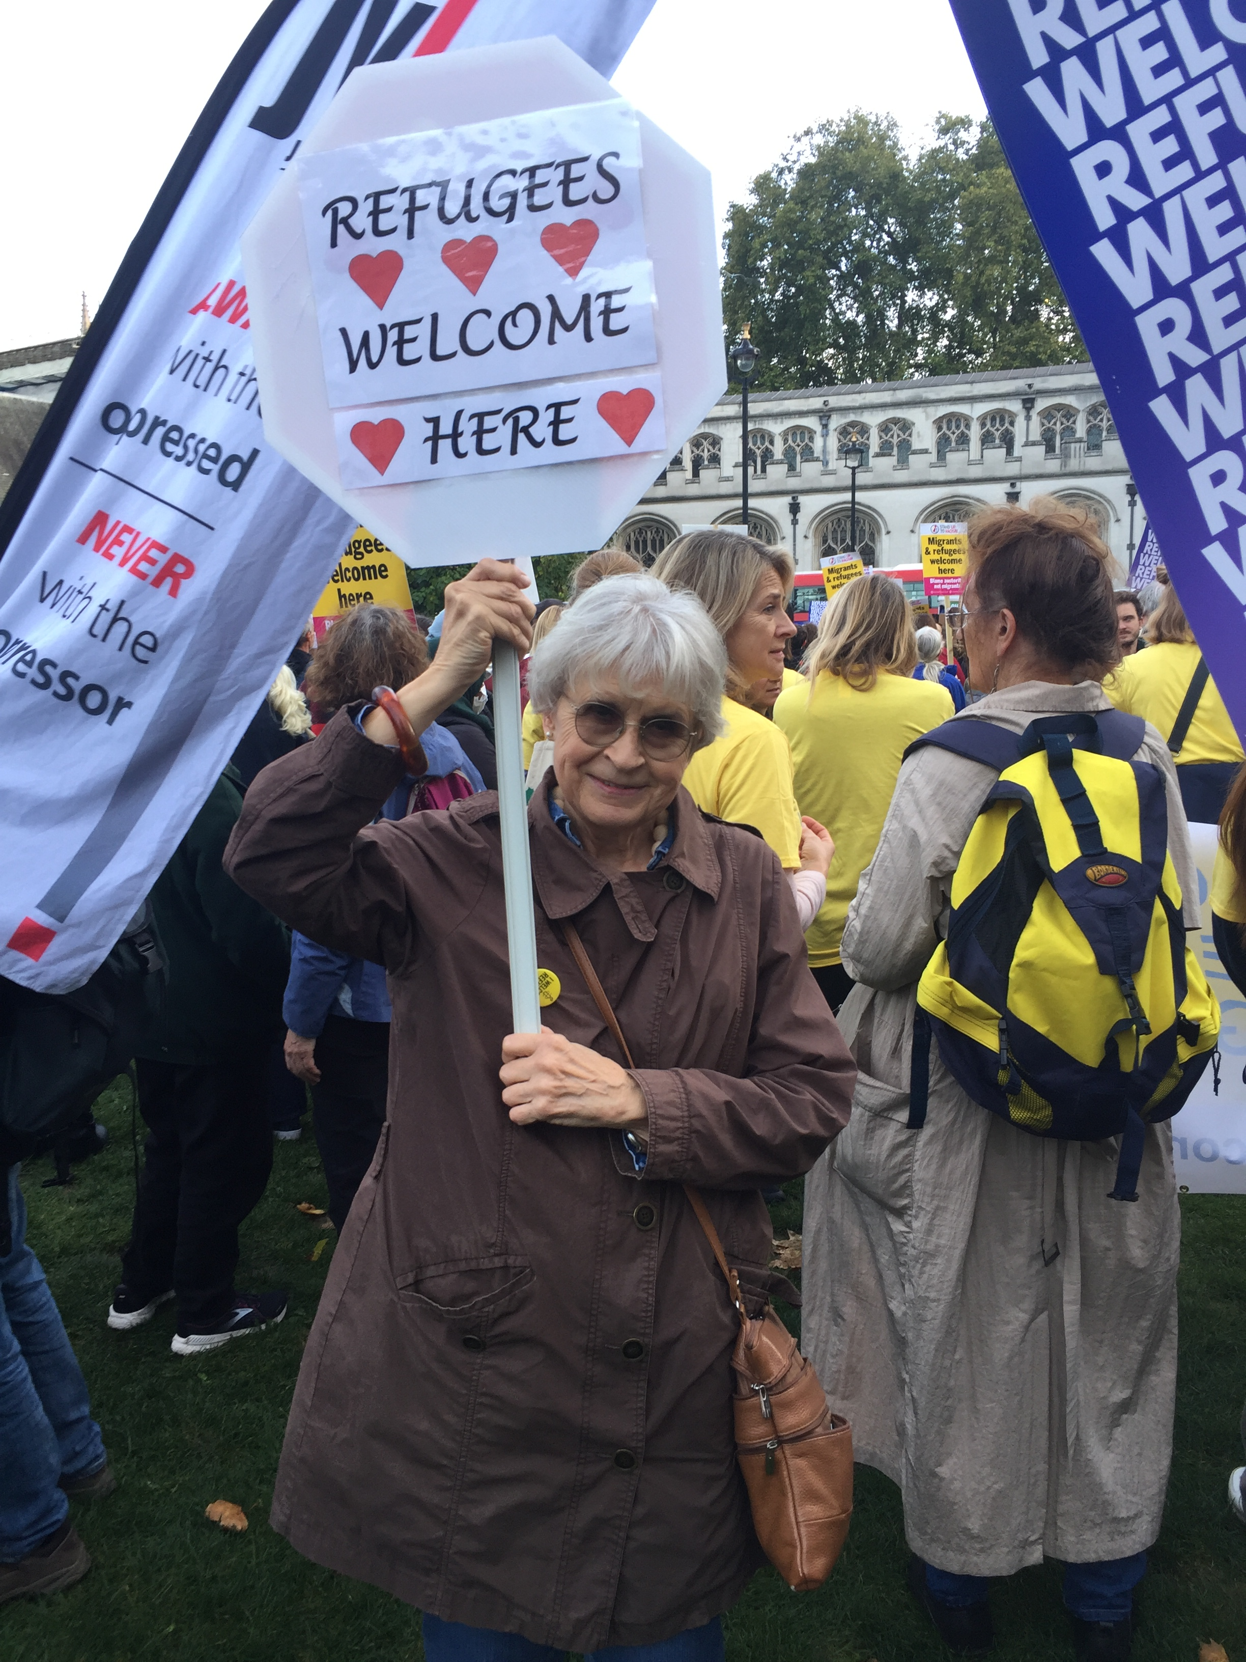

7. Arrangements for Future Meetings
- Tuesday 14th December 2021: next AIBG monthly meeting
  - Christmas festivities, mince pies
  - External Speaker / Discussion – Nabila Khan, AIUK China & Hong Kong desk

- Tuesday 11th January 2022: monthly meeting
  - AGM

- Tuesday 8th February 2022: monthly meeting
  - External Speaker / Discussion – Shaimaa Hassan, AIUK trainer, BRAVE Campaign
(BRAVE is Amnesty’s global campaign calling for the urgent protection of human rights defenders)

- Speakers / events tbc:
  - Sotez Chowdhury, AIUK anti-racism network

8. Letter Writing. The Greenwich Tavern has requested that we change the day or time of our meetings as they close early on Tuesdays. The group agreed to change meeting time to 6.30pm. After the meeting there were two emails from members unable to attend expressing a preference for changing the venue rather than the time. We should review this decision at our Dec. or Jan. meeting.
Tuesday 23rd November at 6.30pm. Please bring 15 copies of letters you have prepared. To avoid duplication email group with details of letters you are bringing and attach a copy of your letter to that email so those who cannot come to letter writing can still send the letters.
The Write for Rights campaign has started. The leaflet can be ordered from AIUK or downloaded. There are details of successes from last year’s campaign

EVENTS 2021
Tuesday 23rd November | Letter Writing Greenwich Tavern 6.30pm
Tuesday 14 December | Group meeting Crypt at St Margarets’s Church, Lee Terrace, London SE13 5DL at 7.30 pm
Tuesday 11th Jan. | Group meeting Crypt at St Margarets’s Church, Lee Terrace, London SE13 5DL at 7.30 pm

AIBG CONTACTS
Position | Name
Chair | Rachel
Deputy Chair | Roger
Secretary (enquiries contact) | David Wi
Treasurer | David We
Membership & AIBG Website | David WW
Publicity & Social Media | Simon
Letter writing co-ordinator | Brigitte
Events co-ordinator
Newsletter | Rotating: Nancy Brigitte  Roger Graham Melanie

AIBG enquiries: enquiries.aibg@gmail.com
Website: www.amnesty.org.uk/groups/blackheath-and-greenwich

