
Amnesty International

Blackheath and Greenwich

Newsletter

OCTOBER 2021

Group Meeting Tuesday, 12.10.2021

- Introductions, Apologies, appointment of Newsletter Writer.
Present:
Angela
Ann H
Brigitte
David Wi
David WW
Geoff
Graham
Katrine
Illona
Ken
Marcia
Nancy

Apologies:
Anne F
Anne
David We
Dee
Melanie
Rachel
Roger

David Wi, chair in Rachel’s absence, gave a warm welcome to new member Katrine on behalf of the group, Graham volunteered to be Newsletter writer.

2. Sept 2021 Book Sale
- Campaign for Anoosheh Ashoori – Angela reported that the letter with its 200 signatures and the 100+ cards of personal solidarity had been received by 10 Downing Street but as yet, there had been no response. Illona mentioned that she had sent a letter and card direct to Annosheh in the Tehran Prison and also copies to his daughter, Elika, so that he will have them when he is released even if he does not receive the originals. The group liked the idea and David Wi said that he would contact Sherry for her agreement to receive copies.
- Donation to AIUK – David Wi stated that this decision had been postponed due to the absence of Rachel, Roger and David We. At the end of this item, David asked the group to give permission to a payment of £400 to the Church of the Ascension as suggested in the treasurer’s report. There were no objections.
- Disposal of unsold/unwanted stock – Geoff reported that Happy Fish would shortly make a third run to pick up the remaining books in both Rachel’s and Olwen’s garages. The group thanked those reponsible for sorting the books to be kept for next year, especially Geoff and Ann H for their untiring effort.

3. AIUK Week of Action – 10-17 October
Brigitte set out the background for this action. This is in the context of major pieces of proposed legislation that threaten to undermine fundamental Human Rights including: the Policing Bill and Nationality and Borders Bill. To make matters worse the Human Rights Act itself is under review.Brigitte talked in particularly about the Nationality and Borders Bill which she thought that far from fixing our asylum system will make it worse. Criminalising people just for trying to reach a place of safety is morally and legally indefensible. People cross the Channel and put themselves in serious danger because there are simply no safe alternatives open to them. Brigitte also drew our attention to the role of the United Nations High Commissioner for Refugees (UNHCR) in raising and directing funds towards helping refugees.
Marcia said that she had written to her MP, Vicky Foxcroft, about about concerns that the group has about Nationality and Borders Bill and the review of Human Rights Act and explored the possibility of a meeting with her.
At this point, David Wi suggested we break to have a group photo taken to accompany the letter to our MP that we had signed during the meeting.

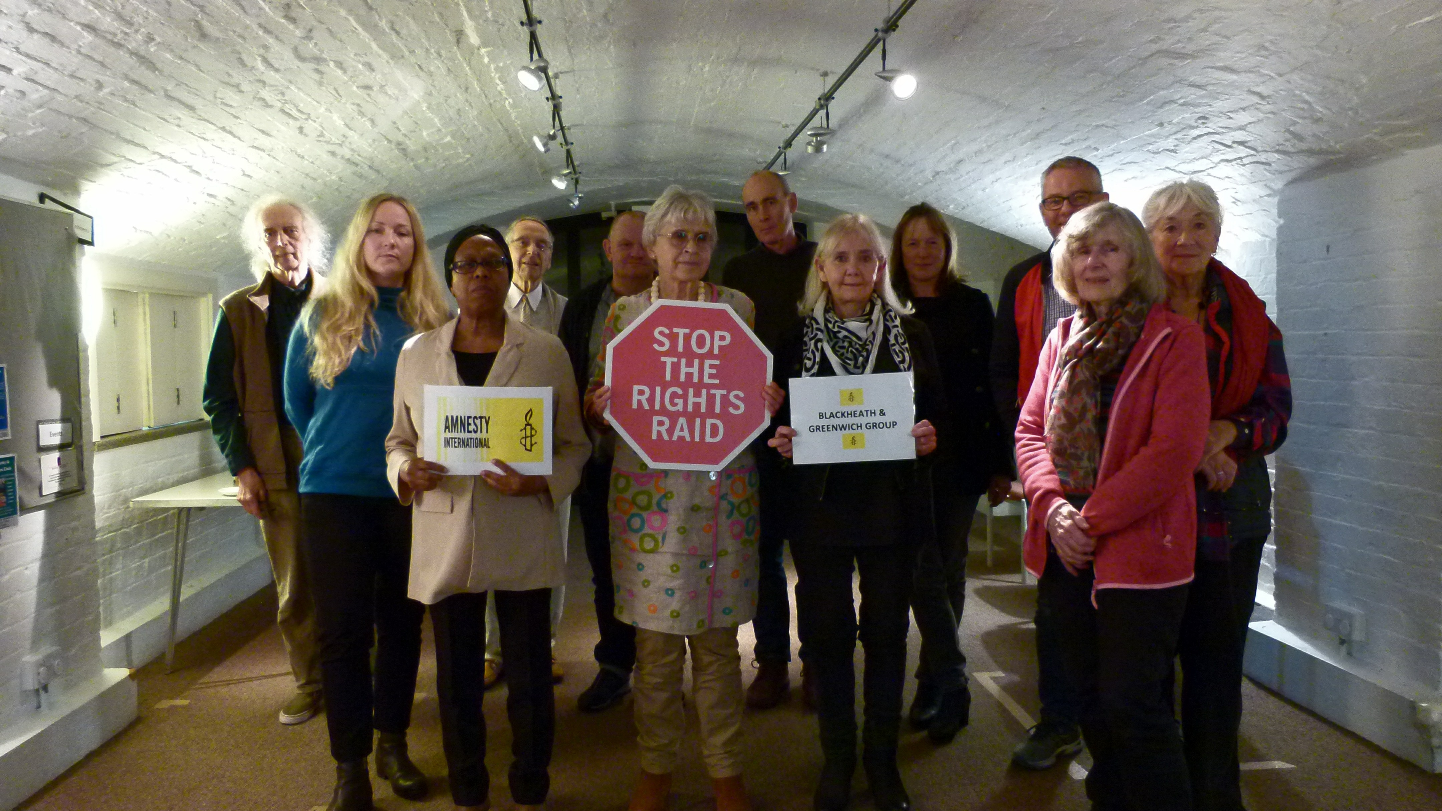

4. Campaign Updates The proposal that our country group reps might give presentations to group meetings about their respective regions provoked Angela and others to question their role. They did not necessarily have specialist knowledge about their countries other than that provided by AI researchers through the Country Coordinators. The role will not change and Geoff suggested that perhaps a better title was Country Contact for the group.

China Angela said that the update this month from Sena Atici, AIUK Campaigns Coordinator focussed once again on a call to help stop the repression of Uyghur communities in China. Since 2017, Uyghurs, Kazakhs and other predomominantly muslim minorities have been detained in camps where they are tortured and forced to give up their beliefs. We have met this before under the banner of Re-Education and have tried to fight it with campaigning and letter writing.AIUK has asked members to donate £5 to help put pressure on the chinese authorities to immediately release everyone detained in camps. Our group expressed doubt about this approach to funding, preferring to raise money for AIUK and allowing them to direct funds where needed.

Angela thanked Anne F for representing the group at the AIUK protest in support of the Uyghurs outside the Chinese Embassy in London on the 7th October. Anne’s full and succinct report gave the meeting a feeling of the action which had been organised by Nabila Khan. .
Colombia. Nancy had not received any updates

Myanmar. Brigiite had not received an update this month.

Iran.Graham had also not received an update from the country coordinator but noted that AIUK website reported on the 11 October that Abdul Abdotall was scheduled to be excuted on the 13 October for a crime that he is said to have commied at the age of 17. We can only hope that there is a last minute reprieve or postponment.

West and Central Africa. Geoff reported that Paul Rusesabagina, a Rwandan, is credited with helping to protect the lives of around 1,200 people who sought refuge at the Hotel des Milles Collines in Kigali during the 1994 Rwandan genocide. He left Rwanda in 1996, and in 2018, co-founded the Rwanda Movement for Democratic Change (MRCD), a coalition of opposition groups of which he was president at the time of his arrest. He was charged with nine terrorism-related charges, and tried in connection with armed attacks in 2018 and 2019 in southern Rwanda attributed to the armed wing of the MRCD in which nine people were killed. At trial, he was found guilty on terrorism charges and sentenced to 25 years in prison. The trial was marred by numerous violations of his fair trial rights, including the unlawful circumstances of his arrest, his enforced disappearance and incommunicado detention. Amnesty International independently monitored the trial, which was livestreamed online. A letter will be prepared for signing.

5. Arrangements for Future Meetings The group confirmed that we should continue meeting in person, Covid 19 permitting.
There was some discussion around inviting AIUK Country Coordinators. Angela and Nancy expressed the sometimes embarrassing turnout when we had external speakers. Illona suggested that we invite other local groups.
Geoff would follow up on offers from both the Activism and the Africa teams to send a speaker to a monthly meeting.
Angela said that she would invite the China coordinator, Nabila Khan, and would coordinate with Geoff over dates.

6. Letter Writing. Next session at The Greenwich Tavern. 1st floor. Tuesday 26th October 7.30pm. Please bring 15 copies of letters you have prepared. To avoid duplication email group with details of letters you are bringing

AOB
Brigitte mentioned two events:

1) the Refugees Welcome Rally in Parliament Square on Oct 20 . You can google the details easily
2) the action on Oct 23 -organised by the AI Europe Team as a Day of Action to Defend the Right to Asylum.
It starts at 12 noon at the Italian Embassy, 14 Three Knights Yard W1K 4EH to protest against Italian collaboration with the Libyan coast guard, boats of refugees being forced to return to Libya where violence,rape and extortion is waiting.
It continues at the Embassy of Malta, Piccadilly, W1D 7ET to ask for the release of the EL Hibu 3, who helped the refugee ship EL Hibu take her load of refugees to Malta and are facing long prison sentences for their heroism.
It ends up at the Home Office, 2 Marsham Street,SW1P 4DF between 2.30 and 3.30.

EVENTS 2021
Tuesday 26th October | Letter Writing Greenwich Tavern 7.30pm
Tuesday 9 November | Group meeting Crypt at St Margarets’s Church, Lee Terrace, London SE13 5DL at 7.30 pm

AIBG CONTACTS
Position | Name
Chair | Rachel
Deputy Chair | Roger
Secretary (enquiries contact) | David Wi
Treasurer | David We
Membership & AIBG Website | David WW
Publicity & Social Media | Simon
Letter writing co-ordinator | Brigitte
Events co-ordinator
Newsletter | Rotating: Nancy Brigitte  Roger Graham Melanie

AIBG enquiries: enquiries.aibg@gmail.com
Website: www.amnesty.org.uk/groups/blackheath-and-greenwich

