GROUP MEETING
Thurs. 16th Sept. 7.30/9.30
Due to unforeseen circumstances we are unable to have the September meeting at Nora Street and will meet at 39 Beechways, Appleton. WA4 5ER
If you intend to join us
Tel: 01925 268871 (a message can be left on the 0151 answer service!)
OR: email benkin64@talktalk.net

As the Warrington group celebrates 30 years of campaigning the group hovers on the brink of extinction. However the Executive Committee are hoping to keep going on a much reduced programme concentrating on a more personalised approach. We will be sending more optional email actions / online petitions etc. to mailing members which individual members can request not to receive. To help us achieve more we need to recruit more mailing members!
Small Actions Big Difference

SEPTEMBER GROUP MEETING
AGENDA IN BRIEF

- How to support the idea ‘Small Actions can make a difference’
- Fund raising ideas for a smaller group
- AIUK news & actions
- A memorial for our late Chair, Jo Busby
- How to mark our 30 years of campaigning
- Write 4 Rights 2021 - ideas
- Israel & Occupied Palestinian territories
- News from Central American

GOOD NEWS

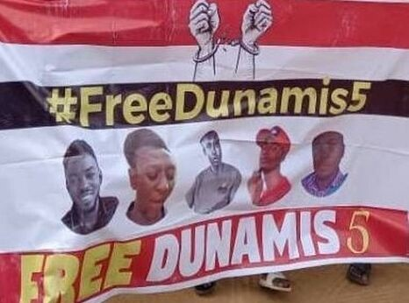

NIGERIA: ACTIVISTS JAILED FORANTI-PRESIDENT T-SHIRTS FREED
Activists, Larry Emmanuel, Anene Victor Udoka, SamuelGabriel, Henry Nwodo, and Ben Mannaseh, who had been arbitrarily detained in connection to their peaceful activism, have been released on bail. On 4 July, they attended a church service at the Dunamis International Gospel Centerin Abuja, the Nigerian capital, when they were arrested and beaten by the Center’s security unit for wearing #BuhariMustGo T-shirts. On 29 July they were charged with ‘constituting themselves as vagabonds’ to disturb public peace. Amnesty International believes the charges to be baseless and in connection to the activists’ peaceful expression of their dissenting views.

Democratic Republic of CONGO:
PEACEFUL ACTIVISTS RELEASED ON BAIL
On 24 July, human rights defenders Elisée LwatumbaKasonia and Eric Muhindo Muvumbu were released on bail.
The two activists were charged with “inciting civil disobedience” and “threatening an attack.” Amnesty International believes the charges, which remain pending, are baseless and must be dropped.

DEATH PENALTY

Amnesty International opposes the death penalty in all cases without exception because it violates the right to life as proclaimed in the Universal Declaration of Human Rights. The death penalty is the ultimate cruel, inhuman and degrading punishment which has no place in our world. Until this day, 22 African countries have abolished the death penalty for all crimes.

WEST AFRICA - SIERRA LEONE:
ABOLITION OF DEATH PENALTY
A MAJOR VICTORY

On the 23 July 2021, the Sierra Leone Parliament voted to abolish the death penalty in the Country. This represents a major victory of tirelessly campaigned to consign this cruel punishment to history and strengthening of the protection of the rights to life.

Now that the abolition Bill has been approved by Parliament, President Julius Maada Bioshould, without delay, must sign it into law and commute all death sentences.
The President should also ensure that Sierra Leone immediately accede to the Second Optional Protocol to the International Covenant on Civil and Political Rights, aiming at the abolition of the death penalty.

CENTRAL AMERICA
WATER DEFENDERS CONTINUE IN JAIL

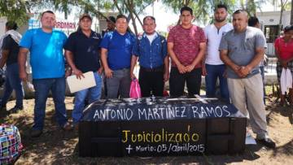

Municipal Committee for the Defence of Common and Public Assets (CMDBCP)
Eight members of this group have spent two years in pre-trial detention for defending water sources in danger from a mining project. Unfortunately the Attorney General Office has requested the Supreme Court to extend the pre-trial detention despite the UN Working Group on Arbitrary Detention declaring their detention as arbitrary and calling for their immediate release.

To help show support send the attached email to the Honduras Embassy in London.

ISRAEL AND OCCUPIED TERRITORIES
Excessive Use of Force
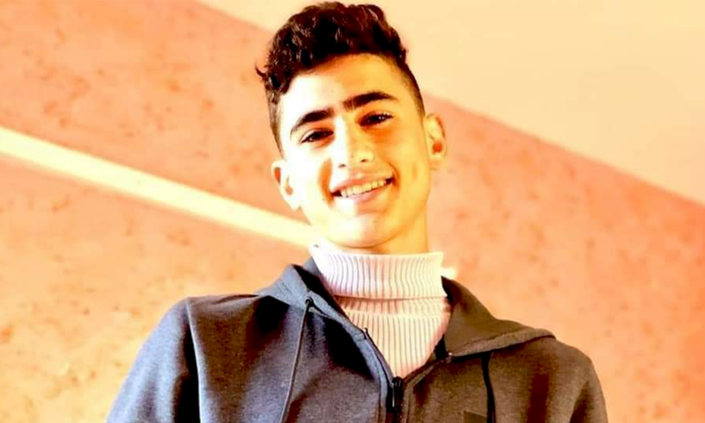

In May, Defence for Children International covered the fatal shooting by Israeli forces of 16-year-old Said Yousef Mohammad Odeh (pictured) in Odala, a village located near Nablus in the occupied West Bank.
The team have since spoken with Said's family and friends to hear their reflections on his life and the impact of his brutal killing. You can watch and share this four-minute video where Said's mother, father, cousin, football teammate, and uncle—who was the paramedic that reached Said's body after being blocked by Israeli soldiers—grieve the loss of Said.

