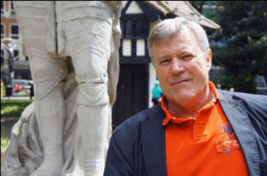
Soho London’s Most Famous Neighbourhood

Sunday October 10 at 2.00 pm.
Fundraiser for Amnesty International
Meet at Tottenham Court Road station concourse.
Book here
£5.00 to access the walk. No upper limit to contributions.

Soho is known around the world for its exquisite mix of squalor and glamour. Explore it with Richard Cohen, local resident, London guide and Amnesty member, who will take you to some of its less well-known corners. Soho has grown from a royal hunting ground into an area of huge diversity and colour. It has welcomed refugees and attracted rebels, outcasts and mavericks over the centuries. Hear about the riotous masked balls of Teresa Cornelys. Enjoy the calm of Soho's green spaces. Absorb the colour of Europe's largest Chinatown. Visit London's most beautiful shop. See the nightclub that never closed and the glittering theatres of Shaftesbury Avenue and the capital’s thriving LGBTQI+ scene.
