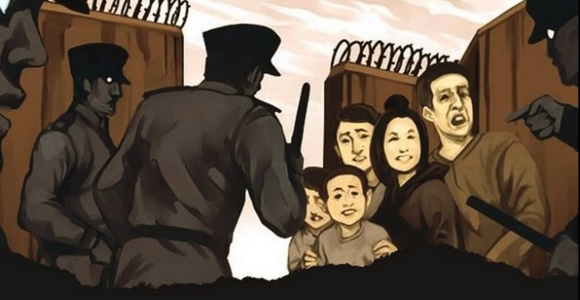
SEPARATED BY REPRESSION
CHINA: UYGHUR FAMILIES

Mihriban and Ablikim fled from Xinjiang to Italy in 2016 after being harassed by police and pressured to give up their passports. They left their four children in the temporary care of grandparents. However, soon afterwards the children’s grandmother was taken to an internment camp and their grandfather was interrogated by police.
For decades many Uyghurs have experienced systematic ethnic and religious discrimination in Xinjiang.
Since 2014 there has been a greatly expanded police presence in the region and heavy surveillance as part of China’s declared “People’s War on Terror”, and in 2016 surveillance and social control measures began spreading rapidly.
In 2017 the situation became worse for Uyghurs, Kazakhs and other predominantly Muslim peoples in the region, with a mass detention campaign combined with systematic repression. An estimated one million or more people have been arbitrarily detained in ‘transformation-through-education’ or ‘vocational training’ centres in Xinjiang, where they have been subjected to torture and ill-treatment, including political indoctrination and forced cultural assimilation.
This terrible situation has prevented Uyghur parents studying or making a living abroad from being able to return home to their children, having been warned that they would almost certainly be locked up in internment camps on return. At the same time, it has been nearly impossible for their children to leave China to reunite with them abroad. Parents were able to have some contact with their children at first, but this has ended as relatives looking after the children were taken to internment camps or jailed themselves.
Amnesty International has spoken to six parents separated from their children and you can read more of their stories and testimonies here: Hearts and Lives Broken: The Nightmare of Uyghur Families separated by repression
In November 2019 Mihriban and Ablikim received a permit from the Italian government to bring their children to join them in Italy. The four children, aged between 12 and 16, had to travel alone across China to the Italian consulate in Shanghai to apply for Italian visas. Sadly, the children were seized by police and sent back to the orphanage and boarding school in Xinjiang.
Now my children are in the hands of the Chinese government and I am not sure I will be able to meet them again in my lifetime. − Mihriban
Like Mihriban and Ablikim, many other Uyghur parents overseas have had to leave one or more children in the care of family members in Xinjiang. Some parents have since learned their children were taken to state-run ‘orphan camps’ or boarding schools after the relatives taking care of them were detained.
The mass detention campaign in Xinjiang has prevented Uyghur parents from returning to their children in China, and has also made it nearly impossible for them to bring children, whose passports have been denied or confiscated, to join them outside of China.

TAKE ACTION:
Write to the Chinese government calling for them to ensure that children are allowed to leave China to be reunited as promptly as possible with parents and siblings already living abroad (if that is preferred by them).

TEMPLATE LETTER
Xi Jinping
President of China
Zhongnanhai
Xichangan’jie
Xichengqu, Beijing Shi 100017
People’s Republic of China
Fax: +86 10 6238 1025
Email: english@mail.gov.cn

Dear President Xi,
I am alarmed to learn of the reports that some Uyghur parents have been separated from their children for years as a result of the unprecedented crackdown on ethnic populations in Xinjiang.

Since 2017, an estimated one million or more people have been arbitrarily detained in ‘transformation-through-education’ or ‘vocational training’ centres in Xinjiang, where they have been subjected to various forms of torture and ill-treatment, including political indoctrination and forced cultural assimilation. This mass detention campaign combined with systematic repression have prevented Uyghur parents from returning to China to take care of their children themselves, and made it nearly impossible for their children to leave China to reunite with them abroad. Some Uyghur parents believe their children may have been taken to state-run ‘orphan camps’ or boarding schools when relatives taking care of them were detained.

I call on you to ensure that children are allowed to leave China to be reunited as promptly as possible with their parents, if that is preferred by them, as well as with siblings already living abroad.

Yours sincerely,

Other action/other address

