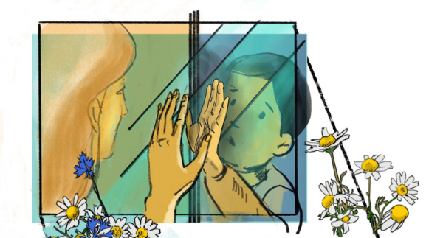
A recent Amnesty report has documented the crackdown on children in Belarus.
BELARUS: CRACKDOWN ON CHILDREN

Mikita was 16 years old when he was arrested at his home in August, accused of through a Molotov cocktail at a police officer. He denies throwing anything and there is no evidence to support the allegation. He was detained without access to his family or a lawyer for over 6 hours When his mother finally saw him, he told her he had been beaten. He was taken to hospital after fainting but returned to police detention within hours. He remains in pre-trial detention.
In Belarus there have been months of protest following the widely disputed Presidential election in August 2020. The government response has been a shocking clampdown on dissent, with many different sectors of society suffering human rights violations.
Amnesty has reported on the impact on children’s rights, with the Belarusian authorities resorting to threats, harassment and prosecution of children as part of ongoing repressive efforts to suppress dissent.
In the months since the protests began, children have been victims of numerous human rights violations, including being:
- Deprived of their right to peaceful assembly
- Arrested for peacefully participating in protests or even as passers-by
- Subjected to police violence on arrest and in detention
- Threatened by school staff for their political views and those of their parents
- Threatened with removal from their families through misuse of child custody legislation.

14 -year-old Aleh* was detained by riot police from the car park of a shopping mall and ill-treated on his way to the police station. Police found a small flyer with the Belarusian red and white opposition flag in his pocket, and he was wearing a red bandana. The child protection department have put the family on a watchlist, claiming Aleh lives in a ‘socially dangerous situation’.
8-year old Olha* told her parents that some people had come to her school and told the class that if their parents went to meetings and said bad things about the president they would be sent to a children’s home. Her mother sais she has been anxious and tearful since and has learnt it is better not to draw anything using red and white colours (the colours of the opposition flag).
*Some names have been changed to protect the children and their families.
SOCIAL MEDIA SOLIDARITY ACTION:
Show your solidarity on social media by taking action to #StandWithBelarus:
- Take or create a picture of a flower
- Write a solidarity message in support of Belarusians
- Post the image on your Instagram, Facebook or Twitter
- Use the hashtag #StandWithBelarus
- Tag @amnesty and your message will be shared

Solidarity Action #StandWithBelarus
