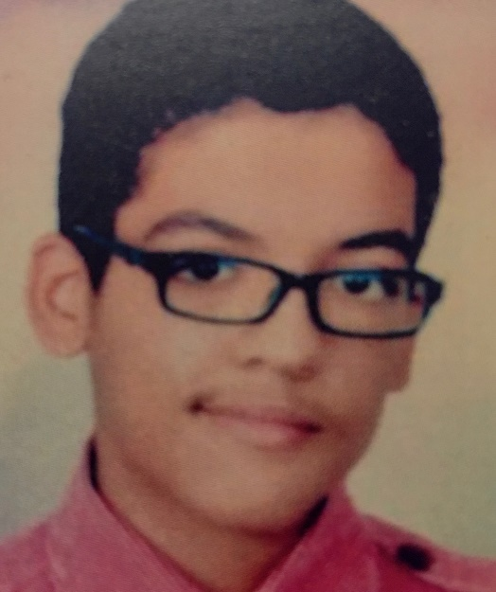
TEENAGER TORTURED AND IMPRISONED
EGYPT: ASER MOHAMED
Aser Mohamed was arrested in 2016 when he was just 14 years old, and subjected to enforced disappearance. Aser reports that he was subjected to torture in detention to force him to “confess” and he was placed in pre-trial detention, despite this being banned in Egypt for children under 15.
On 12 January 2016 armed police and National Security Agency (NSA) officers raided 14-year-old Aser Mohamed’s home. Agents said they were taking him away for brief questioning, but he was gone for 34 days, during which nobody knew where he was or why he had been taken.
On 15 February Aser Mohamed appeared before the Supreme State Security Prosecution in New Cairo for questioning without his lawyer. The prosecutor charged Aser Mohamed with belonging to the Muslim Brotherhood and participating in a hotel attach on 7 January 2016. When Aser denied the charges, he alleged that the prosecutor responded: “It seems that you want to go back to the electric shocks again”, indicating that the prosecutor knew Aser Mohamed had been subjected to electric shocks torture in detention by the NSA to force him to ‘confess’. The prosecutor took no action to investigate or hold those responsible for torture to account.
Aser was held in pre-trial detention, even though this is banned for children under he age of 15. His trial began in August 2016, and after repeated postponements he was convicted and sentenced in October 2019.
Aser’s lawyer filed a cassation request to the criminal court in late 2019 and is still waiting for the court to set a hearing date. The process usually takes 12 to 18 months.

Aser faced a range of charges, including being a member of the banned Muslim brotherhood group and attacking a hotel on the basis of confessions made by the teenager under torture. In October 2019 Aser was sentenced to 10 years in prison.
Amnesty International has called for the quashing of his sentence given the gross violations of his rights to a fair trial, including the use of confessions extracted under torture evidence against him.
Aser has spent nearly a quarter of his life in prison. He has been in prison for the equivalent of his GCSE and A level years, and his first year at university.
Aser suffers from a chronic allergy that causes respiratory difficulties, which puts him at particular risk of severe Covid-19 according to the World Health Organisation’s list of vulnerable groups.
We are calling on the President to quash Aser’s conviction, immediately release him and launch an investigation into his enforced disappearance and torture allegations.

TAKE ACTION:
Write to President Abdel Fattah al-Sisi asking him to quash Aser’s conviction, release him and, pending release, ensure he is provided with the means to communicate with his family and lawyers and that the authorities take measures to protect Aser’s health.

TEMPLATE LETTER

President Abdel Fattah al-Sisi,
Office of the President,
Al Ittihadia Palace,
Cairo,
Arab Republic of Egypt

Your Excellency,
Aser Mohamed
I am writing to you regarding the above named. I understand that the sentence imposed on Aser Mohamed is soon to be reviewed by the Court of Cassation (the application was made around October 2019).

I believe that Aser Mohamed has been unjustly sentenced to 10 years in prison on the basis of evidence obtained under torture and I call on the Egyptian authorities to quash Aser's conviction and release him immediately and launch an investigation into his enforced disappearance (for some 34 days) when he was just 14 years of age and torture allegations.

Pending his release Aser should be provided with the means to communicate with his family and lawyers and the authorities should take measures to protect Aser’s heath. Aser suffers from a chronic allergy that causes respiratory difficulties which puts him at particular risk of Covid 19 according to the World Health Organisation’s list of vulnerable groups.

I look forward to hearing from you further.

Yours faithfully and sincerely,

Please send a copy of your letter to the Egyptian ambassador to the UK:
His Excellency Mr Tarek Ahmed Ibrahim Adel
Ambassador
26 South Street
London
W1K 1DW

