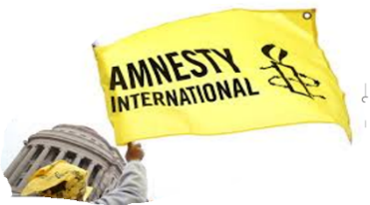
AMNESTY INTERNATIONAL
Bromley & Orpington Group
Flying the Flag July 2021 Newsletter

Dear Supporter,
This newsletter sets out three actions which were discussed at our last Group meeting on 8 June covering human rights violations in Egypt, Poland and Bangladesh. I hope that you will be able to add your support as well by sending the letters referred to.
You would be welcome to join our next Zoom meeting on Tuesday 13th July at 7.30pm, just click the following link.
https://us02web.zoom.us/j/8986966205
Meeting ID: 898 696 6205
With all good wishes,
Patrick Nield, Chairperson, Bromley & Orpington Amnesty Group Email: pdnield@gmail.com Address: 16 Brookmead Avenue, BROMLEY, BR1 2LA Tel: 020 8467 4169

Thanks to Roger Knight for sponsoring this month’s newsletter

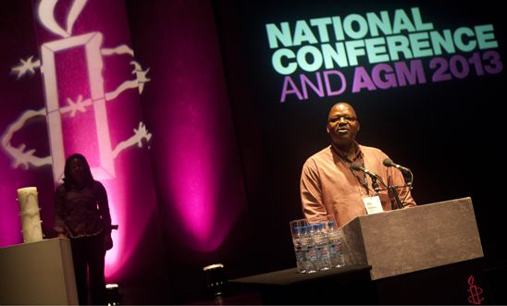
Amnesty International UK Annual Conference and AGM 2021
The Conference and AGM for Amnesty UK was held on 21 June online. The range of Business discussed can be found by clicking the following link to our Group Facebook page or copying it and pasting into your browser. https://www.facebook.com/groups/187817656506
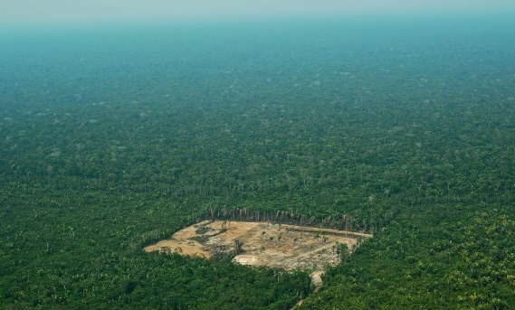
The Adult Lewisham acting class, will be performing a short open air drama (about half an hour) titled “Rainforest Rescue”, written by Ann Garrett (Chair, Beckenham, Penge & West Wickham Amnesty). It will highlight the deforestation of the Brazilian rainforest under President Bolsonaro and the effect this is having on the environment and indigenous people. The play will be performed in the following places:
“Rainforest Rescue"
July 10th – Ladywell Fields, Lewisham – near the café
July 17th – Manor Park Gardens, Lewisham – near the café
July 18th – Chinbrook Meadows, Amblecote Rd, Grove Park -near the café
Please bring your own chair if you need to sit, so people can be at a distance from each other.

Here are three campaign actions from our last meeting you can take
Egyptian lawyer and activist held in unacceptable conditions – Egypt

Mohamed el Baqer Alaa Abdel Fattah
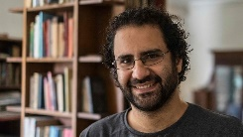
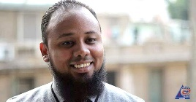
Human rights lawyer Mohamed el-Baqer and activist Alaa Abdel Fattah have been arbitrarily detained since 29 September 2019 without trial over unfounded terrorism related accusations. They are held in a maximum
security prison in inhumane conditions in Cairo, including lack of clean water, poor ventilation and overcrowding and subjected to discriminatory and punitive treatment, because of their human rights stance. The prison conditions have been made even worse by the failure of the prison authorities to deal adequately with the spread of Covid-19 .
Alaa Abdel Fattah is a well-known activist and government critic and has been repeatedly arrested in recent years, including for his role in the 2011 uprising, which toppled President Hosni Mubarak. Mohamed el Baqer is a human rights lawyer and a director of Adalah Centre for Rights and Freedoms, which he founded. The organisation focuses on criminal justice, the right to education and students’ rights. Learning of his arrest the Bar and Law Society of Europe awarded Mohamed el Baqer its Human Rights Award 2020. Thousands of Egyptian human rights defenders, politicians, journalists and lawyers remain in pre-trial detention under the repressive regime of President Abdel Fattah al-Sisi.
Please send draft appeal letter/email provided, to President Abdel Fattah al-Sisi. Postage £1.70p or 2x1Class stamps.

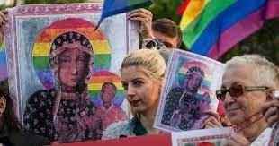
Poland: Drop the prosecution appeal against Elzbieta, Anna and Joanna’s acquittal of “offending religious belief"

Elżbieta, Anna and Joanna are outspoken activists and human rights defenders from Poland. They have stood against hate and discrimination for many years and are fighting for a just and equal Poland. They have been targeted by the Polish authorities just because of their peaceful activism. Their demand for justice continues.
In March 2021, Elżbieta, Anna and Joanna were acquitted after spending months on trial accused of ‘offending religious beliefs’, simply for distributing posters of the Virgin Mary with a rainbow halo, the colours of the LGBTI pride flag. The ‘not guilty’ verdict was a moment of huge celebrations, but their relief was short-lived. The Polish authorities are now appealing against their acquittal, so the three women’s fight for justice continues .Once again, they now face up to two years in prison, just for standing up for LGBTI rights in a climate of hate and discrimination in Poland. Sadly, their case is another example of the constant harassment activists and human rights defenders face in Poland for carrying out peaceful activism. The appeal against their acquittal shows the irrational determination of Polish authorities to use the criminal justice system to that end. Having, creating, or distributing posters such as these is not a crime; it is freedom of expression, a basic human right.
The world is on these activists’ side. Before their acquittal, hundreds of thousands of people took action urging the Polish Prosecutor General to drop the unfounded charges. This solidarity gave Elżbieta, Anna and Joanna the strength to continue fighting for their rights.
Please send the draft letter/ email provided to the Public Prosecutor calling for the appeal against acquittal to be dropped. Postage £1.70p or 2x1Class stamps.
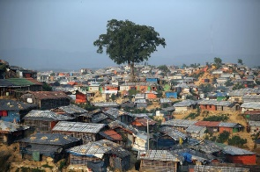
Bangladesh: Give Rohingya refugees a voice in the decisions that affect them.
Nearly one million Rohingya refugees are living in threadbare camps in Cox’s Bazar, Bangladesh, after they fled their homes in Myanmar due to the military’s crimes against humanity - which are currently the subject of a case under the Convention on the Prevention and Punishment of the Crime of Genocide at the International Court of Justice. Now, COVID-19 has exacerbated the conditions of the Rohingya in the camps. Many Rohingya refugees struggle to access healthcare due to language barriers, ill-treatment from some medical staffs and lack of access to information about the availability of healthcare services in the camps. Women in the camps told Amnesty International that their husbands, aggrieved by the loss of opportunity to work, put pressure on them to bring in money, and were violent towards the women in the household.
For decades, the Rohingyas in Myanmar have been denied their rights to nationality, freedom of movement and access to services including education, employment and healthcare. By promoting and protecting their human rights and dignity, the Bangladeshi government and the international community can empower the Rohingya community to claim their rights. That can only happen when they are given a voice in the decisions that affect them.
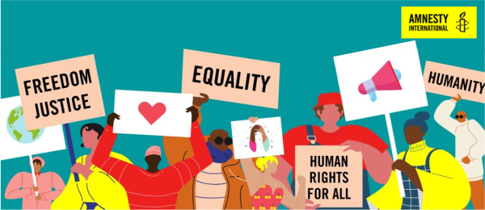
Please sign the AI UK petition calling for the Bangladeshi government and the international community to ensure the participation of Rohingya refugees in the decisions that affect them in order to protect their human rights. You can access the petition via the Group Facebook page https://www.facebook.com/groups/187817656506 You can also send a letter ( draft associated) to the High Commissioner for Bangladesh in London.
Thank you for all your support for Amnesty
Contacts: Patrick Nield (Chair)
Vivien Glanz(Secretary)
pdnield@gmail.com vivienglanz@hotmail.com
The date of our next meeting is 13 July at 7.30pm on Zoom - see link above

President Abdel Fattah al-Sisi
Office of the President
Al Itthadia Palace
CAIRO
Egypt
Email: p.spokesman@op.gov.eg
July 2021

Mr President

I am writing to raise my concerns about the ongoing arbitrary detention of lawyer Mohamed el-Baqer and activist Alaa Abdel Fattah, who have been in pre-trial detention over unfounded terrorist-related accusations since 1 October 2019, solely for their peaceful exercise of human rights. They are held in inhumane conditions at the Tora Maximum Security 2 Prison, in Cairo. From 1 October 2019 to 9 May 2021, Mohamed el-Baqer and Alaa Abdel Fattah shared a small poorly ventilated cell of 3.5m x 5m with two other prisoners. Prison authorities have denied them beds and mattresses; they have been sleeping on the floor on rough blankets. Unlike other prisoners, they are prohibited from exercising in the prison yard and are not allowed to use the prison library nor to receive books or newspapers from outside prison at their own expense. The prison authorities have also been denying them adequate clothing, radios, watches, access to hot water and any personal belongings, including family photos. On 11 May 2021, during a visit, Mohamed el-Baqer informed his wife that he had been transferred to another cell with similar conditions. He said that as a result of limited movement and poor prison conditions, he developed pain in his joints and muscles.

The families of Mohamed el-Baqer and Alaa Abdel Fattah have lodged official complaints about their treatment in prison, including their exclusion from the COVID-19 vaccine rollout amid concerns that detainees are being transferred from prisons to courts without personal protective equipment (PPE) and held in cramped unhygienic conditions. On 10 May 2021, the Egyptian Initiative for Personal Rights (EIPR), an independent human rights organization, filed a lawsuit before the State Council, an administrative court with jurisdiction over complaints regarding state bodies’ action or inaction, against the Ministry of Health and the Ministry of Interior, which has oversight of prisons in Egypt, for their failure to include prisoners in national vaccine plans. The organization is calling for the authorities to enable prisoners to register for the vaccine, and to either transfer prisoners to designated medical facilities or to allocate suitable facilities inside prisons for vaccination. A similar lawsuit was also filed by Alaa Abdel Fattah’s lawyer. On 18 May 2021, authorities announced the vaccination of 5,000 older or chronically ill prisoners and 1,400 medical staff and other prison workers. No additional details have been provided.

I urge you to release Alaa Abdel Fattah and Mohamed el-Baqer immediately and unconditionally and drop all charges against them as they are detained solely for peacefully exercising their human rights. Pending their release, I call on you to ensure they have access to adequate health care, including COVID-19 vaccines, and that they are held in conditions meeting international standards including being granted adequate bedding and outdoor exercise time; and protected from torture and other ill-treatment.

Yours sincerely,

Prosecutor General Zbigniew Ziobro
Minister Sprawiediwosci
AL. Ujazdowskie 11
00-950 WARZAWA
Poland
Email skargi@ms.gov.pl
July 2021

Dear Prosecutor General,

I am writing to express my concern regarding the prosecution appeal against the acquittal of human rights defenders – Elżbieta, Anna and Joanna – absurdly charged with “offending religious beliefs” in relation to posters depicting the Virgin Mary with a halo around head and shoulders in the rainbow colours of the LGBTI pride flag.

Having, creating or distributing posters such as these, should not be a criminal offence and is protected under the right to freedom of expression. In March 2021, after months on trial, the absurd and unfounded charges were dismissed, and the three women were found ‘not guilty’.

But now, Elżbieta, Anna and Joanna have to go on trial once more to defend their rights. They risk prison again for their peaceful activism. The way they are targeted is consistent with a pattern of harassment and intimidation of peaceful activists across Poland.

I therefore urge you to drop the appeal against the acquittal and ensure that the three women can carry out their peaceful activism free from harassment or reprisals by the authorities.

Yours sincerely,

HE Ms Saida Muna Tasneem
High Commissioner for Bangladesh
28 Queens Gate
LONDON
SW7 5JA
July 2021
Your Excellency,

I write to seek your commitment to ensure that the human rights of Rohingya refugees, who have fled horrific crimes in Myanmar and sought refuge in Bangladesh, are protected until they feel safe to return to their homes. Nearly one million Rohingya refugees are living in threadbare camps in Cox’s Bazar, Bangladesh, after they fled their homes in Myanmar due to the military’s crimes against humanity - which are currently the subject of a case under the Convention on the Prevention and Punishment of the Crime of Genocide at the International Court of Justice.

Now, COVID-19 has exacerbated the conditions of the Rohingya in the camps. Many Rohingya refugees struggle to access healthcare due to language barriers, ill-treatment from some medical staffs and lack of access to information about availability of healthcare services in the camps.
Women in the camps told Amnesty International that their husbands, aggrieved by the loss of opportunity to work, put pressure on them to bring in money, and were violent towards the women in the household. More than 100 Rohingya refugees have been allegedly killed in extrajudicial executions between August 2017 and July 2020, according to Odhikar, a Bangladeshi human rights organization.

Rohingya refugees and humanitarian workers have said that barbed-wire fences around the camps have created further obstruction in their movement and response to crisis such as fire incidents in the camps. Thousands of Rohingya men, women and children have been relocated to Bhashan Char, a remote silt island at the Bay of Bengal. Many refugees told Amnesty International that they relocated to the island more out of compulsion rather than a choice. Authorities plan to relocate 100,000 Rohingya refugees to the island.

The future of nearly half a million Rohingya children hangs in the balance with limited access to an accredited and certified education. With no place to call their home, no livelihood opportunities to secure a future for them, hundreds of Rohingya men, women and children, take dangerous recourse to boat journeys in the sea to go to neighbouring countries every year during the break from monsoon season between October and June.

For decades, the Rohingyas in Myanmar have been denied their rights to nationality, freedom of movement and access to services including education, employment and healthcare. By promoting and protecting their human rights and dignity, the Bangladeshi government and the international community can empower the Rohingya community to claim their rights. That can only happen when they are given a voice in the decisions that affect them.

I urge you to use your influence, please, with your government to bring about the participation of Rohingya refugees in the decisions that affect them in order to protect their human rights.

Yours sincerely,

