Dear Amnesty Activists and supporters
One good news, one bad news and 2 demonstrations !
First the good news from France : Frederic Vuillaume is acquitted !
The bad news :
Unfortunately the Polish authorities decided to continue their harassment and targeting of the 3 WHRD activists Elzbieta, Anna and Joanna and they appealed against the acquittal delivered in their case in March 2021. The case will now go towards second instance and we believe a hearing might be scheduled in the coming 2 months, but we do not have yet a confirmation of the timeline. Please see attached background information.
We have updated the action targeting the Prosecutor General which remains available at https://www.amnesty.org/en/get-involved/take-action/poland-activist-elzbieta-podlesna/.
Please also continue to write to the Prosecutor General
Postal address : Zbigniew Ziobro
Minister Sprawiedliwosci Prokurator Generalny
AL.Ujazdowskie 11
00-950 Warzawa Poland
e-mail : skargi@ms.gov.pl

2 Demonstrations !
Please support either by attending or by sending photo messages of support
On 13 June 2021 at 2pm there will be a vigil outside the Embassy of Kosovo remembering the ethnic cleansing from June 1999 of about 80% of the Roma population in Kosovo. Please see further information in the Newsletter and attachment. (Embassy address : 8 St John Street, London WC1N 2EB)

On 20 June 2021 there will be a demonstration outside the Danish Embassy in London protesting against the forced return of Syrian refugees living in Denmark to Syria. See further information in the Newsletter and attached leaflet. Embassy address : 55 Sloane Street London SW1X9SR

Content
Vigil commemorating ethnic cleansing of Roma from Kosovo in 1999 | Page 1
20 June International Refugee Day No deportations to Syria ! Asylum is a Human Right ! Demonstration at Embassy of Denmark | Page 2
Urgent Action Denmark Protect Syrians at risk of return | Page 3
Good News from France Frederic Vuillaume acquitted! | Page 3-6
Not Welcome Viktor Orban visit to Downing Street | Page 6-8
-1-

13. June 2021 2pm Embassy of Kosovo 8 John Street London WC1N2 EB
Vigil commemorating ethnic cleansing of Roma from Kosovo in 1999
On 13th June vigils will be held outside Embassies of Kosovo throughout the world commemorating the violence and ethnic cleansing perpetrated against the Roma population of Kosovo after the war had ended and under the eyes of KFOR the Nato-led peacekeeping force. In Mitrovica where 8000 Roma were forcibly driven from their homes, 600 Roma were “resettled” in a displaced persons camp near a disused lead mine. The families had to live exposed to lethal lead poisoning for more than 10 years. Particularly the children suffered nerve damage resulting in long lasting brain damage and other serious health problems. To date the families have not been compensated and many are destitute, unable to afford medicines and medical treatment. Roma from Kosovo and in Exile are calling for recognition of the crimes committed against Roma communities in 1999 and a memorial to be erected in Priztina, the capital of Kosovo.
The vigil outside the London Embassy at 8 John Street London WC1N2EB will take place on 13th June 2021at 2pm.
Please come and support Roma communities in their call for justice and Equality. If you can’t attend personally but want to support please send messages and/ or photos of yourselves holding messages of support to ulrike.schmidt@amnesty.org.uk

Source ERRC report 2004
In the wake of the cessation of NATO action against the Federal Republic of Yugoslavia in June 1999 and the subsequent return of predominantly ethnic Albanians from abroad, ethnic Albanians violently expelled approximately four fifths of Kosovo's pre-1999 Romani population -- estimated to have been around 120,000 -- from their homes. In the course of the ethnic cleansing campaign, ethnic Albanians kidnapped Roma and severely physically abused and in some cases killed Roma; raped Romani women in the presence of family members; and seized, looted or destroyed property en masse. Whole Romani settlements were burned to the ground by ethnic Albanians, in many cases while NATO troops looked on. A number of Romani individuals who disappeared during the summer months of 1999 remain to date missing and are presumed dead.
Today, most Kosovo Roma, Ashkaelia and Egyptians are refugees outside Kosovo, or are displaced within the province

Please find more Background information attached.

-2-
20th June International Refugee Day
Socially distanced vigil outside the Embassy of Denmark 55 Sloane Street London SW1X9SR 3-4pm
No to deportations to Syria ! Syria is not a safe place. Asylum is a Human Right !
Hundreds of Syrian refugees whose residency permits have been revoked by the Danish authorities could face torture, enforced disappearance and arbitrary detention if forced back, said Amnesty International.
At least 380 refugees, including children, have been informed by the Danish Immigration Service that they will have to return to Syria after Denmark deemed Damascus and its surrounding area safe for return. Their temporary protection status, and therefore residence permits, have been revoked. Many of them are still waiting for their case to be finally decided in appeal.
“Having escaped a warzone, these are now facing the stark prospect of ‘voluntarily’ returning to Syria or being taken to return centres to await deportation
Amnesty International’s Europe Director, Nils Muižnieks.
Syria is not a safe place !
Amnesty UK is organising a vigil outside the Danish Embassy at 55 Sloane Street London SW1H9SR for 3-4 pm. Speakers include : John Elo, Amnesty UK country coordinator for Syria, Ghias Aljundig, and others. Please come and show your solidarity with refugees from Syria. Those who are unable to attend in person, please email messages of support and /or photos holding messages of support to Ulrike Schmidt Ulrike.schmidt@amnesty.org.uk

-3-

URGENT ACTION DENMARK: PROTECT SYRIANS AT RISK OF RETURN
Click below or download attachment

https://www.amnesty.org/download/Documents/EUR1840102021ENGLISH.pdf

Please write to the Minister of Immigration Mr Mattias Tesfaye
Mr. Mattias Tesfaye
Slotsholmsgade 10,
1216 København Denmark
Email: uim@uim.dk

Further information :

- https://www.amnesty.org/en/latest/news/2021/05/denmark-syria-is-not-safe-nationwide-demonstrations-against-return-of-syrian-refugees/
- https://www.amnesty.org/en/latest/news/2021/04/denmark-hundreds-of-refugees-must-not-be-illegally-forced-back-to-syrian-warzone/
- https://www.amnesty.org/en/documents/eur18/4010/2021/en/

Amnesty France
#EyesOnFrance
Great news from the AI France!
Frédéric Vuillaume, long standing unionist acquitted after risking 1 year in prison and a stern fine for peaceful protest!

Frédéric’s trial started on the 20th May (France) and while we expected it to be quite swift, we did not think it will conclude so fast. With great joy, we can inform you, that he got acquitted. That could go to show the absurdity of the charges as well as the importance of mobilisation and solidarity from Amnesty movement and the amazing work that AI France has done on the case in the last months.

Frédéric was on trial with charges of ‘attroupement’ (participation in an assembly that is likely to disrupt public order) for exercising his right to peaceful assembly by attending a demonstration in December 2019 in Dijon. He was risking up to one year in prison and a stern fine.
-4-
Inside and outside the court, Frédéric was supported by Amnesty France’s staff and local activists, as well by many friends and supporters who came to offer their voices and solidarity for his fight for justice. Frédéric and his lawyer acknowledged and thanked Amnesty activists for taking actions and for urging the Prosecutor of Dijon to drop the absurd charges against
him. Around 7,500 emails have reached the Prosecutor until the day of the trial. Peaceful protesters present in court were also very happy.

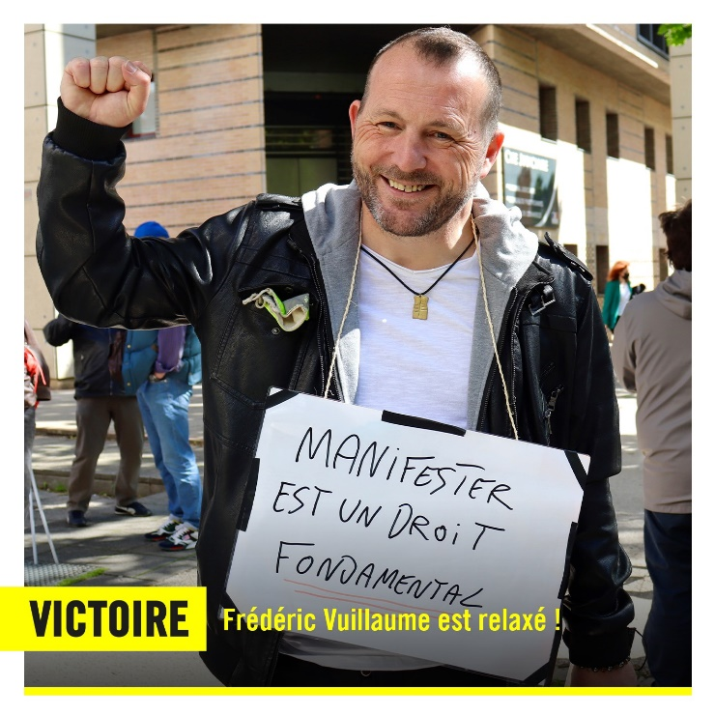

Frédéric told Amnesty: “I thank everyone and this is a victory for the right to peaceful protest in France. It is a great victory also for me too. It doesn’t erase the violent arrests, the hours in the police custody, but at least I am done with trials… for now. I thank everyone for all the efforts, all the emails sent to the Prosecutor to defend the right to protest and the right to freedom of expression. This was very important, it is thanks to you all, to your mobilisation that we got there, I could not have done it by myself, without your solidarity, your determination. Today is a victory, a really great victory, Thank you all!”

Anne Sophie, advocacy officer in Amnesty France, who was present alongside Frédéric in court said: “We went to support Frédéric at the court in Dijon, there were dozens of supporters, trade unionists, Yellow Vests and Amnesty activists welcoming him. He was very moved by our support, for him it is essential to defend the right to peaceful protest. He has been fighting for social rights for years as a unionist and wants to continue doing so. Frédéric thanked Amnesty activists for their presence, for the messages of solidarity, and for the thousands of emails sent to the Prosecutor. It is important for him not to feel alone in the authorities’ sight. When the verdict was announced, people in the room applauded. Normally you are not allowed to do that, but there was such a relief, surprise, joy that people could not hold back. And outside the others were waiting for Frédéric, singing slogans of freedom. He looked so relieved and lighter as he left the court. After two years of harassment against him, we remain vigilant. Amnesty’s mobilisation sends a signal, and we hope that it will protect him in the future and allow him to demonstrate peacefully without risk of being arrested.”

Thank you all for working on the case, for taking part in this action and congratulations again to AI France who did stellar work for and with Frederic.

#EyesOnFrance
We are continuing to campaign for the right to protest in France!
Our report Arrested for protest was launched in September 2020, and is available for reading at: https://www.amnesty.org/en/documents/eur21/1791/2020/en/
-5-
The launch of the report also marked the launch of the international campaign #EyesOnFrance that targets President Macron on the criminalisation of the right to freedom of peaceful
assembly and silencing of dissent (action is available at: https://www.amnesty.org/en/get-involved/take-action/france-right-to-protest-freedom-of-expression/).
The report and the campaign have received a lot of visibility. We need to help them out and we need to mobilise and galvanise international attention to increase the number of signatures collected internationally. We have extended the timeline for the campaign – now until September 2021 – and we hope you will all join and help us raise attention towards France and the treatment of peaceful protesters. We are aiming for 200000 signatures world-wide. Please, help us to achieve this goal!
Sign your name www.amnesty.org/en
https://www.amnesty.org/en/get-involved/take-action/france-right-to-protest-freedom-of-expression/
#Briançon7
Amnesty International considers that the conviction of the Briançon 7 for “facilitation of irregular entry” must be quashed, as it contravenes the rights to freedom of expression and peaceful assembly!

On 13th December 2018, the Criminal Court of Gap convicted Benoit Ducos, Lisa Malapert, Mathieu Burellier, Jean-Luc Jalmain, Bastien Stauffer, Elenonora Laterza and Théo Buckmaster, known as the Briançon 7, accused of “facilitating the irregular entry of foreign nationals” into France. On 22nd April that same year, they had participated in a peaceful demonstration, marching from the ski town of Clavière in Italy towards France, crossing the border and reaching the French town of Briançon. They were part of a protest against the group Génération Identitaire, an anti-human rights group that, the day before, staged a stunt to block the border and whose presence in the area had sparked fear among refugees, migrants and volunteers defending their rights. Amnesty International considers that the conviction of the Briançon 7 for facilitation of irregular entry must be quashed, as it contravenes the rights to freedom of expression and peaceful assembly.
Briançon 7, were formally charged with “facilitation of irregular entry” into France. They were tried in November 2018 and convicted in December 2018. Benoit Ducos, Bastien Stauffer, Eleonora Laterza, Lisa Malapert and Théo Buckmaster were each sentenced to a suspended six-month prison term. Mathieu Burellier and Jean-Luc Jalman were both sentenced to one year of imprisonment, of which eight months were suspended.
The conviction of the Briancon 7 is a violation of the rights to freedom of expression and peaceful assembly!

Solidarity with refugees and migrants can take many forms, including public expression of opinions and peaceful demonstrations. Any limitations on these rights need to pursue a legitimate aim and be necessary and proportionate to such aim. However, French authorities have failed to establish specifically what were the concrete risks for public order. The demonstrators in the Briançon march wanted to express their rejection of the xenophobic actions of Generation Identitaire which would later trigger the conviction of its leaders in court. Marching towards the border was a symbolic way of expressing their opposition to this anti-human rights group that was directly targeting and threatening the safety and rights of migrants and refugees.

In light of the above, Amnesty International urges the authorities to ensure that the conviction of the Briançon 7 for “facilitation of irregular entry” into France is quashed to remedy the undue
-6-
interference with their rights to freedom of expression and assembly. Moreover, France must take immediate action to ensure a safe and enabling environment in which human rights defenders working to protect the rights of migrants and refugees can work without fear of reprisals.
View report of the case: https://www.amnesty.org/en/documents/eur21/4181/2021/en/

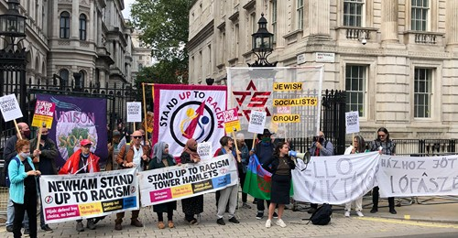

On Friday 28th May the Hungarian Prime Minister visited Downing Street.
At very short notice a demonstration was called by Stand up to Racism and the Jewish Socialist group. I was not able to attend personally but provided a statement :
Amnesty International has grave concerns regarding the Human Rights situation in Hungary since Victor Orban’s Fidez Party took power in 2010. Of major concern is the discriminatory treatment and hate speech directed against minorities : against Roma who have lived in Hungary for over 600 years and against refugees and migrants claiming the universal Human Right to asylum from persecution. We have further grave concerns about the near total government control of the media, the government attempts at curtailing the independence of the judiciary and the criminalisation of civil society, particularly the criminalisation of those who help the most vulnerable ; refugees and the homeless.

-7-

Statement by Sandor Szoke from Hungary
Why we should oppose the visit of the Hungarian Prime Minister Viktor Orban to the UK
Orbàn’s is governing a generic fascist regime of the current crop, with those of the mid Asian post-soviet states, a type of dictatorship closest to the classical Mussolini -Franco-Salazar ones. The main difference is the retention of the gutted facade of democracy: fig leaves for external use - as long as his interests are keeping him inside the EU, he is going to keep this facade. He is the scale-model Trump of the periphery: with deep sympathy and more and more active relationship with Erdogan, Putin, and Xi Jinping. He is currently subscribing to national conservative and populist ideas rooted in of a 19th century ethno-nationalist mindset. But he has no convictions. He had been a lot of things from a reform-communist to a Nazi. He is - an opportunist, who did and will anytime change his „beliefs “. There are many aspects of his rule, a new type of “hybrid-regime” – not the classical, the (often incomplete) transition from an authoritarian regime to a democratic one, but a frightening tendency of the misappropriation of a once democratic state by an authoritarian one. Present-time Hungary under Orban’s rule is not a real parliamentary republic, not a real state of law anymore.
Above all -it is a racist regime. That is why we consider his invitation to Downing Street a political mistake and a provocation, and we strongly condemn it.
Let’s just mention the most revolting aspects of the racism
Zeid Bin Ra’ad Al-Hussein a Councillor at the UN Human Rights Council made the following statement at a meeting in Geneva, citing Orbán’s prior comments about Hungary not wanting to be “diverse” or “mixed,” according to AFP (Times of Israel) : “Xenophobes and racists in Europe are casting off any sense of embarrassment, like Hungary’s Viktor Orbán, who said ‘we do not want our colour … to be mixed in with others,’” Zeid said. “Do they not know what happens to minorities in societies where leaders seek ethnic, national or racial purity? Zeid Bin Ra’ad Al-Hussain described a recent speech by the prime minister, where he spoke of not wanting ‘our’ colour mixed with others, as “a clear-cut statement of racism … an insult to every African, Asian, Middle Eastern or Latin American woman, man and child.”
Anti-Semitism
The so called “Stop Soros “campaign justifying the LEXNGO 2018 legislation featured some not-so-hidden anti-Semitic undertones using antisemitic tropes
-8-
targeted against Hungarian-American stock market billionaire George Soros, a Holocaust survivor, who has since become a divisive figure in Hungary for his philanthropic work through the Open Society.
Orbán has attempted to rewrite history. He has praised Miklos Horthy for reconquering lost territories. Several towns have erected statues or placed plaques on buildings in the wartime leader’s honour. Busts of Horthy still stand across the country, despite his record of virulent anti-Semitism. According to Shapiro, Miklos Horthy wrote “with pride to his Prime Minister in 1940, ‘I have been an anti-Semite my whole life.
Anti Roma Racism
Victor Orban’s government has repeatedly stereotyped the Roma minority who has lived in Hungary for roughly 600 years as “alien, work-shy and criminal” In recent statements he has openly defended racially segregated education and attempted to stop the court-mandated payment of compensation to former pupils in the village of Gyöngyöspata who had been subjected to segregated and substandard education.
Islamophobia: Victor Orban’s government stereotyped refugees from Syria and Afghanistan as terrorists, criminals, rapists and carriers of deadly diseases.
We don’t see these people as Muslim refugees. We see them as Muslim invaders,” he told German tabloid Bild.

