Suggested posts
#Savethedate for the @AmnestyUK London Online Activism Conference: Saturday 17 July, 14.00 to 17.00 UTC+1. More details coming soon... https://www.amnesty.org.uk/groups/london-region/saturday-17-july-2021-2-5pm-london-online-activism-conference #humanrights #freedom #justice #equality
Save the date for the Amnesty UK London Online Activism Conference: Saturday 17 July, 14.00 to 17.00 UTC+1. More details coming soon... https://www.amnesty.org.uk/groups/london-region/saturday-17-july-2021-2-5pm-london-online-activism-conference

Graphics
Facebook/Twitter: Amnesty UK London Online Activism Conference 1200x628
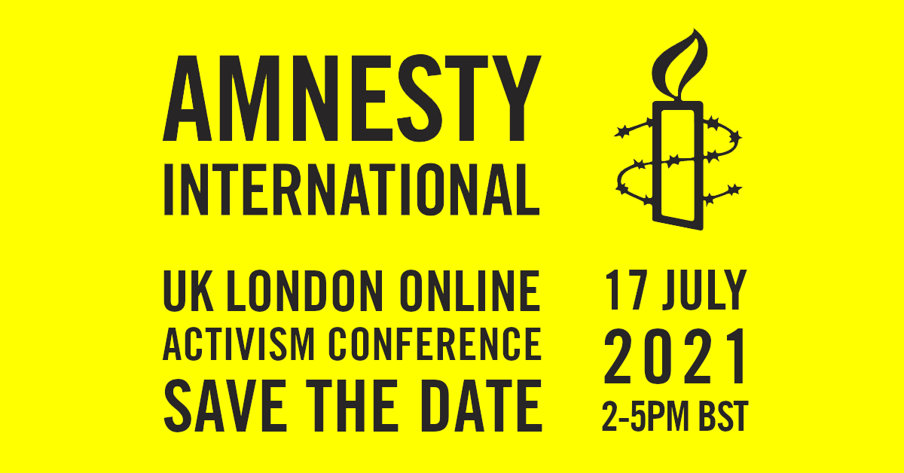
Facebook/Twitter: Amnesty UK London Online Activism Conference 1200x680
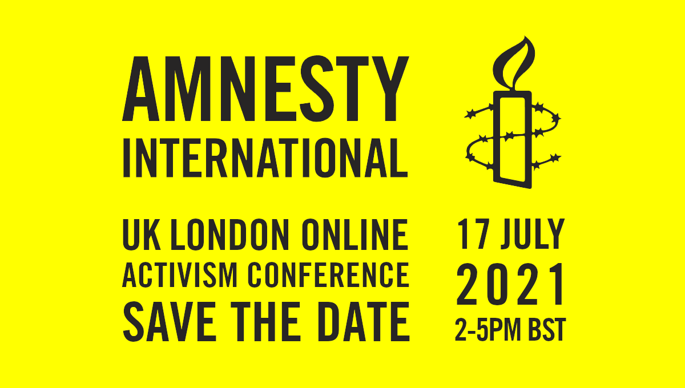
Instagram: Amnesty UK London Online Activism Conference 900x900

