Amnesty International

Blackheath and Greenwich

Newsletter

April 2021

Group Meeting 13.04.2021

Present:
Amanda K
Angela D
Ann H
David Wi
Geoff T
Giulia G
Graham D
Illona L
Juliet C
Lisa S
Marcia K
Margaret A
Melanie D
Miles J
Nancy S
Rachel E
Roger H
Sarah D

Apologies
Anne F
David We
Dee We
Ken R
Laurence B
Olwen P
Raoule

- Rachel was in the chair and Graham volunteered to write the Newsletter.

- Guest Presentation from Cllr Juliet Campbell, London Borough of Lewisham – “Black Lives Matter: the situation in Lewisham”

Juliet began by setting the context for her talk. Lewisham is the 14th largest London borough by population (2019 est.) This population is very diverse. 46.4% identified themselves as Black, Asian and minority ethnic in the 2011 census. It also has a slightly younger profile than the rest of London. The impact of the pandemic has been very high in Lewisham. It has highlighted the food poverty which existed prior to Covid19 and school lockdowns have emphasised the digital divide with learning on phones forming the only option for some pupils. Some 20% of the community can be classified as socially disadvantaged with concurrent affects on health and life chances. Unemployement, especially among the 16-24 age range has risen.

However, all is not gloom and doom. The pandemic and the sharp focus that it has brought can be seen as a call for action; a call to biuld back better than before, to reach for social equity rather than just equality of opportunity and to look to remove all systemic barriers. Juliet also noted that the tragic killing of George Floyd in May 2020 catalysed the Black Lives Matter movement to become a world wide agent for change. It was no coincidence that Black History Month in October had a higher profile in UK than ever,

One of the council roles that Juliet fulfils is to chair ‘The Safer Stronger Communities Select Committee’. This committee monitors, reviews and makes recommendations about a wide range of local matters: police and crime, equalities, community engagement and libraries. It has made the concept of intersectionality central to ithe committee’s approach to working on these matters..

Juliet ended her presentation with some questions for us to think about..
How will we know whether the group:
- understood intersectionality?
- was a voice for the underpriviledged?
- actively challenged racial prejudice?

There followed a lively range of questions from the group including whether Juliet had any suggestions on how we might recruit a more diverse membership. Her recommendation was that we reach out to organisations where people of afro-carribean or asian heritage meet and offer to give presentations about AIBG.

Rachel thanked Juliet for her absorbing presentation, enthusiatically endorsed by our zoom audience. Rachel also thanked Roger for arranging the occasion.

PS I was inspired by Juliet’s talk to read up on the very important concepts of ‘Equality cf Equity’ and of ‘Intersectionality’. I have taken the liberty of adding, at the end of this news letter, a few notes and cartoons that I found online.

- Campaign Updates

China – Angela reported an Urgent Action for China.Two Hongkongers remain incommunicado in China: Quinn Moon and Tang Kai-yin.
Action: Suggested tweet and model letter to follow.

Central America – Roger had nothing new to report, but added that problems for migrants continue at Mexican borders with its central American neighbours and with the US.

West and Central Africa – Geoff reminded us the West and Central Africa news letter that he circulated on the 7 April.

Columbia – Nancy said that Human Rights Defenders have been threatened, harrassed and killed in Columbia and she will circulate a letter that can be sent to the Columbian authorities concerning this.

Iran – David Wi reminded us that, on the 8 April, he circulated links to an online petition to the UK Government to press for the release of Anoosheh Ashoori on the occasion of his 67th birthday. There is still no further news on freedom for Nazanin Zaghari-Ratcliffe. There is a third Uk/Iran citizen in prison in \iran but I lack details at this time.

- Letter writing – Rachel explained to new members that in non-covid times, we used to meet on the 4th Tuesday each month to write letters together but for the present letters are circulated online and Brigitte will supply stamps when requested.

- Matters arising from March Group meeting There was nothing.

- London Regional Conference – David Wi joined the online event and reported:
- there was a general consensus that the London groups should have a regional conference
- timing likely to be on a Saturday, 2-3 weeks after the national conference (i.e. London conference will probably be in early July)
- conference content likely to be a mixture of different things
There will be a follow-up planning meeting in another couple of weeks.

- Book Sale issues – Geoff reported that Jeff & Liza had once again generously offered the use of their double garage to sort our books. Presently, there are large numbers of books stored in Rachel’s and Olwen’s garages and Geoff will look into hiring a van to move them when the weather has warmed up!

- Amnesty International UK 2021 Annual Conference 19th – 22nd June – Rachel reported that this year we are not required to send a group delegate because it is for individual AIUK members only

- Arrangements ror future meetings Rachel confirmed that we would not be able to move back to meeting in person until July as things stand. Geoff suggested that we might take up AIUK to provide a training session on a particular topi. Rachel reminded Georgie that she had volunteered to give atalk on AIUK and refugees.

- AOB Non

 | EVENTS 2021
Tuesday 11 May | Group meeting 7.30 on zoom
Saturday 19 June | AIUK Annual Conference online
Saturday 11 September | Book Sale

AIBG Contacts
Position | Name
Chair | Rachel E
Deputy Chair | Roger H
Secretary (enquiries contact) | David Wi
Treasurer | David We
Membership & AIBG Website | David WW
Publicity & Social Media | Simon W
Letter writing co-ordinator | Brigitte H
Newsletter | Rotating:  Nancy S  Brigitte H  Roger H  David W  Graham D  Melanie

AIBG enquiries: enquiries.aibg@gmail.com

Website: www.amnesty.org.uk/groups/blackheath-and-greenwich

The difference between equality and equity

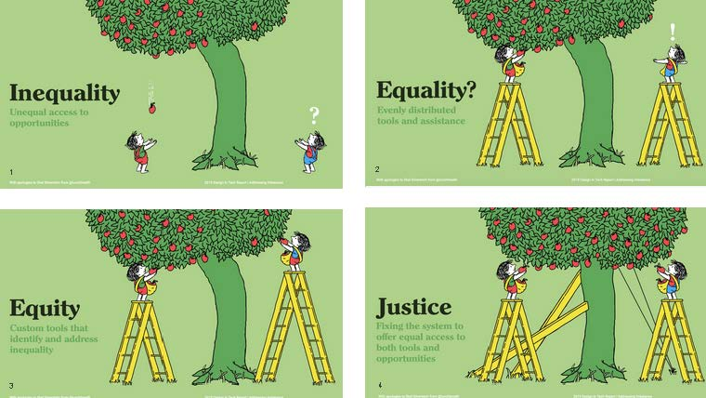

Copyright Paper Pinecone

Intersectionality:

the interconnected nature of social categorizations such as race, class, and gender as they apply to a given individual or group, regarded as creating overlapping and interdependent systems of discrimination or disadvantage

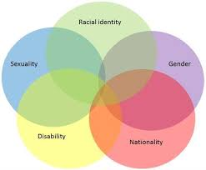

Poste by Bridie Taylor on Womankind.org.uk

