No GROUP MEETINGS until further notice

INDIVIDUAL AT RISK
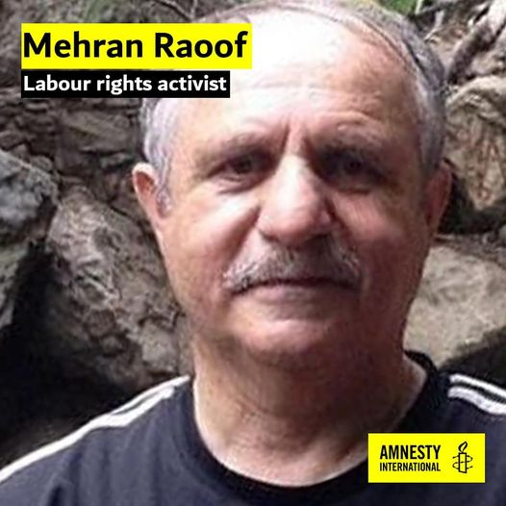
Mehran Raoof, a British-Iranian national and a labour rights activist, is being arbitrarily detained in Tehran’s Evin prison. Agents of the Revolutionary Guards arrested him on 16 October 2020. He is being held in prolonged solitary confinement, in violation of the absolute prohibition of torture and other ill-treatment. He is a prisoner of conscience and must be immediately and unconditionally released.
Take Action: Email Iranian Embassy in London, iranemb.lon@mfa.gov.ir
Mr Hamid Baeidinejad, Ambassador
Suggested text attached.

CENTRAL AMERICA
GUATEMALA
Survivors of civil war march for justice
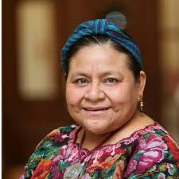
Indigenous survivors and relatives of victims recently marched in Guatemala City to commemorate the National Day of Dignity for Victims of the Internal Armed Conflict, demanding the government uphold its commitments to peace and justice. The victims, including Nobel Peace Laureate Rigoberta Menchu, called for justice, as trials against ex-military officials stagnate in court and a court ruling on the closure of peace institutions last year by President Giacometti’s government remains pending.

Attacks against Xinca people continue
An urgent action was sent after Julio González Arango was shot in January. We sent appeals in March on behalf of Luis García Monroy who was sent death threats. Both men defend the rights of the Xinca people from the impact of the Canadian owned Pan American Silver’s Escobal mine.

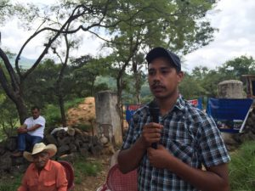

NICARAGUA
Ortega is silencing opponents
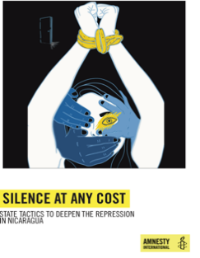
Amnesty’s new report on Nicaragua: “Silence at Any Cost – State Tactics to Deepen the Repression in Nicaragua,” details the ways the Ortega government is using to stifle dissent. One tactic is a new cybercrime law which aims to gag journalists and opponents, and there are new restrictions on NGOs. Ex-political prisoners are ostracized from society leaving them struggling to find jobs and lead normal lives. Some are unable to leave their own house. The country is under scrutiny of the UN Human Rights Council. The UK Ambassador on Human Rights at the UN has expressed her concern to the Council about the continuing repression in Nicaragua. Amnesty also has made a statement to the Council.

THREATENED BEDOUIN COMMUNITY HADIDIYA AND HUMSA

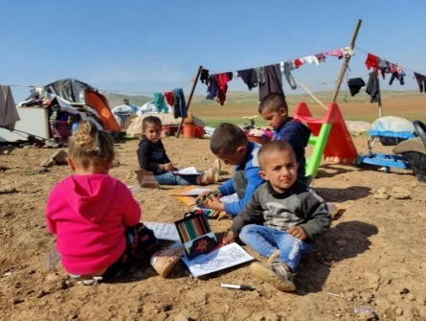

The UN and European members of the Security Council on 26th February called on Israel to stop demolitions of Bedouin settlements in the Jordan Valley, and demanded humanitarian access to the community living in Humsa Al-Baqaia.
In a joint statement at the end of a monthly session of the Security Council on the conflict in the Middle East, Estonia, France, Ireland, Norway and the United Kingdom said they were “deeply concerned at the recent repeated demolitions and confiscation of items, including of EU- and donor-funded structures carried out by Israeli authorities at Humsa Al-Baqaia in the Jordan Valley.”
It said the concern was also focused on the 70 people or so living in the Bedouin community, including 41 children. “We reiterate our call on Israel to halt demolitions and confiscations,” the statement said.
“We further call on Israel to allow full, sustained and unimpeded humanitarian access to the community in Humsa Al-Baqaia.”
Humsa al-Baqia sits in the Jordan Valley, a fertile and strategic patch of land that runs from Lake Tiberias to the Dead Sea, which has emerged as a flashpoint in the struggle over the West Bank.
The Jordan Valley is home to approximately 60,000 Palestinians, according to the UN, but nearly 90 percent of the land is part of what is known as Area C, the three-fifths of the West Bank that is under complete Israeli control.

DEATH PENALTY

Yahaya Sharif-Aminu (Nigeria)

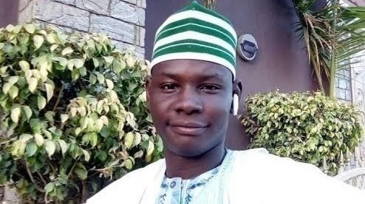
On 21 January, an Appeal Panel ordered the case of 22-year old Yahaya Sharif-Aminu be retried by a different judge on the basis that he was not represented by a legal representative throughout his trial. The singer was convicted and sentenced to death by hanging for blasphemy in August 2020, accused of circulating a song on Whatsapp that allegedly contained derogatory comments against Prophet Muhammad SWAT. Amnesty are asking for his release and charges to be dropped. We have taken action previously for Yahaya but further additional action was needed.

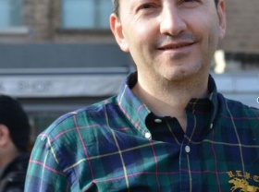
AHMADREZA DJALALI
An Iranian-Swedish academic being held in Iran and at risk of execution no later than 1 Dec. 2020. This led to international calls leading to a halt in his execution. Ahmadreza Djalali is a medical doctor and academic living in Sweden who was on a business trip to Iran when he was arrested on 26 April 2016. He was held in Evin prison for seven months in section 209, which is under the control of the ministry of intelligence. He was held for three months in solitary confinement, without access to a lawyer. Ahmadreza Djalali said he was subjected to torture and other ill-treatment, in order to force him to “confess” to being a spy. He was forced to read out “confessions” pre-written by his interrogators in front of a video camera. Ahmadreza Djalali denies the accusations against him as they were fabricated solely because of his refusal to use his academic ties in European institutions to spy for the Iranian authorities.

