No GROUP MEETINGS until further notice

SOUTH AFRICA: 'ALARMING' LEVELS OF GENDER-BASED VIOLENCE AND FEMICIDE.

“Gender-based violence has reached undeniably alarming levels in South Africa. It is absolutely unacceptable that women feel they have to watch what they wear in public and be careful about where they are seen socialising, for fear that they may face violent reprisals including rape or even death.
“The time for sloganeering and politicking has passed. President Cyril Ramaphosa must now translate into action his vow that “enough is enough”. It’s nothing short of a national emergency that femicide and rape rates are must act decisively to tackle these issues.’
POPI QWABE & BANGEKA PHUNGULA
Shot dead 3 years ago

3 years on from the murders of Popi Qwabe & Bongeka Phungula in Soweta, their families are still waiting for justice. The two friends disappeared in May 2017. After a frantic search Bongeka’s cousin and Popi’s sister discovered Popi & Bongeka had been shot and dumped by the side of the road. They may also have been raped. The families are attempting to seek justice & reparations, but to date no one has been held to account and the families say the police failed to properly investigate the murders. Send a message of suppot to:
Amnesty International South Africa ,97 Oxford Road, Rosebank, Johannesburg 2196. South Africa. (Don’t put your full name and address and don’t use a religious card.)

GOOD NEWS

VICTORIA BIRAN - BELARUS
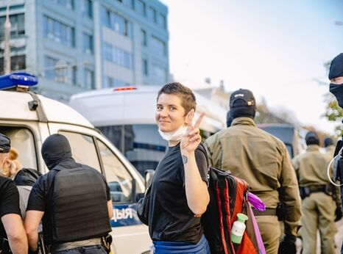

On 11 October LGBT+ activist Victoria Biran was released after two weeks in detention. Victoria Biran was detained on her way to the Women’s March in Minsk on 26 September and sentenced on 28 September to 15 days of administrative detention for intending to exercise her rights to freedom of expression and peaceful assembly. .

ALEKSANDR GABYSHEV - SIBERIA
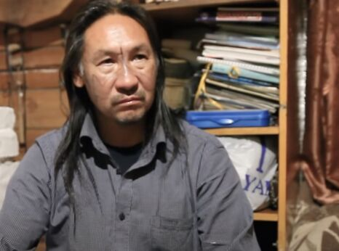

Siberian shaman Aleksandr Gabyshev was released from psychiatric detention on 22 July after his defence team succeeded in their request for a psychological and psychiatric examination on 21 July. Aleksandr Gabyshev was targeted for his open criticism of the authorities and spent more than two months arbitrarily deprived of his freedom.
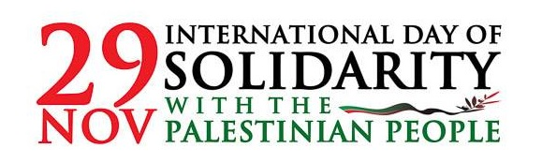

2020 Observance
1 December, 10 a.m. (EST)
This year, the International Day of Solidarity with the Palestinian People will be observed on 1 December. The exhibit will be launched on the same day. #Rights4Palestine @unispal
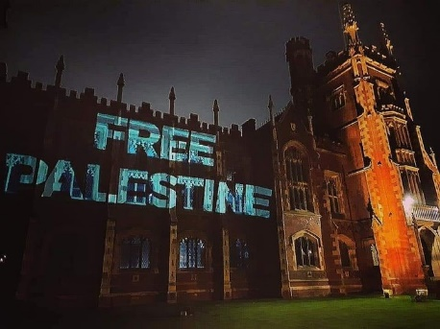
On 29th November, International Day of Palestine Solidarity. Belfast illuminated a building in support of Palestine re-affirming its commitment to the international campaign of boycott, divestment and sanctions against the violent state of Israel.
‘People before Profit’ activists organised a visual projection onto the BBC in Belfast, in support of the Palestinian struggle. The BBC has a long history of bias when it comes to reporting the occupation of Palestine. It presents a conflict of two equally balanced 'waring factions'. The reality is Israel is one of the most powerful military forces in the world propped up and maintained by its allies the UK and US.

Israel has breached countless human rights laws and innumerable UN treaties by brutally annexing and occupying Palestinian territories; and slaughtering civilians with regularity.
Israel is a terrorist state, one which continues to defy International law.

People in Palestine live under siege and military occupation, with bombs reigning down on them at the behest of the most powerful military forces in the world.
We stand in solidarity with them. Say no to BBC bias. Stand against the Israeli military occupation. Speak out for the people of Palestine.
Palestinians protesting against US Secretary of State Mike Pompeo’s recent visit to an illegal Israeli settlement on their land.
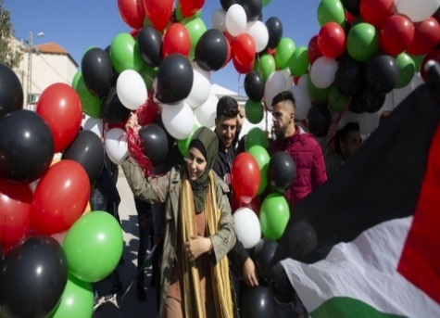

SUPPORTERS of Palestine were urged to lobby their MPs in a virtual “Lobby Day” this week against Israel’s annexation of land that violates international law.

Participants are also expected to ask MPs to take action through trade bans, sanctions and the signing of parliamentary early day motions, including number 1140 “Demolition of Palestinian Homes” and number 1139 “Israeli annexation of Palestinian land.”

The TUC pledged its “priority” of supporting Palestinian people in their ongoing struggle for peace and justice to mark the UN Day of International Solidarity with Palestinian People. It called on the British government to support moves to end the illegal military occupation of Palestine, take firm action to block further annexation, speak out in support of protecting Palestinian human rights and to recognise the state of Palestine and get behind “genuine efforts” towards a “lasting two-state solution.”

“Every Palestinian should have their human rights and labour rights respected, have a decent job and be able to live in dignity.”

The TUC said it supported a ban on trade with illegal settlements, ending arms trading with Israel, boycotts and divestment, and suspension of the UK-Israel Trade and Partnership Agreement until Palestinian rights were respected.

Around 600,000 Israeli settlers now live in the occupied West Bank.

