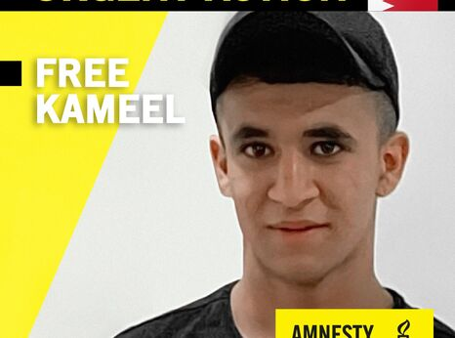
BAHRAIN: TEENAGER IMPRISONED
IN FAMILY REPRISAL
Kameel Juma Hasan, a 17-year-old secondary school student, has been imprisoned in Bahrain after he and his mother refused to become informants, and his mother, Najah Ahmed Yusuf, spoke out about her abuse in detention in the international press.
Kameel’s mother, Najah Ahmed Yusuf, has reported that she was subjected to beating and sexual assault by interrogators. After she refused to become an informant she was prosecuted on charges of circulating online opposition content and imprisoned for over 2 years.
Later in 2017, after his mother had been imprisoned, Kameel was summoned again under a new set of charges based on alleged participation in a violent demonstration. Having previously experience coercion and conviction in an unfair trial, Kameel did not respond to the summons. He was convicted in his absence and ordered to be held for the remainder of his probation in a youth detention centre. Kameel did not turn himself in – he managed to take his final exams for middle school in spring 2018, and then went into hiding so could not start secondary school in September 2019.
Throughout 2018 and 2019 summons, charges and prosecutions were added against Kameel, many arising from his alleged participation in demonstrations. By the end on 2019 cases were being added to rapidly he was sometimes expected to attend separate hearings in separate prosecutions in a single day. Faced with mounting threats to his family, who were summoned for interrogations on his whereabouts, Kameel turned himself in and several days later was taken to sign prepared “confession” documents. Given the increasing number of identical cases against Kameel as Najah continued speaking about her own ordeal, it appears his prosecution and imprisonment have been in reprisal against his mother.
He was first summoned with this mother for interrogation on charges including “unlawful assembly” and “hooliganism” in April 2017, when he was 14. While he was being held in the interrogation centre a court convicted him in a grossly unfair trail, in his and his lawyer’s absence and sentenced him to probation for a year.
Najah has described in interviews that during the interrogations intelligence officers demanded her and Kameel become informants on opposition activities and threatened to take revenge on Kameel using criminal charges raised against him, and told Najah they would kill members of her family if they did not agree.
Kameel is currently being held at the Juvenile Reform and Rehabilitation Centre at Dry Dock. He faces over 20 separate prosecutions based on his non-violent participation in demonstrations against the Bahraini monarchy.
On 13 September 2020 Kameel was sentenced to five years imprisonment on one set of charges, in a trial of 39 defendants, all of whom were Shi’a citizens, reflecting discrimination in the criminal justice system of Bahrain, which has a Sunni-led government.
Amnesty International has received credible reports that, in January 2020, Kameel was compelled to sign a prepared “confession” placed in front of him by interrogators after being beaten and forced to stand for prolonged periods of time.

TAKE ACTION:
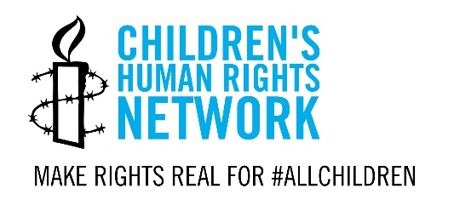
Write to the Bahrain Ministry of Justice calling for Kameel to be released, his conviction to be quashed, remaining charges against him to be dropped, and from him to be protected from torture and ill-treatment.
Please take action before 27 January 2021.
Read more or take action online at:
https://www.amnesty.org.uk/urgent-actions/bahraini-youth-targeted-family-reprisal
TEMPLATE LETTER

Ministry of Justice
82 Road No. 1702
Diplomatic Area
Manama, Bahrain
Fax No.: +973 1753 0574

Ambassador to the UK Fawaz bin Mohammed Al Khalifa
Embassy of the Kingdom of Bahrain
30 Belgrave Square
London, SW1X 8QB

Dear Sir,
Re: Imprisonment of Kameel Juma Hasan
I am writing to you to express my concern about the arbitrary detention of Kameel Juma Hasan, a 17-year-old student who has been jailed since 31 December 2019.
Kameel is currently being held at the Juvenile Reform and Rehabilitation Centre at Dry Dock. He faces over 20 separate prosecutions based on demonstrations against the Bahraini monarchy and appears to have been targeted because his mother Najah Yusuf Ahmed, who was arbitrarily detained from 2017 to 2019, spoke up about her abuse in detention. On 13 September 2020, Kameel was sentenced to five years in prison on one such set of charges, in a trial of 39 defendants – all Shi’a citizens, reflecting discrimination in the criminal justice system. Amnesty International has received credible reports that, in January 2020, Kameel was compelled to sign a prepared “confession” placed in front of him by interrogators after being beaten and forced to stand for prolonged periods of time.
I urge you to immediately release Kameel, drop all outstanding charges against him stemming from his non-violent participation in demonstrations, end the targeting of his family, and quash his conviction in the unjust group trial concluded on 13 September. Pending his release, I urge you to ensure that he is granted access to his family and lawyers and protected from torture and other ill-treatment. Allegations that he has been tortured or otherwise ill-treated must be independently and effectively investigated, and statements obtained under torture must not admitted as evidence in criminal proceedings.

Yours sincerely,

