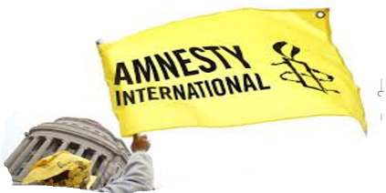
AMNESTY INTERNATIONAL
Bromley & Orpington Group
Flying the Flag January 2021 Newsletter

Dear Supporter,
Well, good-bye 2020,a strange and deeply worrying year in anybody’s calendar. Let us hope the bells ring in a better 2021 for everyone. Not least, for those persecuted and imprisoned for standing up for human rights. Under the present restrictions, Group members still cannot meet in person, but we will continue to meet monthly online. There is much to do, so if you have not joined us for a meeting before, think about it now. You just need to email me and I will send you the Zoom link for the next meeting. Together we can make a difference.
With all good wishes for a healthy and peaceful 2021.
Patrick Nield, Chairperson, Bromley & Orpington Amnesty Group Email: pdnield@gmail.com Address: 16 Brookmead Avenue, BROMLEY, BR1 2LA Tel: 020 8467 4169

The Chairperson is sponsoring this month’s Newsletter.

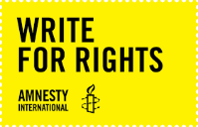
Here are 3 campaign actions we can take this month in support of the Write for Rights Campaign.
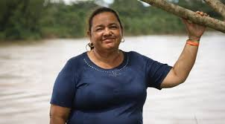
Action 1 – Jani Silva, Colombian Amazon reserve, environmental campaigner, at risk of attack.
“Because I defend my territory, people have put a gun to my head to kill me. However, I stay. We cannot run away or let ourselves be won over by fear”.
Jani Silva is a campesina, or small-scale farmer. She organizes to protect the environment and the rights of those living in the Amazonian Pearl, a campesino reserve in the southern state of Putumayo, Colombia, where she lives. She faces death threats for defending the territory and the environment. The armed groups in the region want to control the crops, land and the communities. She is also at loggerheads with the Amerisur oil company whose oil spills have poisoned the water the communities depend on.
Please send a letter or email using the following letter as a draft. Postage £1.70p or two 1 Class stamps (£1.70p).
Mr Iván Duque, President of the Republic of Colombia, Palacio de Nariño, Carrera 8 No. 7-26, BOGOTA, Colombia
Email: contacto@presidencia.gov.co
Mr President,
Jani Silva is well known as a campaigner for the campesino farmers in the Putumayo region, dedicating her life to the peaceful defence of the environment and natural resources. She is a founder member of ADISPA (Association for the Integral and Sustainable Development of the Amazonian Pearl). Through this organisation she has been working to protect the rights of those living in the Amazon Pearl, which is very important in the world’s ecosystem. This work includes the prevention of oil spills, which poison the water sources the local community depend on. Access to clean, safe water is an indisputable human right
Jani’s work of defending the territory has put her in danger. She has been followed , intimidated by unknown people with guns and has received death threats. Covid19 has made things worse by limiting her protection.
I call on you to protect Jani Silva and all other members of ADISPA. I ask you to create and implement a protection plan for the campesino in the Amazon Pearl Reserve Zone. In doing so, you will be safeguarding not just the campesino, but a whole ecosystem important to the health of the planet. Yours sincerely…………

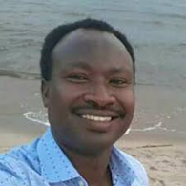
Action 2 - Germain Rukkuki, Burundi, human rights campaigner, jailed for 32 years.
He was arrested on 13 July 2017 because of his human rights campaigning, particularly for his connection with the Action by Christians for Abolition of Torture (ACAT-Burundi), which had been banned by the late President Pierre Nkurunziza, intolerant of all dissent. Germain Rukkuki charged with a range of trumped- up charges including, “rebellion”, “threatening State security” and “attack on the authority of the State” for which he was imprisoned for 32 years. Since his imprisonment he has not seen his family, his youngest son was born after his arrest. President Evariste Ndayishimiye was appointed on 18 June, 2020, and undertook to improve human rights in Burundi. On 30 July, 2020, the Supreme Court overturned the previous rejection of Germain’s appeal against his sentence and ordered that the appeal should be heard again, so now is a good time to send an appeal to the new President on Germain’s behalf calling for him to be cleared of all charges and released from prison without delay.
Please send a letter or email using the following letter as a draft. Postage £1.70p or two 1 Class stamps (£1.70p).
Email: presidence@burundi.gov.bi
President Evariste Ndayishimiye
President Evariste Ndayishimiye
c/o His Excellency Mr Ernest Ndabashinze
Uganda House Second Floor
58-59 Trafalgar Square
LONDON
WC2N 5DX

Ntare Rushatsi House
BUJUMBURA
Burundi
Or send letter via the Burundian Ambassador

Dear Mr President,
I am writing to you about the wrongful imprisonment of Germain Rukuki who is serving a 32-year prison sentence for campaigning against the use of torture in state institutions and other human rights abuses in Burundi. He was arrested on 13 July 2017 and charged and convicted of a range of trumped- up charges including, “rebellion” and “threatening state security”. He is regarded as a prisoner of conscience who has committed no recognizable crime.
Germain has been separated from his wife and family and imprisoned in the notoriously overcrowded and insanitary Ngozi Prison, where his health is additionally at risk from Covid19. On 17 July 2019, an appeal court confirmed Germain’s conviction, but on 30 June 2020, the Supreme Court set aside the appeal court’s decision and ordered that the appeal should be heard again.
I urge you to clear Germain Rukuki of all charges against him and to ensure his release from prison without delay.
At the time of your inauguration as President you promised to protect human rights and I hope that you will make good on that promise by releasing the journalists and human rights activists now languishing in prison. Yours sincerely …

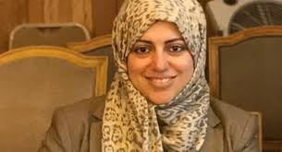
Action 3 – Nassima al-Sada, Saudi Arabian human rights activist at risk of lengthy prison sentence.
‘When a woman feels that she can’t carry out basic tasks as a citizen without her male guardian, this restricts her humanity.’
Nassima al-Sada

Nassima al-Sada, a prominent Saudi Arabian activist and human rights educator, has been detained in Al-Mabahith prison in Dammam for over two years. She has spent many years campaigning for women’s freedom, including campaigning for women’s right to drive and ending the male guardianship system. She is at risk of being sentenced to a lengthy prison term. She was arrested on 31 July 2018, and was held in solitary confinement from February 2019 for a year. She has also endured threats and ill treatment. Her first trial session began on 25 June 2019. Her latest trial session in March 2020 was cancelled due to Covid-19. So far, all of her court sessions have been closed, with diplomats and journalists banned from attending. A mother of three, she is allowed one weekly phone call with her family, but no visits, not even from her lawyer. Her detention is part of a recent wave of arrests that target Saudi women’s human rights activists.
Please send a letter to the Saudi King c/o the Saudi Embassy, London
His Majesty King Salman bin Abdul Aziz Al Saud,
c/o His Excellency HRH Prince Khalid Bin Bandar Bin Sultan Al-Saud, Royal Embassy of Saudi Arabia, 30 Charles Street,
LONDON, W1J 5DZ
Your Majesty,
I am writing to you about the arrest and detention of the prominent human rights activist, Nassima Al-Sada. She has spent many years campaigning peacefully for women’s rights, including the right to drive and the right to independence of the male guardianship system and is regarded by Amnesty International as a prisoner of conscience.
She was arrested on 31 July 2018 and has had to endure solitary confinement, threats and ill treatment. Her first trial session began on 25 June 2019, her latest in March 2020 was cancelled because of Covid-19 restrictions. All her court appearances have been closed, with observers banned from attending.
Nassima, a mother of three, has been allowed no visits in prison, not even from her lawyer. She is detained in the Al-Mabahith prison in Dammam.
Nassima Al-Sada’s detention is seen as part of a recent campaign to target Saudi women’s human rights activists and I ask you to immediately and unconditionally to release her and all those detained for their peaceful human rights work. Yours sincerely…

Thank you for all your support for Amnesty in 2020
Contacts: Patrick Nield (Chair) Vivien Glanz(Secretary)
pdnield@gmail.com vivienglanz@hotmail.com

Group Finance Balance at 5 November £625.04
Payments in - Donations 40.00
Payments out Group contribution 150.00
Balance at 8 December 2020 £515.04
Group contribution to Amnesty UKHQ 2020 £1672

