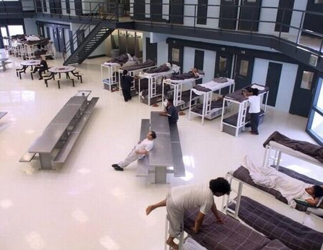
CHILDREN DETAINED FOR OVER A YEAR
US: FAMILIES IN IMMIGRATION DETENTION
As Covid-19 runs rampant in US family detention centres, immigration authorities continue to lock up families who came to the US seeking safety from violence and persecution.
Ana* (22) and her daughter Victoria* (4) fled Honduras after repeated threats against their lives, after Ana’s partner and Victoria’s father was killed because of his political beliefs. ICE received multiple reports that Victoria is asthmatic and at particular risk of severe Covid-19, but still refuses to release them. Ana also suffers from ovarian cysts, causing daily pain for months, and has not received appropriate medical care. Victoria now has anxiety attacks, nightmares and wets the bed.
US Immigration and Customs Enforcement (ICE) is detaining nearly ninety families at three facilities in Pennsylvania and Texas. Covid-19 was confirmed in family detention centres in June, including the centres were Ana, Victoria, Juana and Norma are held.
Detained families are placed at grave risk due to inadequate hygiene and negligent medical care. ICE has the legal authority to release families together, and has historically done so, but is choosing not to exercise its authority and instead leaving families trapped behind detention walls.
In May 2020, ICE presented detained parents with children as young as one-year-old with an impossible choice: either separate from their children, who would be released to sponsors while their parents remain in indefinite detention facing possible deportation, or stay detained together indefinitely.
Under international law, the US government has an obligation to ensure the human rights of migrants and asylum seekers are respected and that children are detained only in exceptional circumstances and for the shortest possible time.
Read more in Amnesty’s update: Family Separation 2.0: ‘You aren’t going to separate me from my only child’.

Juana* (45) and Norma* (4) fled Honduras with Juana’s other daughter, Paula*, after gang members threatened them with rape and murder. They were separated at the US border and Paula was sent to Mexico under he unlawful ‘Remain in Mexico’ policy, whilst Juana and Norma were put in detention. Juana suffers from joint pains and high blood pressure and is stressed by the situation and uncertainty of Paula’s fate. Norma has become despondent and depressed and constantly asks when they are getting out.
Both families recently passed the anniversary of a year spent in detention.
Authorities must release all families together, to protect them from the pandemic whilst maintaining family unity. The alternative, separating families and only releasing children is completely unacceptable. Family separation by coercive ‘choice’ violates multiple human rights including the right to family life, the right to liberty, and the requirement to prioritise the best interests of the child.
TAKE ACTION:
Write to the ICE Director calling for families to be released from immigration detention.

TEMPLATE LETTER

Tony Pham
Acting Director
U.S.A, Immigration and Customs Enforcement
500 12th St., SW
Washington, D.C. 20536
Email: tony.h.pham@ice.dhs.gov

Dear Acting Director Pham,
I am deeply concerned about the safety and wellbeing of families and children detained by Immigration and Customs Enforcement (ICE).
With confirmed cases of Covid-19 in family detention facilities, families face grave complications and even the risk of death if they contract the virus. There are credible, consistent and disturbing accounts by families of dangerous conditions that put all families, facility staff, and surrounding communities at risk.
These families came to the United States seeking protection from violence and persecution. They must be able to pursue the right to seek asylum in safety and without being separated.
I call on you to release all the families together.
Yours sincerely,

You can also take action online at: https://www.amnesty.org.uk/urgent-actions/free-families-immigration-detention-1

