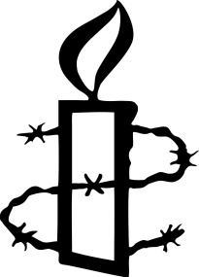

Mayfair and Soho Group

ACT OF WITNESS

Thursday 17 December 2020 at 7.00 pm, online

Every day, all over the world, people’s human rights are being violated - people like Khaled Drareni, imprisoned in Algeria for his journalism, Paing Phyo Min, a student in Myanmar, jailed for performing satirical poetry, and Jani Silva, a Colombian threatened because of her work as an environmental defender. On 17 December the Mayfair and Soho Group will be remembering by name these and hundreds of other people who have suffered violence, imprisonment and other human rights abuses. Please sponsor us generously for the number of names we read, so that Amnesty can continue its vital campaigns for the victims of human rights violations throughout the world.

NAME AMOUNT

We have a justgiving page - http://www.justgiving.com/fundraising/Amnesty-Mayfair-and-Soho-Group1/
Please see www.amnesty.org.uk for our privacy notice.

