WRITE for RIGHTS 2020
Due to ‘Covid19’ Warrington Group will not be able to hold any events but will need to choose more individual ways of promoting W4R 2020.
If you would like to send a message let me have your address and I will send you all you need in early November or you may prefer to download the cases yourself from the AI website. If you have a Twitter account there are 3 cases to tweet.
Brief summary of this year’s cases:
SEND A CARD TO:
COLOMBIA - Jani Silva - Environmental defender receiving death threats.
BURUNDI - Germain Rukuki given 32 year sentence for defending human rights
S.AFRICA - Popi Qwabe & Bongeke Phungula shot dead 3 years ago.
MYANMAR - Paing Phyo Min - student poet imprisoned for criticising government
SAUDI ARABIA - Nassima Al-Sada - Imprisoned for defending women’s rights.
MALTA - El Hiblu 3 – 3 teenage refugees from Libya arrested for stopping others being returned to Libya due to threat of torture.
PAKISTAN - Idris Khattak - abducted in 2019 for exposing disappearances
SEND AN EMAIL TO:
CHILE - Gustavo Gatica - blinded in both eyes during a demonstration
SEND TWEETS TO:
ALGERIA - Khaled Drareni - journalist/ covering weekly protests - faces 10 years prison
TURKEY - Melike & Ôzgúr – METU PRIDE - LGBTI – detained for organising pride sit-in – they face 3 years jail..
PAKISTAN - Idris Khattak - abducted in 2019 for exposing disappearances

Christmas Tree Festival at Newchurch Parish Church Culcheth - 11th to 13th December.
We have been invited to take part again this year and hope to be able to do some promotion of W4R20. Some of the trees will remain throughout the Christmas period to help decorate the church.
GOOD NEWS

Investigative journalist Ignace Sossou was freed from Cotonou prison on 24 June after having served six months in arbitrary detention. He was sentenced to prison and fined for “harassment” for tweets quoting the Public Prosecutor during a conference in which he described Benin’s digital code as ‘a weapon’ to be used against journalists
Russian Federation: Jehovah's Witness' sentence commuted

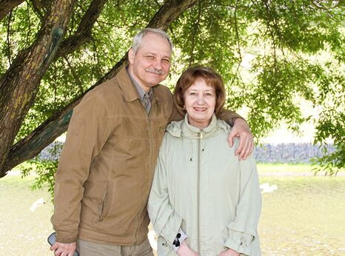

On 3rd August, the Pskov Regional Court, in western Russia, commuted Gennadiy Shpakovsky’s six-and-a-half-years’ prison sentence to a suspended sentence of the same duration including two years on probation. The 61-year-old Jehovah’s Witness was released from detention on the same day. He was prosecuted solely for exercising his right to freedom of religion.
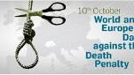

World Day against the Death Penalty is a day to advocate for the abolition of the death penalty and to raise awareness of the conditions and the circumstances which affect prisoners with death sentences. The day was first organised by the World Coalition against the Death Penalty in 2003.
NIGERIAN SINGER AT IMMINENT RISK OF EXECUTION
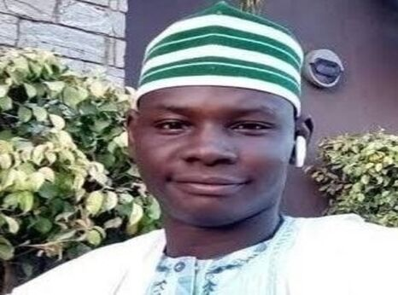
Yahaya SharifiAminu, a 22 year old singer detained in Northern Nigeria, is at risk of imminent execution sentenced to death by hanging for circulation a song via WhatsApp considered to be blasphemous.
Influential individuals and religious leaders are mounting pressure for the sentence to be cared out as soon as possible. Yahaya is now appealing the sentence. Please go on line and sign the petition.
https://www.amnesty.org.uk/urgent-actions/nigerian-singer-risk-imminent-execution

Belarus must not execute Viktar Serhil

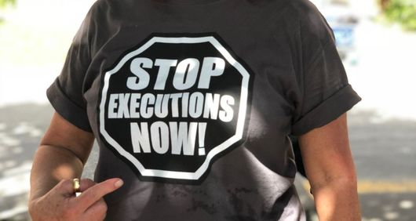
Viktar Serhil is at imminent risk of execution in Belarus after his conviction and death sentence were upheld by the Supreme Court on 31 January. Viktar Serhil can now appeal to President Lukashenka for clemency, but it is extremely unlikely that it will be granted. so Viktar Serhil may be executed.
Background
Despite continuing pressure on Belarusian authorities from within Belarus and the international community, Belarus continues to impose death sentences and execute prisoners in secrecy. Belarus remains the only country in Europe and the former Soviet Union that is still executing prisoners. President Lukashenka recently reiterated his support for retaining the death penalty in Belarus.
In Belarus, death sentences are often imposed after unfair trials; they are implemented in strict secrecy and without giving adequate notice to the prisoners themselves, their families or legal representatives. The authorities refuse to return the bodies of those executed to their relatives or even tell them where they are buried. The secrecy surrounding executions in Belarus has been identified by the UN as amounting to cruel, inhuman and degrading treatment of the relatives.
TAKE ACTION
You can send letters demanding the abolition of the death penalty and commuting the sentences of those on death row to:
Volha Ivanauna Chuprys
Chairperson of the Clemency Commission
Presidential Administration
Vul. Karla Marxa, 38
220016, Minsk
Belarus

