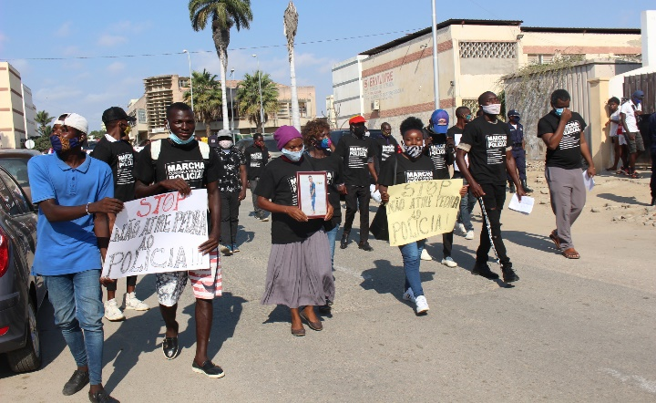
EXCESSIVE FORCE DURING COVID-19
ANGOLA: TEENAGERS KILLED BY POLICE
An investigation by Amnesty International and Angolan human rights organisation OMUNGA has reported that Angolan security forces responsible for implementing COVID-19 restrictions have killed at least 7 boys and young men, using excessive and unlawful force.
In Angola the government declared a state of emergency on 27 March in response to the Covid-19 pandemic. This was extended until 26 May when the public calamity state entered into force marking a new phase of the Covid-19 response.
Since the state of emergency Angolan security forces in various provinces have resorted to excessive, disproportionate, abusive and even lethal use of force to deal with infringements of Covid-19 prevention measures.
Amnesty International and OMUNGA have received overwhelming reports of police use of excessive force and firearms by security forces and are concerned that coercive penalties for non-compliance often targeted disadvantaged communities that are marginalized, impoverished or at risk of discrimination.
Amnesty and OMUNGA are concerned that the government has contributed to an increased environment of intimidation and violence in the streets of Angola. The justification of police behaviour given by Minister of Interior Eugênio César Laborinho at a national press conference on 3 April was “The police are not on the streets to distribute sweets, nor to give chocolates, they will act according to the behaviour of each citizen or gathering.” The Ministry’s social media also reinforced repressive messages.
Even in times of emergency, security forces must only use force that is necessary and proportionate to achieve a legitimate objective.
It is also crucial that the authorities give consideration to the situation of people particularly at risk of being seriously impacted or unable to comply with lockdown regulations, such as people living in poverty, and provide appropriate support.

On 13 May 2020 14 year old Mário Palma Romeu (Marito) was going to buy sugar for his mother in the square at Tombas’ beach in Benguela province. That morning there was a riot involving young men working on fishing boats on the beach. A police officer shot twice into the air to disperse the disturbance and the second shot hit Marito’s head, killing him.
On 5 June 2020, 15 year old Altino Holandês Alfonso went to see his grandmother and aunt at the canteen they owned. Shortly after he arrived police began shooting in the streets, possibly to disperse people. Witnesses report that an officer chased Altino, who tried to run to his aunt’s home, and was shot in the back just outside the door. Witnesses also alleged that the office who shot him was drunk.
On 4 July 2020, 16 year old Clinto Dongala Carlos was walking home from dinner at his aunt’s house (a 300 metre walk). According to witnesses he was chased by security agents and shot in the back. The officers then approached Clinton, asked neighbours for water, and poured it in his face. Neighbours report that they heard a second shot, and after officers left they saw Clinton had been shot in the face.

TAKE ACTION:
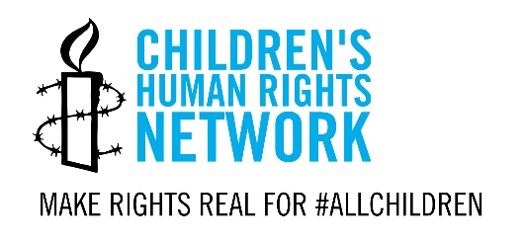
Write to the Angolan Ambassador calling the government to bring an end to the use of excessive force; ensure the reported killings are thoroughly and independently investigated; provide justice to victims; and empower and support people to comply with the Covid-19 restrictions.
Read more and sign the petition: https://www.amnesty.org/en/latest/campaigns/2020/08/security-forces-brutality-in-angola/

TEMPLATE LETTER
His Excellency Gerlado Sachipengo Nunda
Ambassador of Angola in the UK
Embassy of Angola
22 Dorset Street
London
W!U 6QY

Dear Ambassador,
Re: Security forces use of lethal force in Angola
I am writing regarding concerning reports of the Angolan security forces’ use of excessive, disproportionate, abusive and even lethal force to deal with infringements of COVID-19 prevention measures.
While I recognise the economic and social challenges Angola faces due to COVID-19 as well as the government efforts to curb the pandemic spread to protect public health, it is important to highlight that even in times of emergency, security forces may only use force that is necessary and proportionate to achieve a legitimate objective. Not to cause more harm than they are trying to prevent, in this case, the spread of COVID-19.
With huge concern, I note that, since the state of emergency declaration in March, the Angolan security forces in various provinces have resorted to excessive, disproportionate, abusive and even lethal use of force to deal with infringements of COVID-19 prevention measures. The coercive penalties for non-compliance with the COVID-19 measures often targeted disadvantaged communities which are marginalized, impoverished or at risk of discrimination, resulting in stigma, fear and lack of trust in authorities.
The use of lethal force by the Angolan security forces between May and July 2020 caused the killings of Mário Palma Romeu – Marito, 14 years old, Altino Holandês Afonso - Hernani, 15 years old, Mabiala Rogério Ferreira Mienandi – Kilson, 15 years old, Clinton Dongala Carlos, 16 years old, João de Assunção Eliseu, 20 years old, António Vulola - Toni, 21 years old, and José Quiocama Manuel - Cleide, 25 years old. The use of lethal force in all the seven cases was unnecessary and disproportionate.
I am concerned that the government has contributed to increased intimidation and violence in the streets of Angola, instead of ensuring that people are empowered and supported to comply with the required measures being enforced to contain the spread of the COVID-19 in Angola.
I urge the Government of Angola to:
- Take immediate and urgent steps to ensure that law enforcement officials stop resorting to the use of excessive force as a means of punishment at any time, including for violations of COVID-19 regulations;
- Take steps to promptly, thoroughly, independently and impartially investigate the allegations of the killings of Mário Palma Romeu, Altino Holandês Afonso, Clinton Dongala Carlos, Mabiala Rogério Ferreira Mienandi, João de Assunção Eliseu, António Vulola and José Quiocama Manuel by security forces while enforcing the COVID-19 regulations and ensure that perpetrators are held to account;
- Adopt immediate and urgent measures to provide justice to the victims of human rights violations related to the government’s response to COVID-19, including appropriate and adequate compensation for the families of Mário Palma Romeu, Altino Holandês Afonso, Clinton Dongala Carlos, Mabiala Rogério Ferreira Mienandi, João de Assunção Eliseu, António Vulola and José Quiocama Manuel; and
- Take immediate and urgent steps to empower and support people to comply with the restrictions, including by ensuring access to public health information and by enabling people who are marginalised to meet their essential needs without discrimination.
I thank you in advance of your attention to this matter.
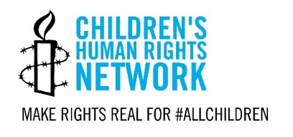
Yours sincerely,

