ALBERTOPOLIS
A Virtual Tour on Zoom
Sunday 4 October at 6:00 pm
This virtual tour is a fundraiser for Amnesty International. Booking is through Eventbrite with a minimum contribution of £5.00. Use this link to book your place: -
https://www.eventbrite.co.uk/e/albertopolis-tickets-118425839875
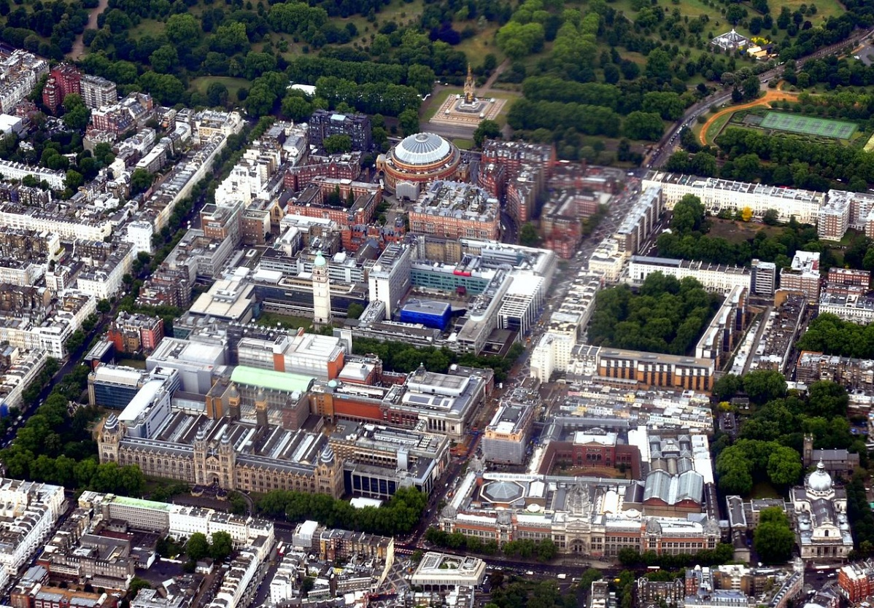
This walk takes us past the great museums and institutions of South Kensington. We will see the Natural History Museum, the Victoria and Albert, Imperial College, the Royal College of Music, the great Albert Hall known to many as the nation’s Village Hall and the Royal Geographical Society. We will also see other nearby buildings like the Ismaili Centre and the Brompton Oratory which reflect different traditions. We finish close to that magnificent Gothic monument to the man who conceived the idea of setting up what has become the world’s greatest cultural quarter – the Albert Memorial. We will see some of the most imposing and famous buildings in London created at the zenith of Victorian era of confidence and sense of Imperial destiny.

