GROUP MEETIGS
No group meetings until further notice

COVID 19 IN CENTRAL AMERICA

High rates of inequality, poverty and an informal workforce have led to civil unrest in countries where more than 30% of the population lives on $5.50 a day or less.
In Honduras police used tear gas against protesters wanting food. Street vendors, laid-off workers and trash collectors have blocked roads to protest against the strict curfew that has worsened conditions for the nearly 50 percent of the population that lives in poverty. Most people in this country live day by day - they are hungry so they have to go out.”
Desperate citizens in El Salvador have been met with repression and arrest as police and military take charge in the public health crisis. Mexico’s President has introduced severe austerity measures abolishing 10 government departments, initiated a hiring freeze and a 25% cut in government salaries.
Some Guatemalan highland communities report extreme hardship due to the quarantine. With no economy to speak of and all public transportation halted, including the daily van that takes locals to nearby market towns to buy food. Most villagers are malnourished; they are told to stay home, but with no social safety net to keep their families fed. US deportation flights are driving up the number of COVID-19 infections in Guatemala on one flight about 75% of the deportees tested positive for the virus.
In Nicaragua there is a greater risk of COVID-19 as the country is devastated by years of crisis and the government is putting at risk the health and lives of thousands of the people.

AZZA SOLIMAN IS A HUMAN RIGHTS HERO!

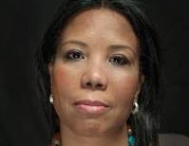
We're all experiencing some travel restrictions to protect everyone's health. But imagine you were denied travel for over three years. Azza Soliman has not been allowed to travel since November 2016.
Azza Soliman is a human rights lawyer and protects victims of torture, arbitrary detention, domestic abuse, and rape. She co-founded the Centre for Egyptian Women's Legal Assistance and Lawyers for Justice and Peace to give much-needed legal aid, support, and literacy lessons for women in poverty and survivors of abuse.

Azza and other Egyptian human rights defenders have been labelled as spies and national security threats, targeted with smear campaigns and government surveillance and criminal prosecution. She has been banned from travel, her assets have been frozen and she could face time in prison. Azza has been charged with tax evasion, operating a civil society organisation without proper registration, and slandering Egypt’s image by claiming that women in Egypt face rape.
Support Azza. Her appeal against the travel ban was scheduled for 23 April.
e-mail the Egyptian Embassy calling for the travel ban to be lifted.

His Excellency Mr. Khaled Wafik Ismail Sarwat Embassy of the Arab Republic of Egypt 12 Clyde Road, Ballsbridge, Dublin 4 E-mail: info@embegyptireland.ie
KATE ALLEN’S VISIT TO ISRAEL-PALESTINE
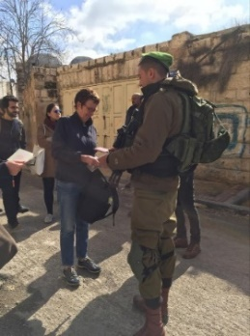
Image – Kate Allen at Israeli check-point
Five Days in Israel-Palestine (Kate Allen’s visit to the region) – In February, AIUK’s Director, Kate Allen, toured Israel and the Occupied Palestinian Territories, to be up-dated on the condition of human rights, by people on the ground.
Commenting, Kate Allen concludes:
“It isn’t just violence and intimidation Palestinians face. A complex system of discriminatory laws, unfair permit systems, housing laws and control of movement means Palestinians are being squeezed out of their homes, business, land and even denied basic amenities with impunity to make way for Israel’s illegal settlements As the grip tightens, a heavy military presence and surveillance system keeps a watchful eye for any signs of dissent - and the consequences are dire”.
UBAI ABOUDI

End the Israeli Military Detention of Ubai Aboudi.
Please sign the petition on Action Network to the People of the International Community, and to UN Members and its General Secretary.
Ubai Aboudi, a US citizen, director of the Ramallah-based Bisan Center for Research and Development and a key player in Palestinian civil society, was abducted by the Israeli military occupation on Nov. 13, 2019 and forcefully taken from his home by 12 soldiers. The brutal arrest and detention without charges of Mr. Aboudi violates international law and is a direct attack on anyone attempting to help elevate Palestinian science and education.

To take action paste into the address bar: https://actionnetwork.org/petitions/end-the-detention-of-ubai-aboudi?source=email&

GOOD NEWS - EQUATORIAL GUINEA – JOAQUIN ELO AYETO RELEASED

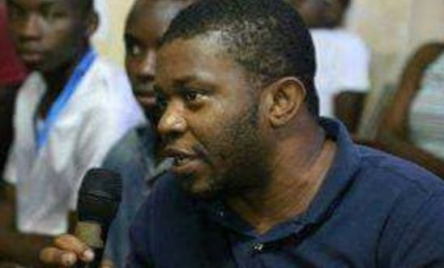

On 14 February 2020 Joaquín Elo Ayeto, was released from Black Beach Prison in Malabo, Equatorial Guinea, where he had been imprisoned for almost a year. Joaquín was not given an explanation or any information prior to his release, he was simply taken out of the prison and left on the street without a phone or money. Following his release, Joaquín shared the following message with Amnesty International: “I have been told of the work that you have done for me and I want to thank the titanic effort by Amnesty International that has resulted in my release. I want to thank all the work that has been done to achieve my release”. Joaquín was arrested at his home on 25 February 2019, accused of having information about a plot to kill the President. Joaquín was tried for defamation and threats against the President on 21 November 2019. His sentence was never read. Joaquín is a member of Convergence for Social Democracy or Convergencia Para la Democracia Social (CPDS), and a member of the coordination body for Somos+, a civil society platform with around 15 young men and women working to challenge the injustices affecting young people. The platform was established in 2015 to enable young people to respond to the arbitrary arrests of some of their peers during the Africa Cup of Nations.

