A TALE OF TWO BRIDGES

Fundraiser for Amnesty International
Sunday 14 June at 6:30
Tickets are £5.00 Booking via Eventbrite
After you book you will receive an e-mail with the Zoom Call ID & password
To book use this Eventbrite Link:-
https://www.eventbrite.com/e/a-tale-of-two-bridges-tickets-106738555894
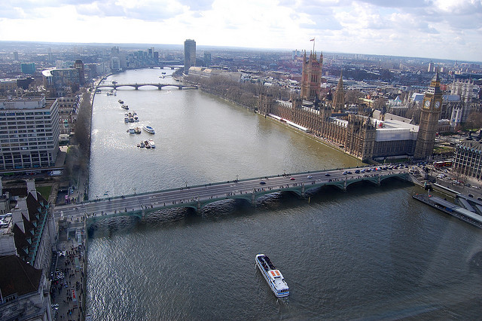
This virtual walk led by Richard Cohen, Amnesty member and London Guide, takes in the most spectacular river views in London. We will see Westminster Bridge (Earth has not anything to show more fair!). We will hear about the great medical pioneers who worked at St Thomas's Hospital. We will pass Lambeth Palace and pause at St Mary's Lambeth before crossing back over the river so that we can explore some of the wonderful streets of old Westminster. Our cybertour ends at Parliament Square where we can take a look at the outside of the Palace of Westminster and Westminster Abbey and hear about some of the great political leaders and champions of democracy and human rights who are honoured there.

